Metro College of Technology – Data Science and Application Program

SAS Final Project Report

Food Expense

What impacts Expense behaviour?

Ana Clara Tupinambá Freitas, oriented by Professor Arkar Min

Contents

Executive Summary 3

Introduction 4

Methodology 4

Data Collection 4

Data Definition 5

Identification of target Dataset 5

Model dataset 6

Softwares used 6

Business Questions 6

Identification of target 7

Data Transformation 7

Study Framework 15

Data preparation 16

Exploratory Data Analysis(Descriptive Statistics) 16

Univariate analysis 18

Household 18

Reference Person 19

Spouse 20

Bivariate analysis 23

Summary – businesses values 23

Household 24

Reference Person 26

Spouse 28

Inferential Statistics 31

Is the expense diverse regarding geography(Region and Provinces)? 31

Is the expense diverse regarding Household Type? 33

Does higher Household Income mean higher expense? 34

Model 35

Parameters 36

High level Findings/Conclusions 38

Summary of Results 38

Recommendations 39

Next steps – Questions 39

Appendix 40

Observations 40

Code 40

# Executive Summary

To know how much a household spends on food can help decide which products maintain in shelfs and give insights to marketing. This study has 2 phases:

1. Identification of product with biggest expense nationally by drilling-down from National to Province to identify which subcategory impacts the most on purchase store expenses, and then proceed to the identification of the product nationally within the subcategory identified.
2. Identification of what impacts the expense of the identified product: non-alcoholic beverages.

To maintain revenue, special attention should be applied for logistics to maintain stock keeping and market to retain (bigger spending consumers) in areas with higher concentration of:

* Households with Couple with other related or unrelated persons
* Households with Couple with children
* Males
* Separated, widowed or divorced
* Households with couples that both have Less than high school diploma or its equivalent

And due to larger population of consumers: Ontario Province.

Some actions can include: customizations of products flavours, package themes, and target advertisement.

To increase sales, target promotions to acquire consumers and boost spending of existing ones in areas such as with higher concentration of:

* One person households
* Households with couples with a combination of age group of with more than 65 years and over and spouse within 30 to 39 years
* And due to larger population of consumers: Quebec Province.

Customize products: package size

Target advertisement

**Next Steps**

Territorial capitals (biggest expected expense) x Quebec (smallest expected expense)

* Is the price, availability, product characteristics or culture that motivates these regions to such contrast spending with non-alcoholic beverages?

# Introduction

To know how much a household spends on food can help decide which products maintain in shelfs and give insights to marketing. This study has 2 phases:

1. Identification of product with biggest expense nationally by drilling-down from National to Province to identify which subcategory impacts the most on purchase store expenses, and then proceed to the identification of the product nationally.
2. Model for explanation purposes of what impacts on the expense of the identified product given the features:

* Geography
* Household Type
* Household Total Income
* Reference Person – Age Group
* Reference Person – Marital Status
* Reference Person – Education Level
* Reference Person – Sex
* Spouse – Age Group
* Spouse – Employment Status
* Spouse – Education Level
* Spouse – Sex

The data used in this study is sourced from Statistics Canada: the **Survey of Household Spending (SHS)[1]**.

# Methodology

## Data Collection

The **Survey of Household Spending (SHS)[2]** collects detailed spending information, as well as selected information on dwelling characteristics and household equipment. […] **Diary microdata**: The diary microdata file contains information from the subset of households that completed both the interview and the diary. (Extracted from: User Guide from the SHS PUMF,2017[3])

For this study the method 2(Using only the diary) recommended in the “User guide for the Survey of Household Spending public-use microdata file, 2017” file was chosen.

## Data Definition

The data set comes with a data dictionary annexed to this project package.

### Identification of target Dataset

For the first phase of this study, the features are:

* CaseId: A unique record identifier for each household in the survey.
* WeightD: Estimated number of actual households the sampled household represents. Applies to the diary file.
* Region: Engineered from the Prov feature to identify the regions in which each province belongs to.
* Prov: Province, territory or region in which the household resides at the time of the interview.
* FD: Code for each of the food expenses in the hierarchy.
* Product_Category: engineered from the FD to identify the labeled hierarchy to each the instance belongs to.
* Product_Sub_Category: engineered from the FD to identify the labeled hierarchy to each the instance belongs to.
* Product: engineered from the FD to identify the labeled hierarchy to each the instance belongs to.
* Expense: annualized expense value.

Figure - Hierarchy of features

### Model dataset

For the second phase of this study, the features are:

* FD806: Non-alcoholic beverages expense Dollars($)
* HHType6: Describes types of households in terms of the relationship between household members at the time of the interview.
* HH_TotInc: Household total income before taxes in the year prior to the reference year of the survey. Includes income from earnings (employment income), investments, government transfer payments and other sources.
* Region: Engineered from the Prov feature to identify the regions in which each province belongs to.
* Prov: Province, territory or region in which the household resides at the time of the interview.
* RP_AgeGrp: Age group of the reference person at the time of the interview.
* RP_Educ: Reference person - Education level
* RP_MarStat: Reference person - Marital status
* RP_Sex: Reference person - Sex
* SP_AgeGrp: Spouse - Age group
* SP_Educ: Spouse - Education level
* SP_EmpStat: Spouse - Employment status
* SP_Sex: Sex of the reference person's spouse.
* Expense: annualized expense value.

## Softwares used

* SAS Enterprise Guide 8.3 Update 2 (8.3.2.140) (64-bit)
* Microsoft Excel
* Adobe Acrobat Reader

# Business Questions

* Which product expense is the biggest?
* Is the expense diverse regarding geography (Region and Province)?
* Is the expense diverse regarding Household Type?
* Does higher Household Income mean higher expense?
* What impacts the expense of the previously identified product?

# Identification of target

## Data Transformation

The dataset was formatted per data dictionary and then the profiling of features was made.

The dataset was the subset to the following hierarchy of food’s purchased from store as described on the SHS package[4]:

|  |  |  |  |  |  |  |
| --- | --- | --- | --- | --- | --- | --- |
| FD003 - Food purchased from stores | | |  |  |  |  |
|  | FD100 - Bakery products | |  |  |  |  |
|  |  | FD101 - Bread and unsweetened rolls and buns | | | |  |
|  |  |  | FD102 - Bread | |  |  |
|  |  |  | FD103 - Unsweetened rolls and buns | | |  |
|  |  | FD104 - Cookies and crackers | | |  |  |
|  |  |  | FD105 - Cookies and sweet biscuits | | |  |
|  |  |  | FD106 - Crackers and crisp breads | | |  |
|  |  | FD107 - Other bakery products | | |  |  |
|  |  |  | FD108 - Other bakery products (except frozen) | | | |
|  |  |  | FD112 - Frozen bakery products | | |  |
|  | FD200 - Cereal grains and cereal products | | | |  |  |
|  |  | FD201 - Rice and rice mixes | | |  |  |
|  |  |  | FD202 - Rice | |  |  |
|  |  |  | FD203 - Rice mixes | |  |  |
|  |  | FD204 - Pasta products | |  |  |  |
|  |  |  | FD205 - Pasta (fresh or dry) | | |  |
|  |  |  | FD206 - Pasta (canned) | |  |  |
|  |  |  | FD207 - Pasta mixes | |  |  |
|  |  | FD208 - Other cereal grains and cereal products | | | |  |
|  |  |  | FD209 - Flour and flour-based mixes | | |  |
|  |  |  | FD212 - Breakfast cereal and other grain products (except infant) | | | |
|  | FD300 - Fruit, fruit preparations and nuts | | | |  |  |
|  |  | FD301 - Fresh fruit | |  |  |  |
|  |  |  | FD302 - Apples (fresh) | |  |  |
|  |  |  | FD303 - Bananas and plantains (fresh) | | | |
|  |  |  | FD304 - Grapes (fresh) | |  |  |
|  |  |  | FD305 - Peaches and nectarines (fresh) | | | |
|  |  |  | FD308 - Pears (fresh) | |  |  |
|  |  |  | FD309 - Berries (fresh) | |  |  |
|  |  |  | FD315 - Citrus fruit (fresh) | | |  |
|  |  |  | FD316 - Other fruit (fresh) | | |  |
|  |  | FD330 - Preserved fruit and fruit preparations | | | |  |
|  |  |  | FD331 - Fruit juice | |  |  |
|  |  |  | FD350 - Other preserved fruit and fruit preparations | | | |
|  |  | FD380 - Nuts and seeds | |  |  |  |
|  |  |  | FD381 - Peanuts (shelled or unshelled) | | | |
|  |  |  | FD382 - Other nuts and seeds | | |  |
|  | FD400 - Vegetables and vegetable preparations | | | |  |  |
|  |  | FD401 - Fresh vegetables | |  |  |  |
|  |  |  | FD402 - Potatoes (except sweet potatoes) | | | |
|  |  |  | FD403 - Tomatoes (fresh) | |  |  |
|  |  |  | FD404 - Lettuce (fresh) | |  |  |
|  |  |  | FD405 - Cabbage (fresh) | |  |  |
|  |  |  | FD406 - Carrots (fresh) | |  |  |
|  |  |  | FD407 - Onions (fresh) | |  |  |
|  |  |  | FD408 - Celery (fresh) | |  |  |
|  |  |  | FD409 - Cucumber (fresh) | |  |  |
|  |  |  | FD410 - Mushrooms (fresh) | | |  |
|  |  |  | FD411 - Broccoli (fresh) | |  |  |
|  |  |  | FD418 - Peppers (fresh) | |  |  |
|  |  |  | FD412 - Other vegetables (fresh) | | |  |
|  |  | FD440 - Frozen and dried vegetables | | |  |  |
|  |  |  | FD441 - Potato products (frozen) | | |  |
|  |  |  | FD442 - Other frozen vegetables | | |  |
|  |  |  | FD447 - Dried vegetables and legumes | | |  |
|  |  | FD470 - Canned vegetables and other vegetable preparations | | | | |
|  |  |  | FD471 - Canned or bottled vegetables | | |  |
|  |  |  | FD478 - Ready-to-serve or ready-to-cook prepared salads and side dishes, fruit or vegetable based | | | |
|  |  |  | FD479 - Vegetable juice (canned or bottled) | | | |
|  | FD500 - Dairy products and eggs | | |  |  |  |
|  |  | FD501 - Cheese | |  |  |  |
|  |  |  | FD502 - Cheddar cheese | |  |  |
|  |  |  | FD503 - Mozzarella cheese | | |  |
|  |  |  | FD504 - Processed cheese | | |  |
|  |  |  | FD505 - Other cheeses | |  |  |
|  |  | FD520 - Milk | |  |  |  |
|  |  |  | FD521 - Fluid whole milk | |  |  |
|  |  |  | FD522 - Fluid low-fat milk | | |  |
|  |  |  | FD525 - Skim and other fluid milk | | |  |
|  |  | FD540 - Butter | |  |  |  |
|  |  | FD541 - Ice cream and ice milk (including novelties) | | | | |
|  |  | FD550 - Other dairy products | | |  |  |
|  |  |  | FD551 - Other processed milk products | | | |
|  |  |  | FD555 - Other processed dairy products | | | |
|  |  | FD570 - Eggs and other egg products | | |  |  |
|  |  |  | FD571 - Eggs | |  |  |
|  |  |  | FD572 - Other egg products | | |  |
|  | FD600 - Meat | |  |  |  |  |
|  |  | FD601 - Meat (except processed meat) | | |  |  |
|  |  |  | FD602 - Beef | |  |  |
|  |  |  | FD603 - Pork | |  |  |
|  |  |  | FD604 - Poultry | |  |  |
|  |  |  | FD607 - Other meat and poultry | | |  |
|  |  | FD650 - Processed meat | |  |  |  |
|  |  |  | FD651 - Bacon and ham | |  |  |
|  |  |  | FD660 - Other processed meat | | |  |
|  | FD700 - Fish and seafood | |  |  |  |  |
|  |  | FD701 - Fresh or frozen fish | | |  |  |
|  |  |  | FD1003 - Cod, flounder, sole and haddock (fresh or frozen, uncooked) | | | |
|  |  |  | FD705 - Salmon (fresh or frozen, uncooked) | | | |
|  |  |  | FD706 - Other fish (fresh or frozen, uncooked) | | | |
|  |  | FD720 - Canned fish or other preserved fish | | | |  |
|  |  |  | FD721 - Tuna (canned) | |  |  |
|  |  |  | FD722 - Salmon (canned) | |  |  |
|  |  |  | FD724 - Cured fish | |  |  |
|  |  |  | FD723 - Other fish (canned or bottled) | | |  |
|  |  | FD730 - Seafood and other marine products | | | |  |
|  |  |  | FD731 - Shrimp and prawns | | |  |
|  |  |  | FD732 - Other seafood and marine products | | | |
|  | FD800 - Non-alcoholic beverages and other food products | | | | |  |
|  |  | FD801 - Non-alcoholic beverages and beverage mixes | | | | |
|  |  |  | FD802 - Coffee and tea | |  |  |
|  |  |  | FD806 - Non-alcoholic beverages | | |  |
|  |  | FD814 - Sugar and confectionery | | |  |  |
|  |  |  | FD815 - Sugar, syrups and sugar substitutes | | | |
|  |  |  | FD821 - Candies and chocolates | | |  |
|  |  | FD827 - Margarine, oils and fats (excluding butter) | | | |  |
|  |  |  | FD828 - Margarine | |  |  |
|  |  |  | FD829 - Cooking and salad oils | | |  |
|  |  |  | FD1004 - Other oils and fats | | |  |
|  |  | FD833 - Condiments, spices and vinegars | | | |  |
|  |  |  | FD834 - Mayonnaise, salad dressings and dips | | | |
|  |  |  | FD835 - Pasta and pizza sauces (canned, bottled or dried) | | | |
|  |  |  | FD836 - Other sauces and gravies (canned, bottled or dried) | | | |
|  |  |  | FD837 - Dried herbs and spices | | |  |
|  |  |  | FD879 - Food seasonings (including table salt) | | | |
|  |  |  | FD838 - Ketchup | |  |  |
|  |  |  | FD840 - Pickled vegetables (including olives) | | | |
|  |  |  | FD421 - Fresh herbs | |  |  |
|  |  |  | FD839 - Other condiments (including vinegar) | | | |
|  |  | FD841 - Infant food | |  |  |  |
|  |  |  | FD842 - Infant formula | |  |  |
|  |  |  | FD843 - Infant cereals and biscuits | | |  |
|  |  |  | FD844 - Canned or bottled infant food | | |  |
|  |  |  | FD889 - Other infant food (including frozen) | | | |
|  |  | FD845 - Frozen prepared food | | |  |  |
|  |  |  | FD846 - Frozen dinners and entrees | | |  |
|  |  |  | FD847 - Frozen pizza | |  |  |
|  |  |  | FD857 - Fish portions (pre-cooked and frozen) | | | |
|  |  |  | FD1001 - Frozen side dishes and other frozen prepared food | | | |
|  |  | FD850 - Soup (except infant soup) | | |  |  |
|  |  |  | FD851 - Soup (chilled, frozen, canned or bottled) | | | |
|  |  |  | FD852 - Soup (dried) | |  |  |
|  |  | FD853 - Ready-to-serve prepared food | | |  |  |
|  |  |  | FD854 - Dinners and entrees (except frozen) | | | |
|  |  |  | FD855 - Pizza (except frozen) | | |  |
|  |  |  | FD1002 - Other ready-to-serve prepared food | | | |
|  |  | FD883 - Snack food | |  |  |  |
|  |  |  | FD884 - Potato-based snack foods | | |  |
|  |  |  | FD885 - Other snack foods | | |  |
|  |  | FD870 - Other food preparations | | |  |  |
|  |  |  | FD871 - Peanut butter and other nut butters | | | |
|  |  |  | FD872 - Honey | |  |  |
|  |  |  | FD873 - Flavoured drink powders, crystals and syrups | | | |
|  |  |  | FD874 - Non-dairy frozen ice treats | | |  |
|  |  |  | FD875 - Dessert powders | |  |  |
|  |  |  | FD881 - Tofu | |  |  |
|  |  |  | FD882 - Other canned, bottled or dried meals | | | |
|  |  |  | FD880 - Other materials for food preparation | | | |

Figure - Hierarchy

The data set was then denormalized, having its final shape the following features:

* CaseId: A unique record identifier for each household in the survey.
* WeightD: Estimated number of actual households the sampled household represents. Applies to the diary file.
* Region: Engineered from the Prov feature to identify the regions in which each province belongs to.
* Prov: Province, territory or region in which the household resides at the time of the interview.
* FD: Code for each of the food expenses in the hierarchy.
* Product_Category: engineered from the FD to identify the labeled hierarchy to each the instance belongs to.
* Product_Sub_Category: engineered from the FD to identify the labeled hierarchy to each the instance belongs to.
* Product: engineered from the FD to identify the labeled hierarchy to each the instance belongs to.
* Expense: annualized expense value.

Product_Category, Product_Sub_Category and Product is following the construction of the hierarchy showed in Figure 2- Hierarchy generating the FOOD dataset.

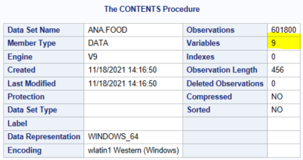

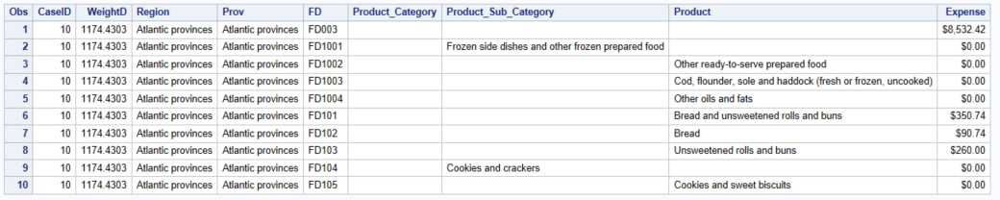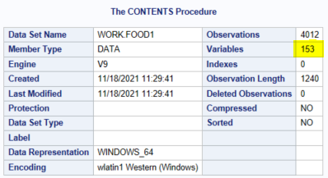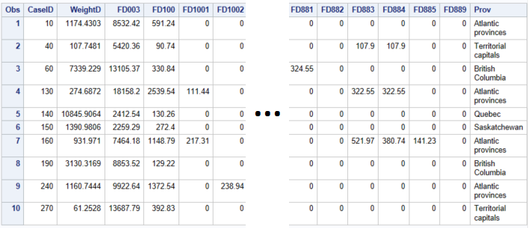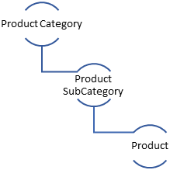

Although the number of observations is 4012. The number of datapoints after applying the multiplications factor weightd is: 14,462,249.

Which product expense is the biggest?

The initial exploration of behaviour expense was the proceed with the graphing observations in a drill-down manner: from national to provincial and back to the national product:

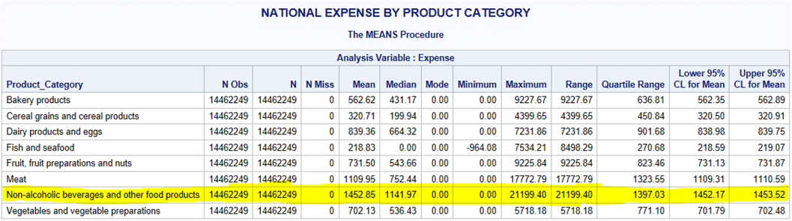

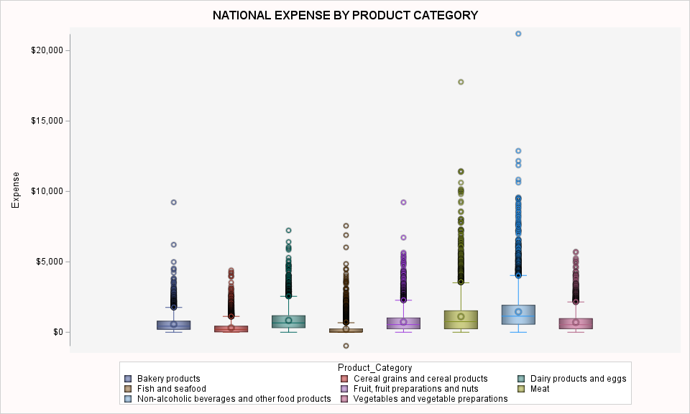

#### What's the distribution of products category expense nationally?

We see that the biggest median ($1,141.97) national expense is from Non-alcoholic beverages and other food products.

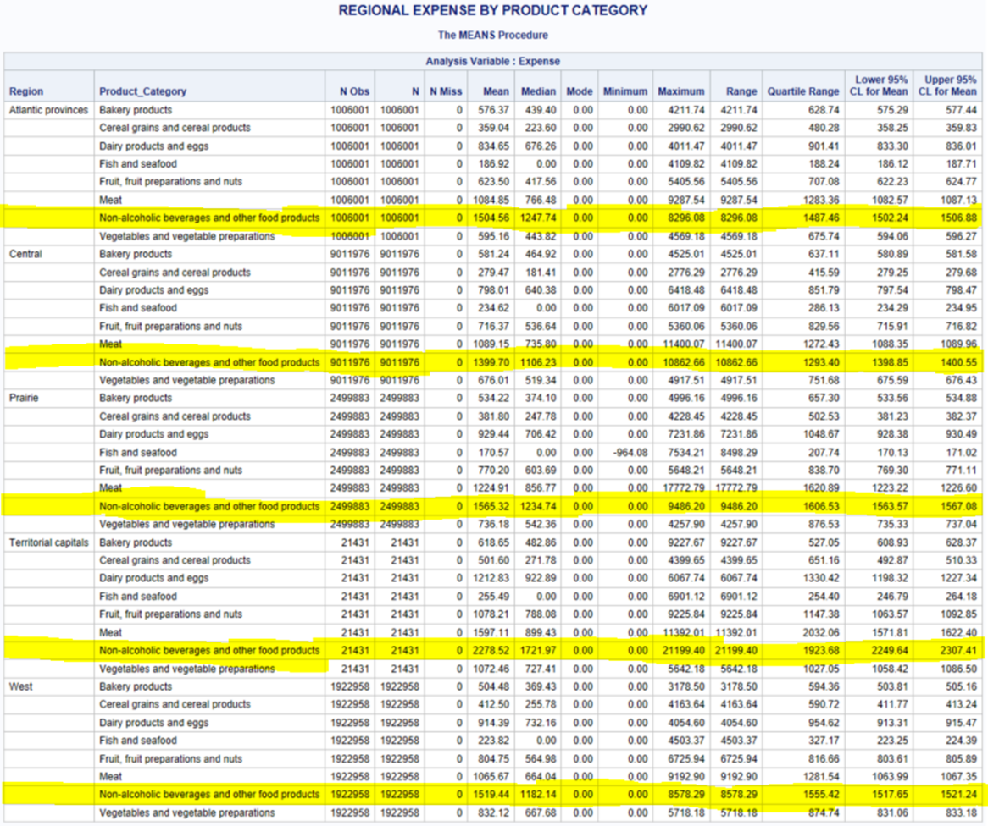

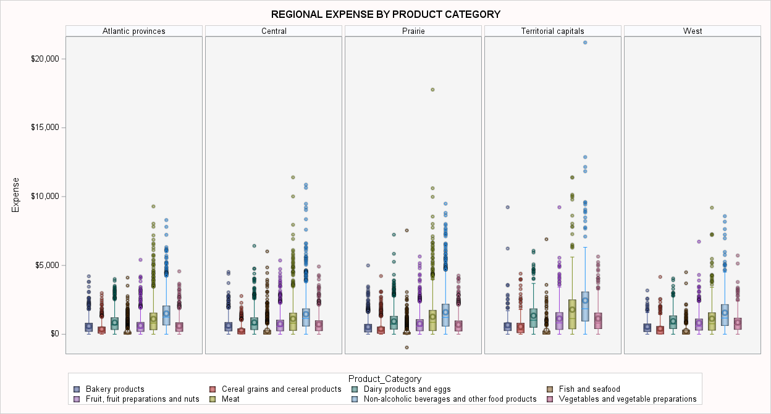

#### What's the distribution of products subcategory expense regionally?

The same behaviour repeats regionally: the biggest median national expense is from Non-alcoholic beverages and other food products for all Regions.

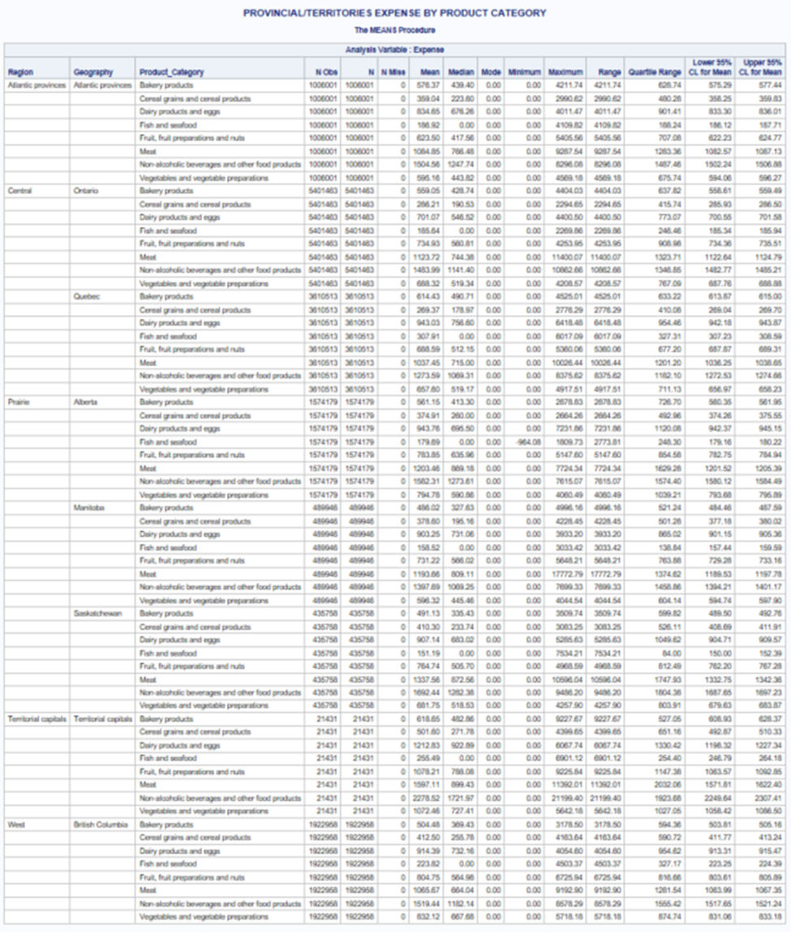

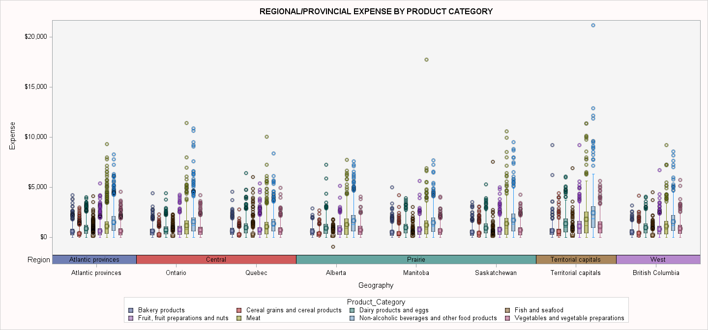

#### What's the distribution of products subcategory expense provincially?

The same behaviour repeats provincially: the biggest median national expense is from Non-alcoholic beverages and other food products for all provinces.

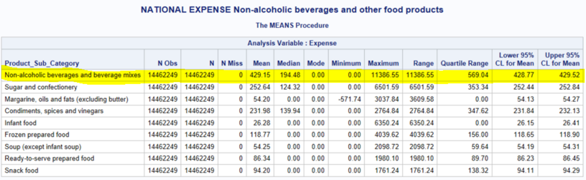

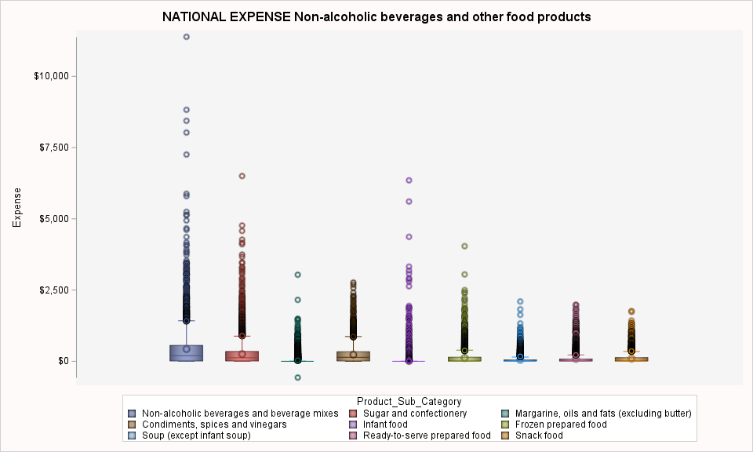

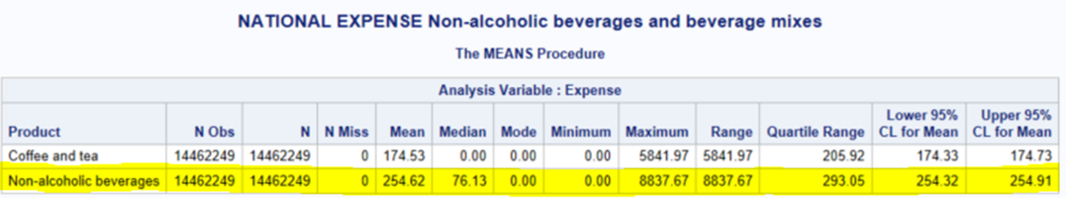

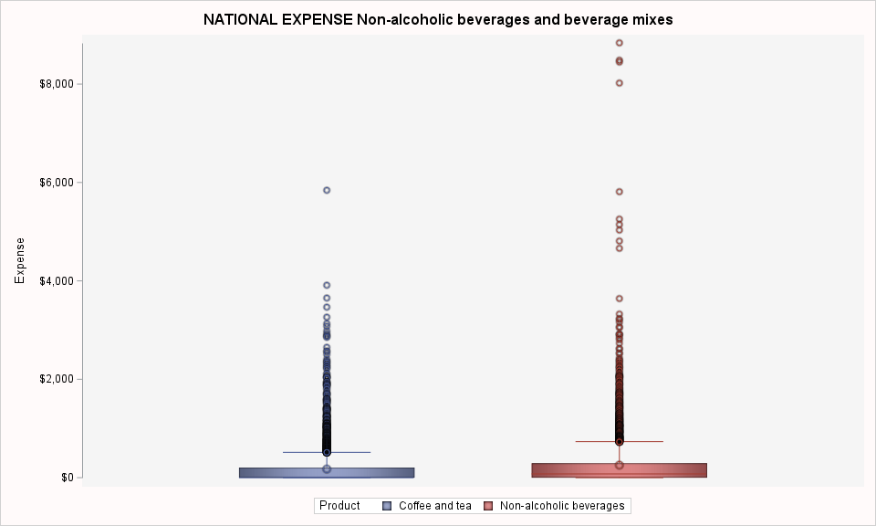

When Non-alcoholic beverages and other food products sub-category is drill down nationally we see that **Non-alcoholic beverages is the biggest expense.** For the next phase this will be the target.

Nationally, we see that Non-Alcoholic beverages represents approximately 4% of total purchased food from store expenses:

# Study Framework

Total Income

Reference person - Education level

Reference person - Age group

Reference person - Marital status

Spouse - Sex

Reference person - Sex

Spouse - Employment status

Spouse - Education level

Spouse - Age group

Province

Household Type

Region

## Data preparation

The formatted dataset was subset and engineered to:

* FD806: Non-alcoholic beverages expense Dollars($)
* HHType6: Describes types of households in terms of the relationship between household members at the time of the interview.
* HH_TotInc: Household total income before taxes in the year prior to the reference year of the survey. Includes income from earnings (employment income), investments, government transfer payments and other sources.
* Region: Engineered from the Prov feature to identify the regions in which each province belongs to.
* Prov: Province, territory or region in which the household resides at the time of the interview.
* RP_AgeGrp: Age group of the reference person at the time of the interview.
* RP_Educ: Reference person - Education level
* RP_MarStat: Reference person - Marital status
* RP_Sex: Reference person - Sex
* SP_AgeGrp: Spouse - Age group
* SP_Educ: Spouse - Education level
* SP_EmpStat: Spouse - Employment status
* SP_Sex: Sex of the reference person's spouse.
* Expense: annualized expense value.

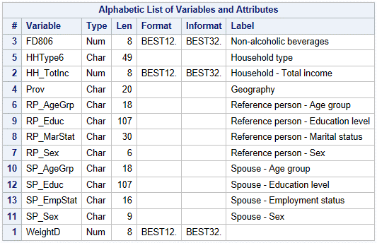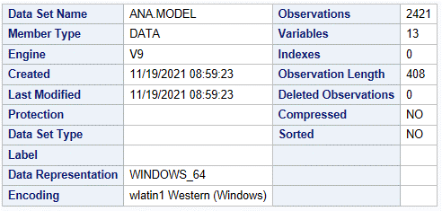

Outliers[5] were excluded from the dataset as well instances with zero expense.

# Exploratory Data Analysis(Descriptive Statistics)

The following analysis were made using the data set prepared as mentioned above, p-values and Tukey visuals for bivariate analysis were extracted from the transformed data as explained below[6]. Unfortunately, Q-Q plot were not rendered due to computational power limitations. Statistics and CLT(Central Limit Theorem) were used to test assumption for normal distribution as follows:

CLT :

a.If it looks normal and each group have more than 30 observations

b.If moderately skewed, each group must have more than 100 observations*

*rule of thumb: If skewness is between -1 and -0.5 or between 0.5 and 1, the distribution is moderately skewed[7].

To comply with assumptions to build the model, BoxCox within Transreg procedure having being executed and the recommendation was to apply log transformation as expected. After transformation, we see that Non-alcoholic beverages expense distribution approximates to normal:

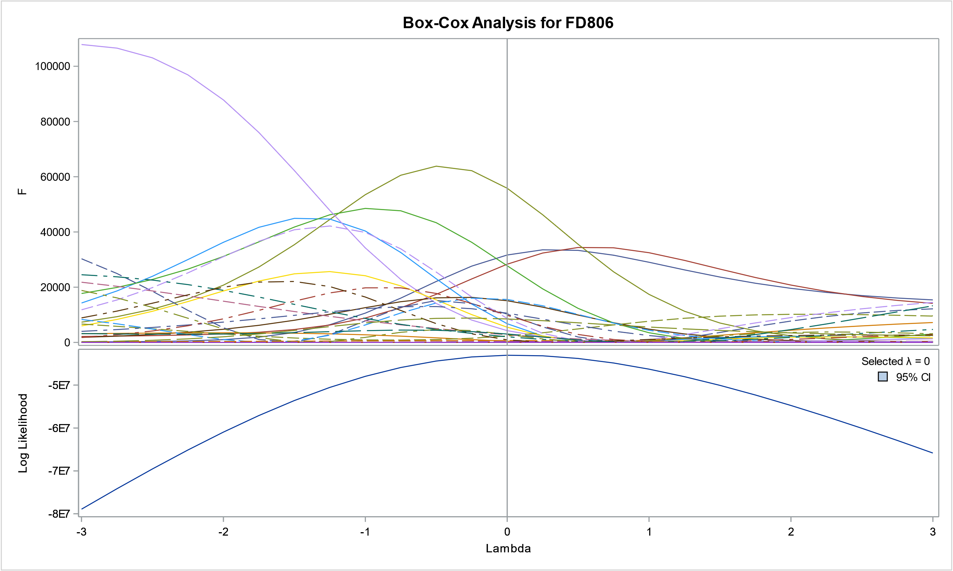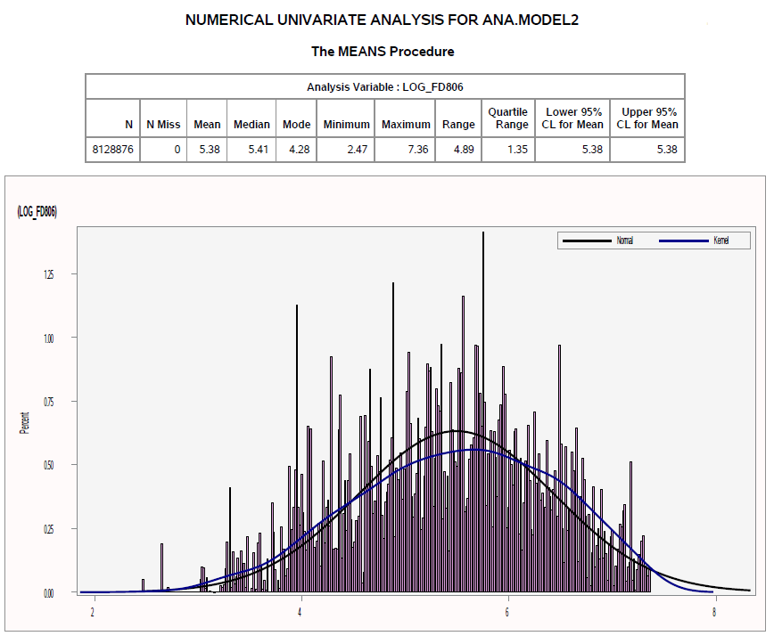

## Univariate analysis

### Household

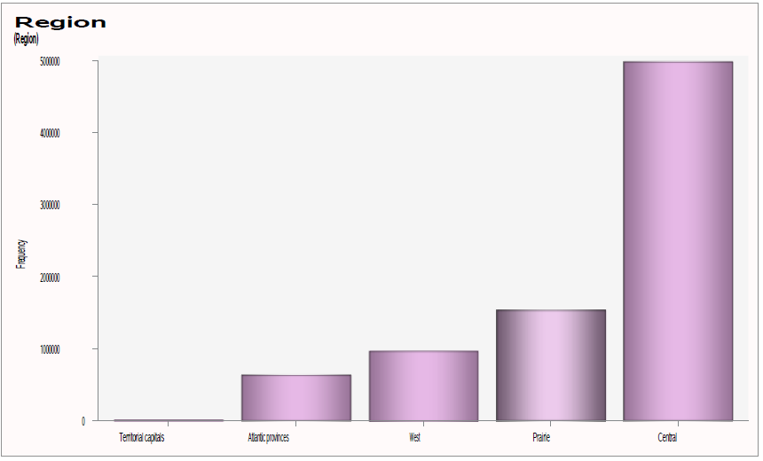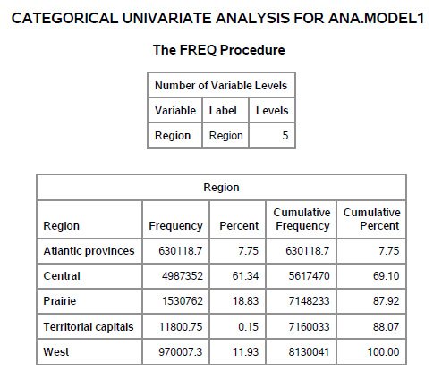

We see that most of the household surveyed are in Central region.

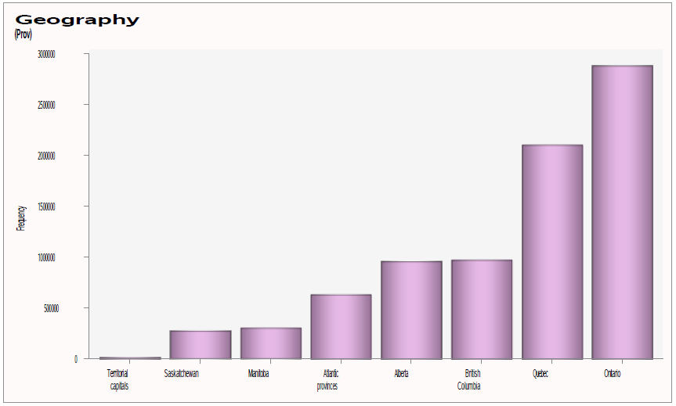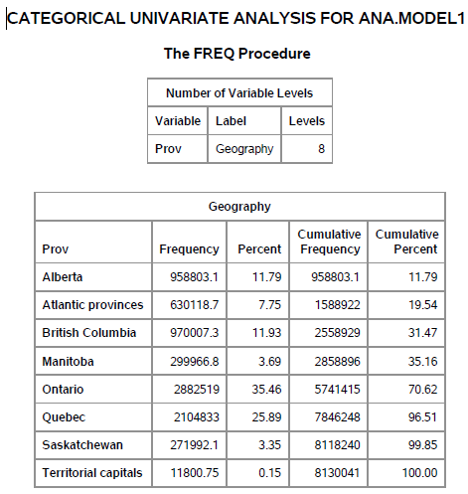

We see that most of the household surveyed are in Ontario.

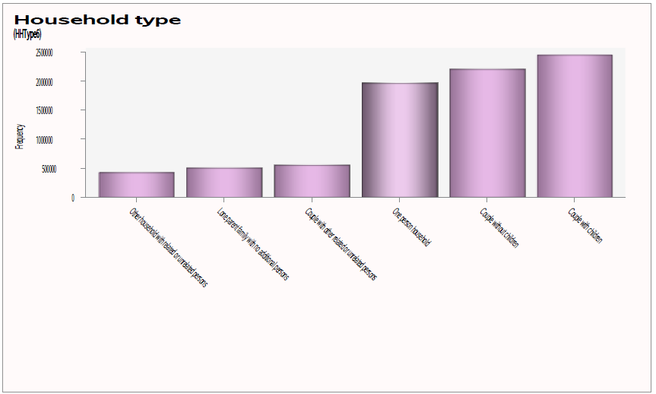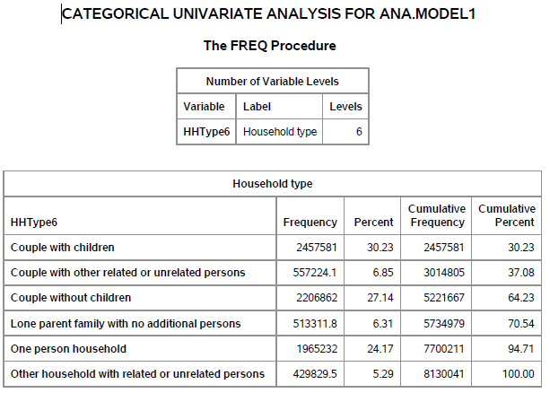

We see that most of the households surveyed are of couple with children.

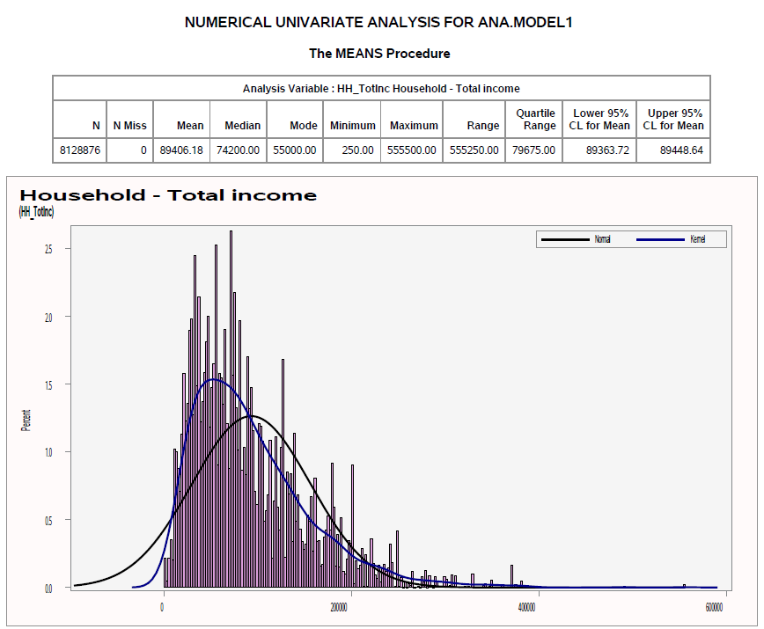

We see that the minimum household income in this study (households that consume non-alcoholic beverages) is $250,00 with the maximum being $5,555.00 and median expense of $74,200.00.

### Reference Person

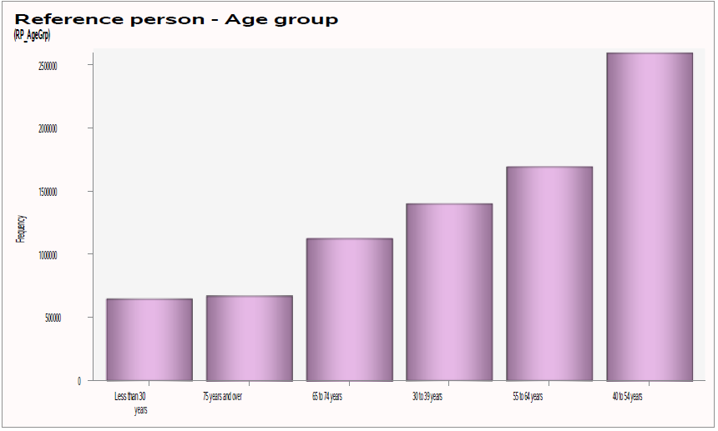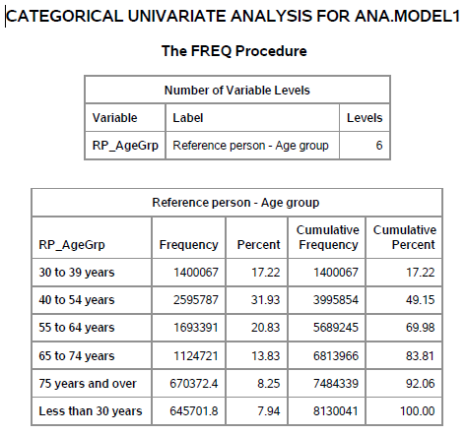

We see that most respondents to the survey are in the age group of 40 to 54 years.

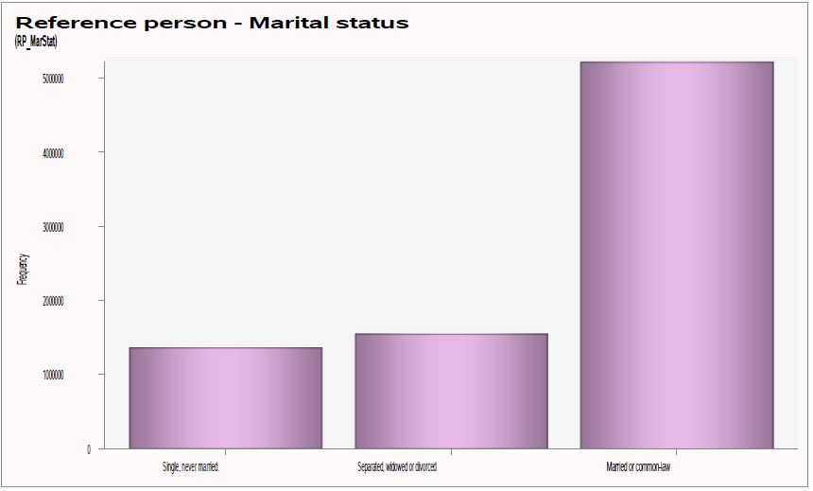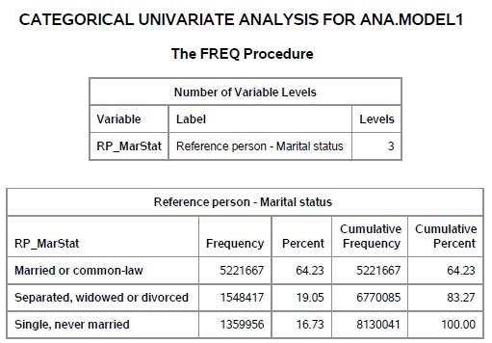

We see that most respondents to the survey are married or in a common-law partnership.

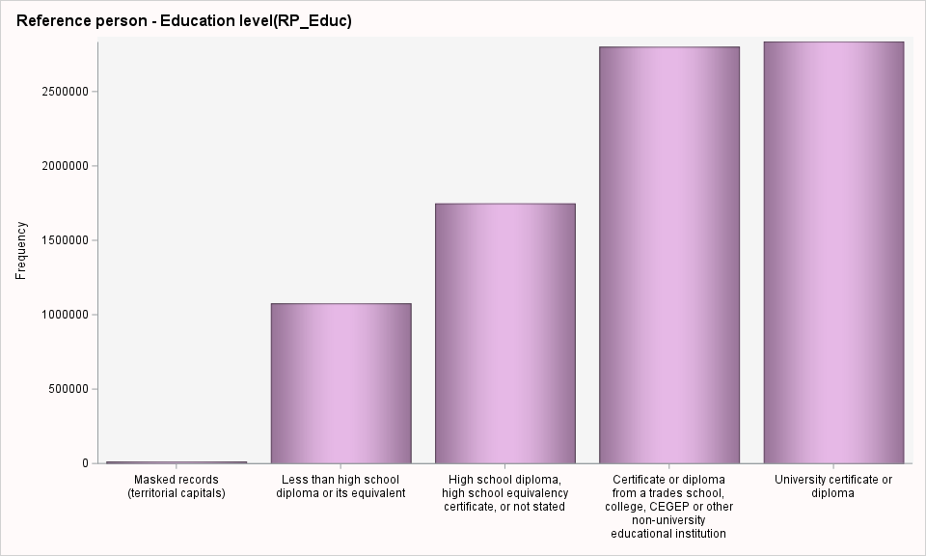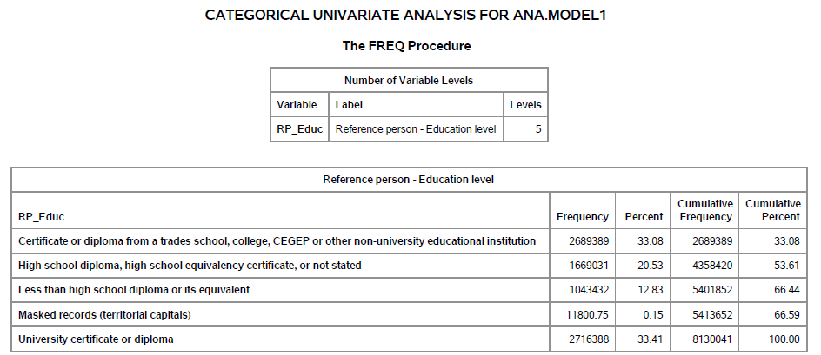

We see that most respondents to the survey have a University certificate or diploma.

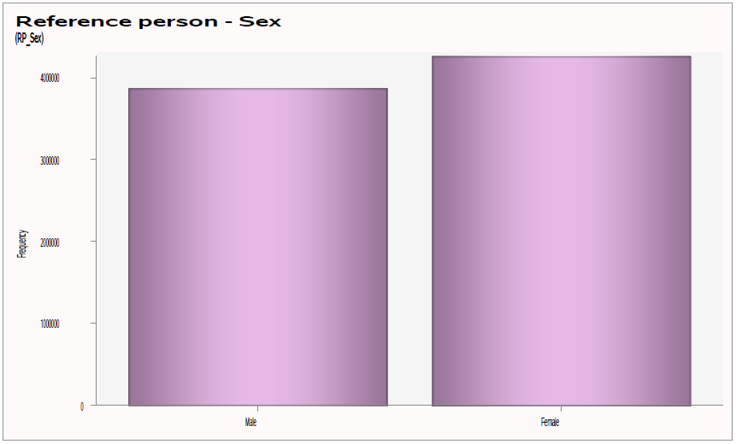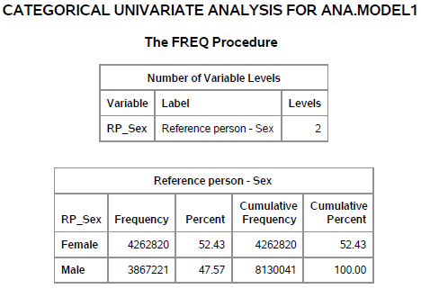

We see that most respondents to the survey are female.

### Spouse

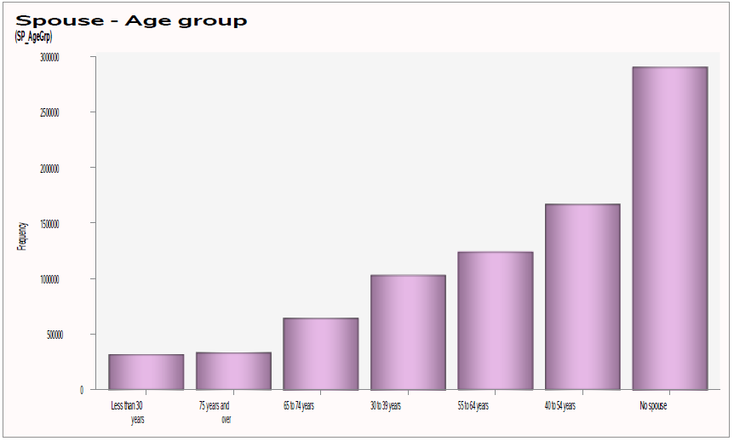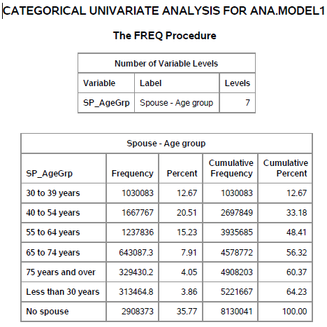

We see that most respondents to the survey don’t have a spouse, but of those who does have it, the predominant age group of spouse is 40 to 54 years.

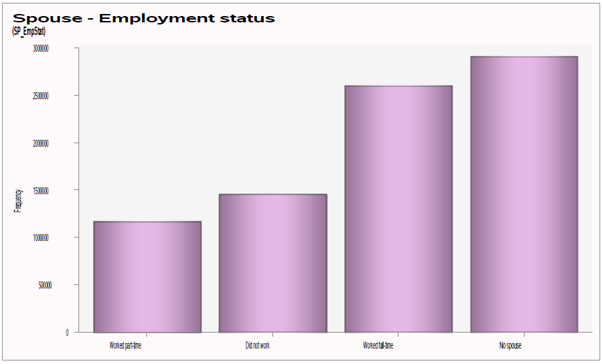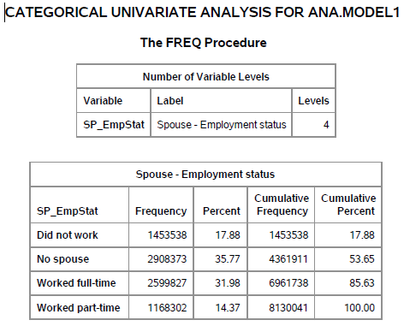

We see that most respondents to the survey don’t have a spouse, but of those who does have it, most spouses worked full-time.

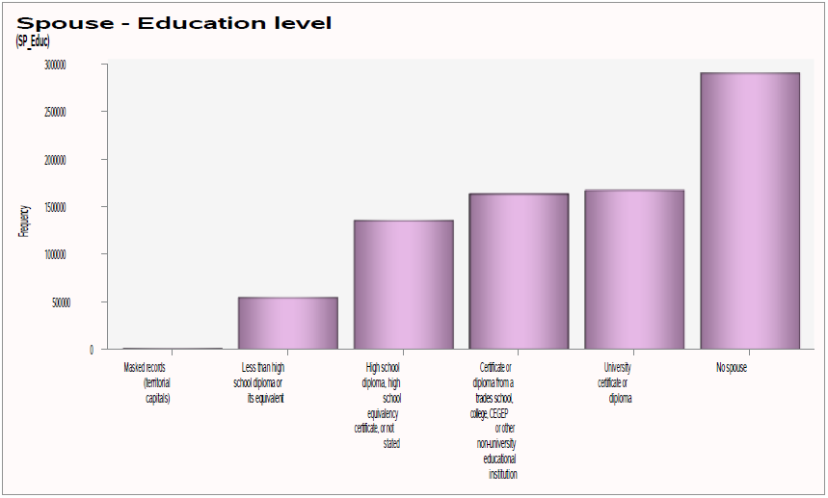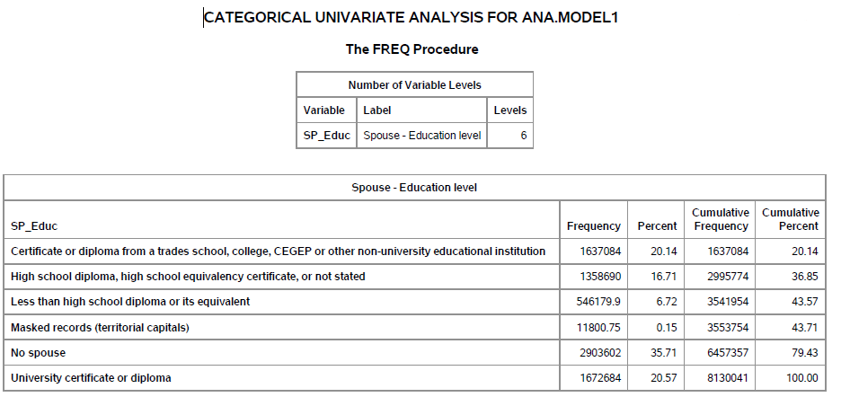

We see that most respondents to the survey don’t have a spouse, but of those who does have it, most spouses have a university or certificate diploma.

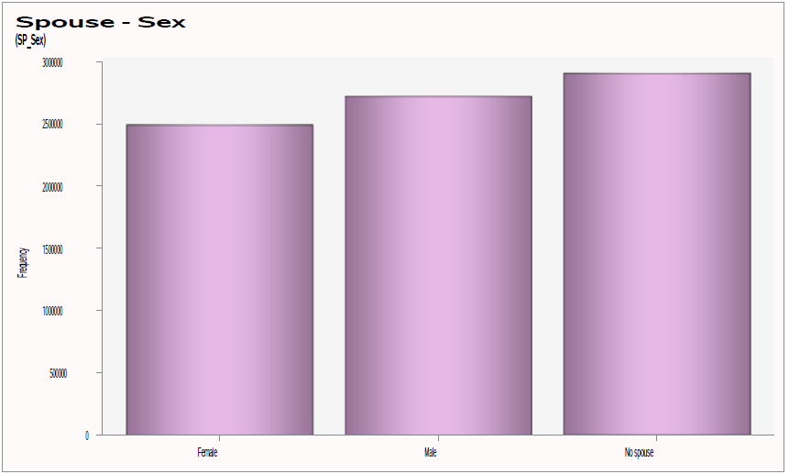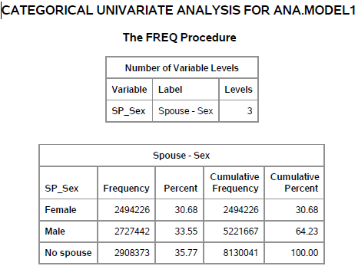

We see that most respondents to the survey don’t have a spouse, but of those who does have it, most spouses are male.

#### Target: Expense with Non-alcoholic beverages

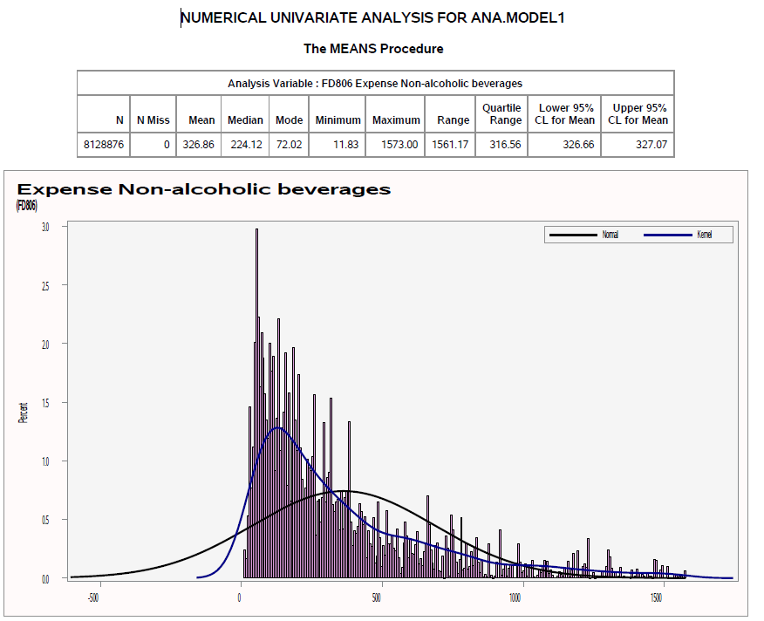

As we can see, Non-alcoholic beverages expense distribution is skewed, with a minimum expense of $11.83, maximum of $ 1,573 and median of $224.12.

## Bivariate analysis

### Summary – businesses values

|  |  |  |  |  |  |  |  |  |
| --- | --- | --- | --- | --- | --- | --- | --- | --- |
| Factor | Label | Level | N | Mean | 95% CL (Lower) | 95% CL (Upper) | Skewness8 | P-value[8] |
| Region | Region | Atlantic provinces | 629768 | 404.59 | 403.75 | 405.44 | -0.41 | <.0001 |
| Central | 4987062 | 294.35 | 294.1 | 294.59 | -0.07 |
| Prairie | 1530428 | 387.31 | 386.77 | 387.84 | -0.28 |
| Territorial capitals | 11711 | 447.33 | 440.68 | 453.98 | -0.28 |
| West | 969907 | 346.77 | 346.17 | 347.36 | -0.29 |
| Prov | Geography | Alberta | 958697 | 404.36 | 403.65 | 405.06 | -0.29 | <.0001 |
| Atlantic provinces | 629768 | 404.59 | 403.75 | 405.44 | -0.41 |
| British Columbia | 969907 | 346.77 | 346.17 | 347.36 | -0.29 |
| Manitoba | 299857 | 324.21 | 323.17 | 325.24 | -0.23 |
| Ontario | 2882375 | 305.37 | 305.03 | 305.72 | 0.02 |
| Quebec | 2104687 | 279.25 | 278.91 | 279.58 | -0.20 |
| Saskatchewan | 271874 | 396.78 | 395.59 | 397.97 | -0.29 |
| Territorial capitals | 11711 | 447.33 | 440.68 | 453.98 | -0.28 |
| HHType6 | Household type | Couple with children | 2457237 | 377.09 | 376.69 | 377.5 | -0.29 | <.0001 |
| Couple with other related or unrelated persons | 557180 | 409.09 | 408.21 | 409.96 | -0.38 |
| Couple without children | 2206478 | 317.62 | 317.23 | 318 | -0.08 |
| Lone parent family with no additional persons | 513225 | 302.25 | 301.51 | 302.98 | -0.24 |
| One person household | 1964999 | 257.47 | 257.08 | 257.85 | 0.08 |
| Other household with related or unrelated persons | 429757 | 327.27 | 326.48 | 328.06 | -0.35 |
| RP_AgeGrp | Reference person - Age group | 30 to 39 years | 1399872 | 341.41 | 340.89 | 341.93 | -0.03 | <.0001 |
| 40 to 54 years | 2595446 | 341.19 | 340.82 | 341.56 | -0.23 |
| 55 to 64 years | 1693126 | 343.97 | 343.49 | 344.44 | -0.14 |
| 65 to 74 years | 1124539 | 281.24 | 280.7 | 281.79 | 0.09 |
| 75 years and over | 670281 | 287.33 | 286.7 | 287.97 | -0.37 |
| Less than 30 years | 645612 | 313.39 | 312.71 | 314.07 | -0.16 |
| RP_MarStat | Reference person - Marital status | Married or common-law | 5220895 | 355.37 | 355.1 | 355.64 | -0.20 | <.0001 |
| Separated, widowed or | 1548207 | 272.2 | 271.79 | 272.61 | -0.13 |
| Single, never married | 1359774 | 279.65 | 279.17 | 280.14 | 0.02 |
| RP_Educ | Reference person - Education level | Certificate or diploma from a trades school, college, CEGEP or other non-university educational institution | 2688986 | 351.14 | 350.76 | 351.53 | -0.18 | <.0001 |
| High school diploma, high school equivalency certificate, or not stated | 1668821 | 302.08 | 301.62 | 302.53 | 0.08 |
| Less than high school diploma or its equivalent | 1043308 | 305.61 | 305.1 | 306.12 | -0.33 |
| Masked records (territorial capitals) | 11711 | 447.33 | 440.68 | 453.98 | -0.28 |
| University certificate or diploma | 2716050 | 325.7 | 325.35 | 326.06 | -0.22 |
| RP_Sex | Reference person - Sex | Female | 4262186 | 326.98 | 326.68 | 327.27 | -0.08 | <.0001 |
| Male | 3866690 | 326.74 | 326.45 | 327.03 | -0.23 |
| SP_AgeGrp | Spouse - Age group | 30 to 39 years | 1029929 | 369.03 | 368.36 | 369.69 | -0.14 | <.0001 |
| 40 to 54 years | 1667543 | 360 | 359.53 | 360.46 | -0.19 |
| 55 to 64 years | 1237655 | 374.4 | 373.84 | 374.95 | -0.27 |
| 65 to 74 years | 642970 | 314.79 | 314.07 | 315.51 | -0.13 |
| 75 years and | 329381 | 296.11 | 295.2 | 297.01 | -0.3 |
| Less than 30 | 313417 | 356.29 | 355.24 | 357.34 | -0.44 |
| No spouse | 2907981 | 275.69 | 275.37 | 276 | -0.06 |
| SP_EmpStat | Spouse - Employment status | Did not work | 1453314 | 330.34 | 329.83 | 330.86 | -0.09 | <.0001 |
| No spouse | 2907981 | 275.69 | 275.37 | 276 | -0.06 |
| Worked full-time | 2599458 | 357.87 | 357.49 | 358.25 | -0.22 |
| Worked part-time | 1168123 | 380.96 | 380.4 | 381.52 | -0.28 |
| SP_Educ | Spouse - Education level | Certificate or diploma from a trades school, college, CEGEP or other non-university educational institution | 1636840 | 359.03 | 358.56 | 359.5 | -0.29 | <.0001 |
| High school diploma, high school equivalency certificate,or not stated | 1358512 | 366.33 | 365.79 | 366.87 | -0.16 |
| Less than high school diploma or its equivalent | 546094 | 339.5 | 338.73 | 340.27 | -0.46 |
| Masked records (territorial capitals) | 11711 | 447.33 | 440.68 | 453.98 | -0.28 |
| No spouse | 2903242 | 275.52 | 275.21 | 275.84 | -0.06 |
| University certificate or diploma | 1672477 | 347.48 | 347 | 347.97 | -0.07 |
| SP_Sex | Spouse - Sex | Female | 2493849 | 357.82 | 357.43 | 358.21 | -0.22 | <.0001 |
| Male | 2727046 | 353.13 | 352.76 | 353.51 | -0.19 |
| No spouse | 2907981 | 275.69 | 275.37 | 276 | -0.06 |

### Household

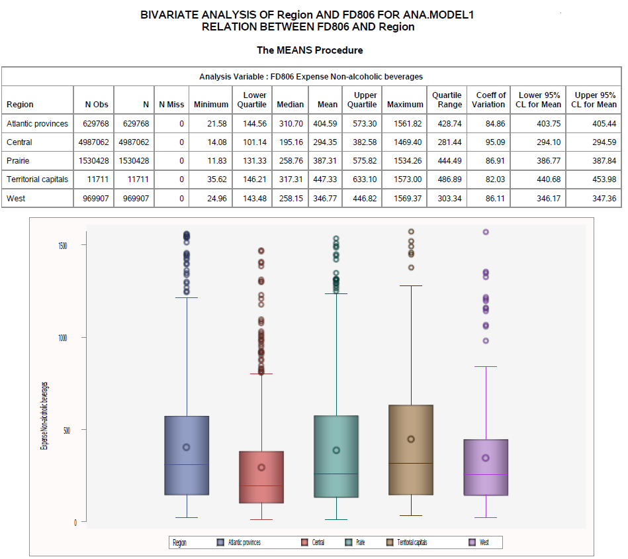 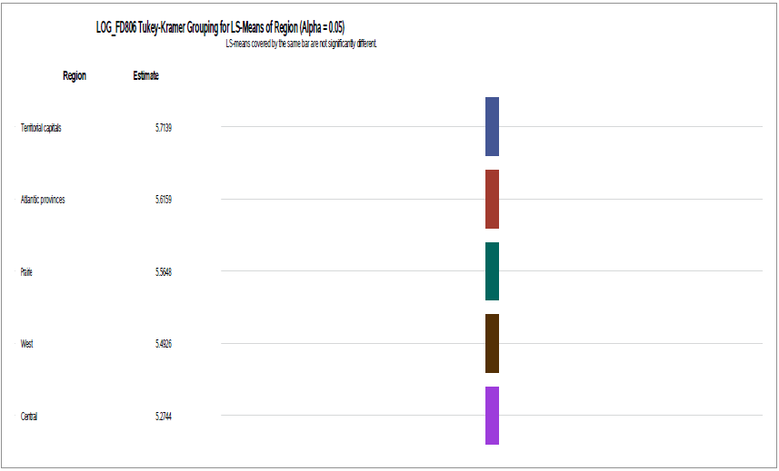

We see that the biggest mean expense is within Territorial capitals. Even though the Central area has the largest population. We, also, see that all groups are different at 5% significance level.

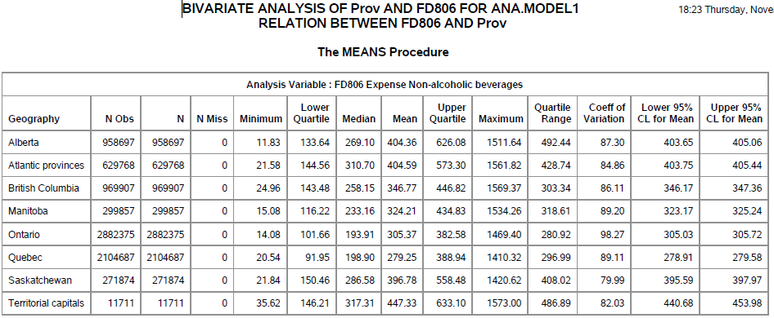

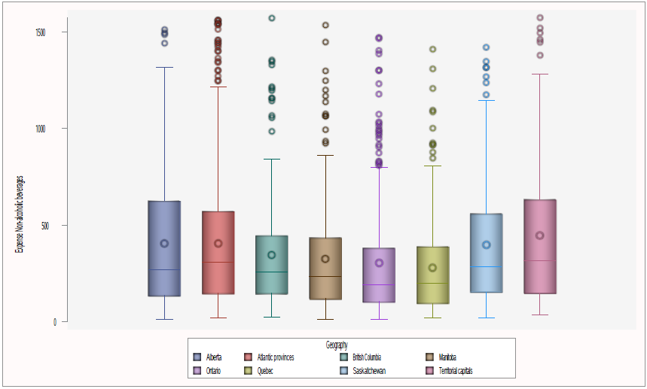 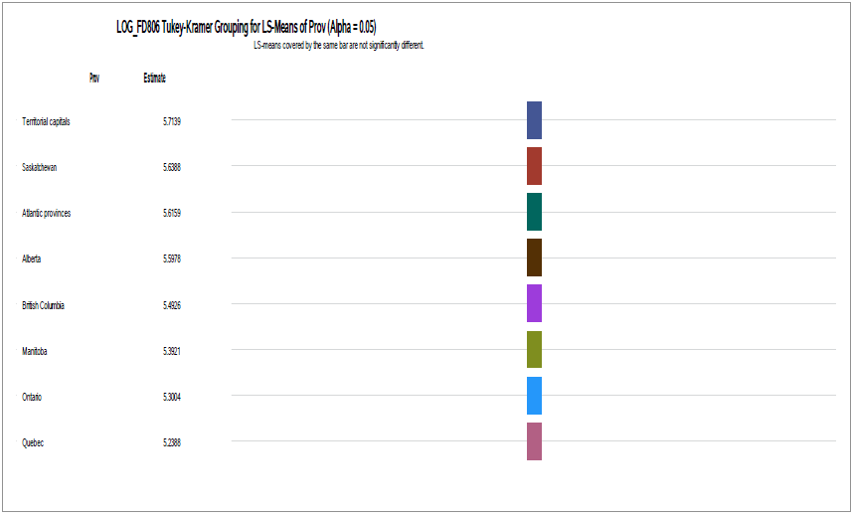

We see that the biggest mean expense with non-alcoholic beverages is in Territorial capitals despite being the one with smallest population. We, also, see that all groups are different at 5% significance level.

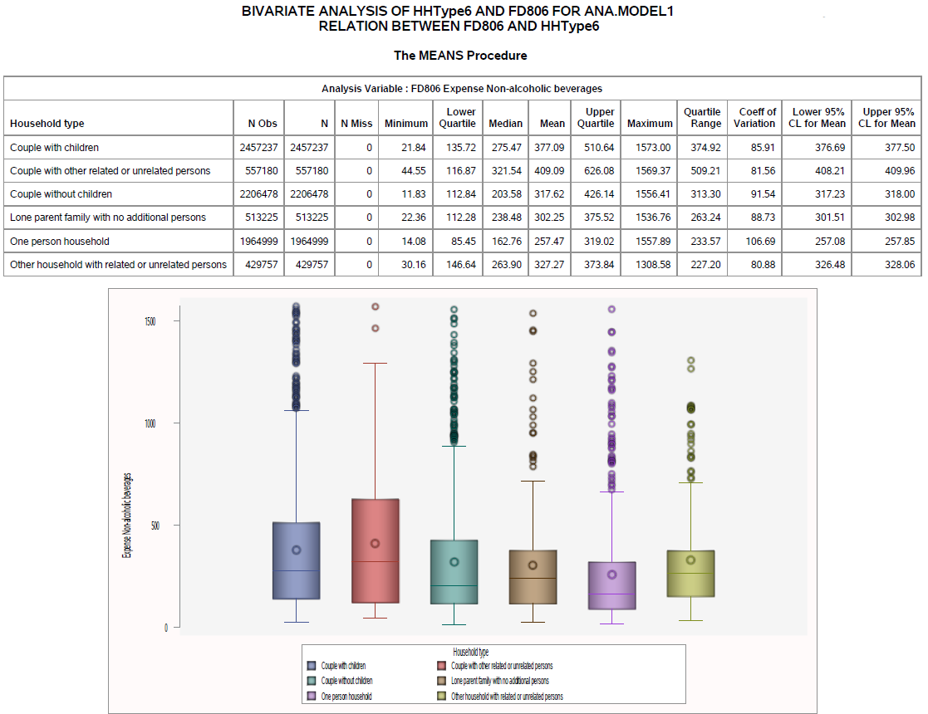 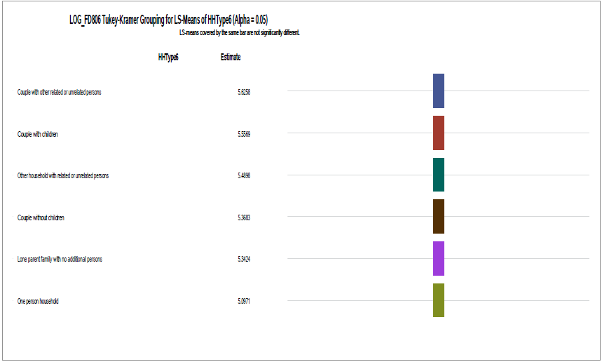

We see that the biggest mean expense with non-alcoholic beverages is in households with Couple with other related or unrelated person. We, also, see that all groups are different at 5% significance level.

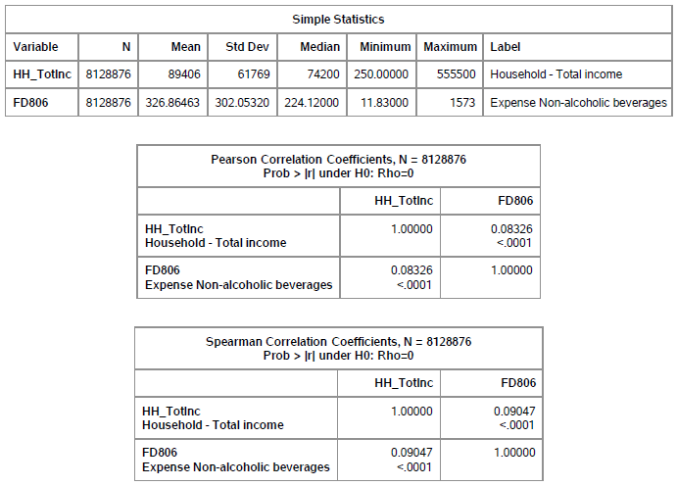

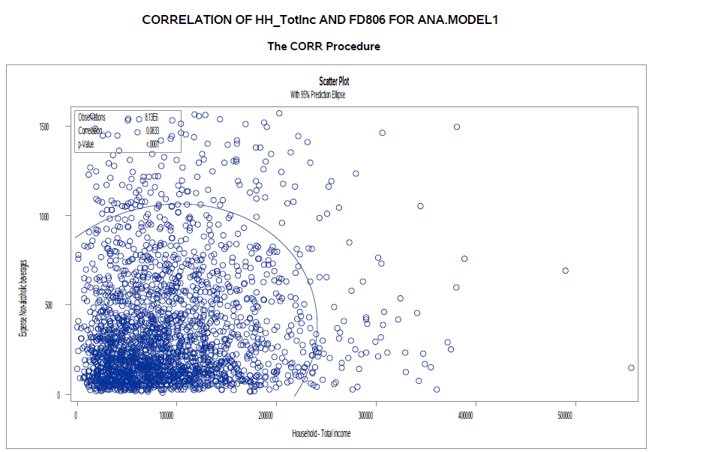

We see that there is little to no correlation between Household - Total income and Expense Non-alcoholic beverages.

### Reference Person

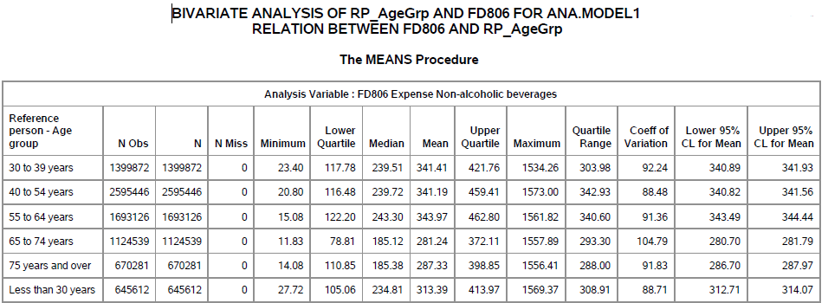

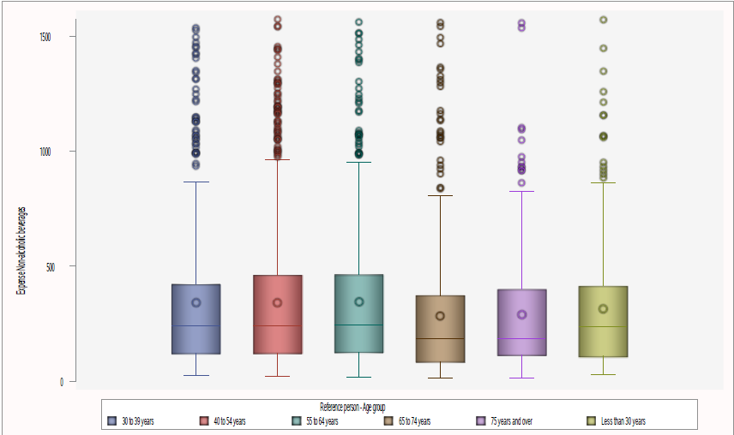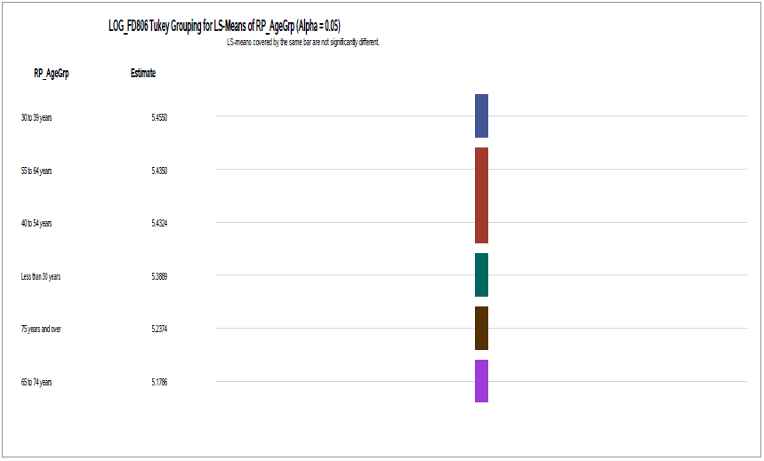

We see that the biggest expense is within 30 to 39 years old group. We, also, see that all groups are different at 5% significance level.

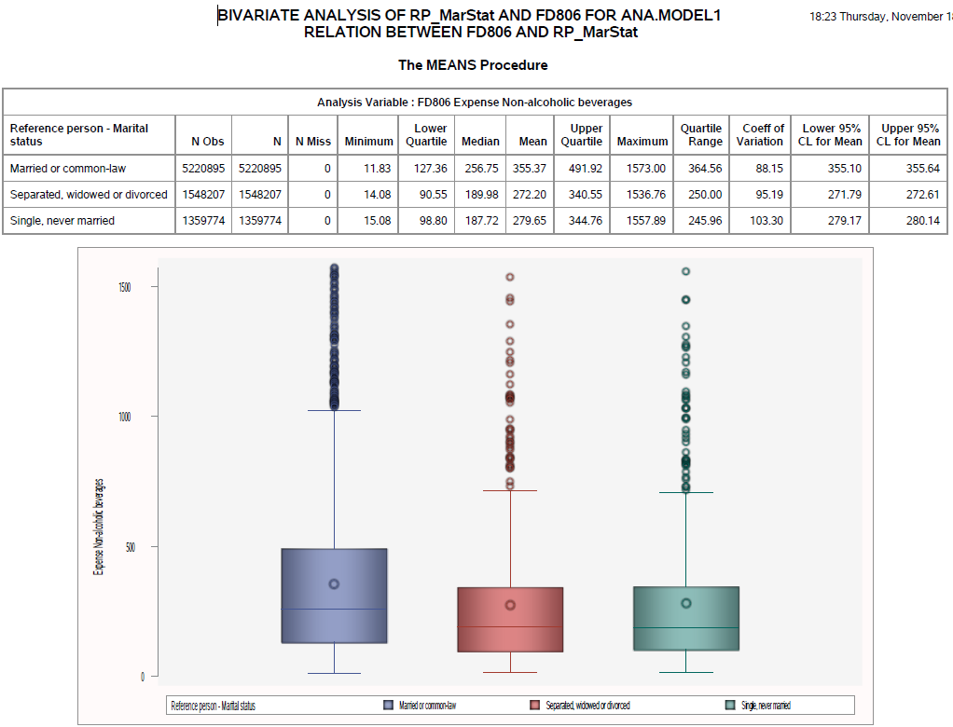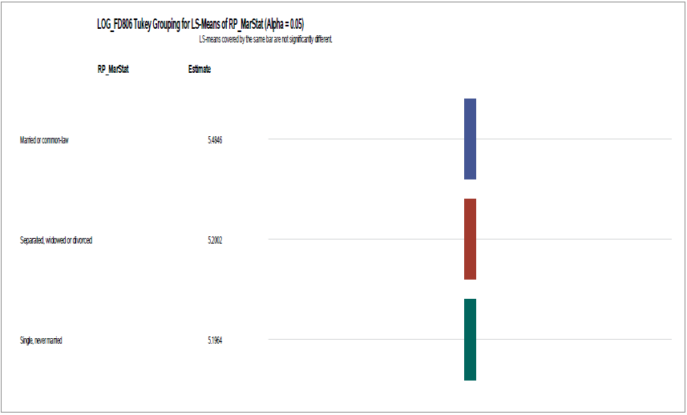

We see that the biggest expense is within Married or common-law. We, also, see that all groups are different at 5% significance level.

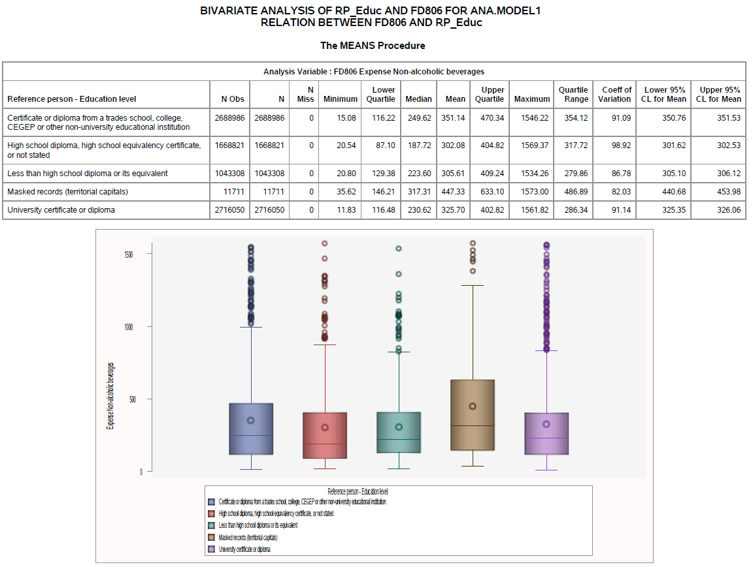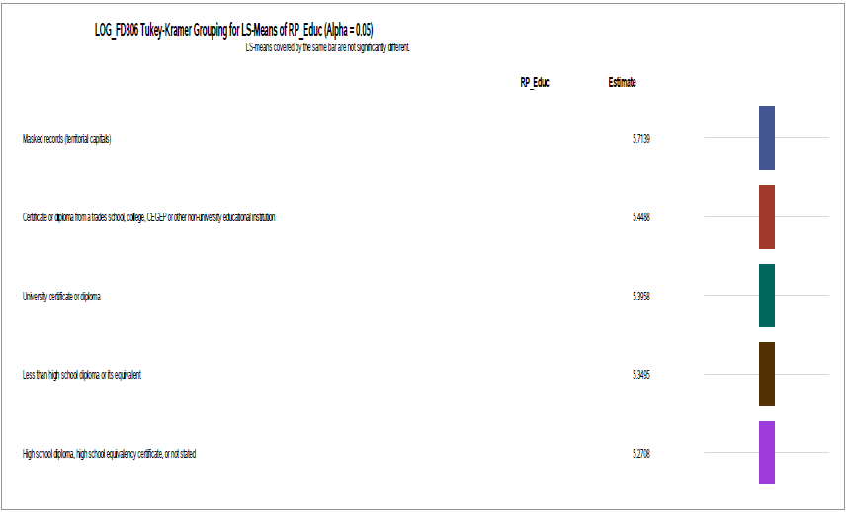

We see that Territorial capitals (masked records) have the biggest expense. We, also, see that all groups are different at 5% significance level.

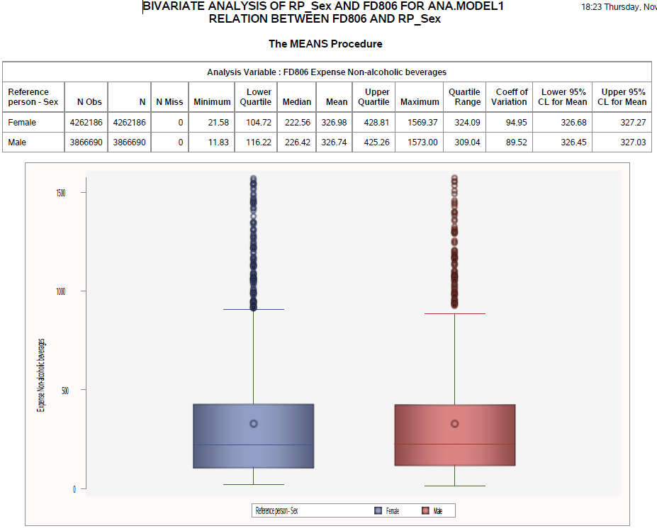

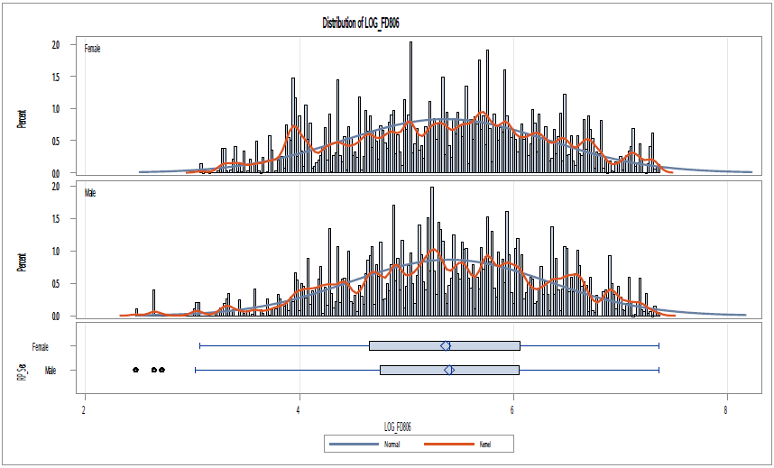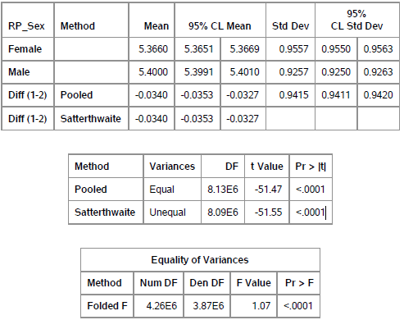

We see that Female respondents have the biggest expense, but closely followed by males. We see that Satterthwaite t-test points that groups are different at 5% significance level.

### Spouse

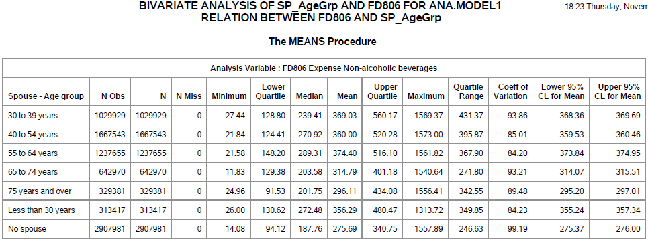

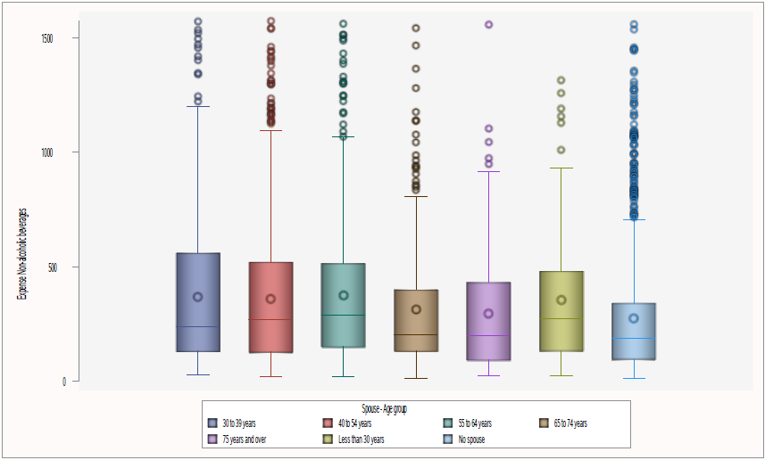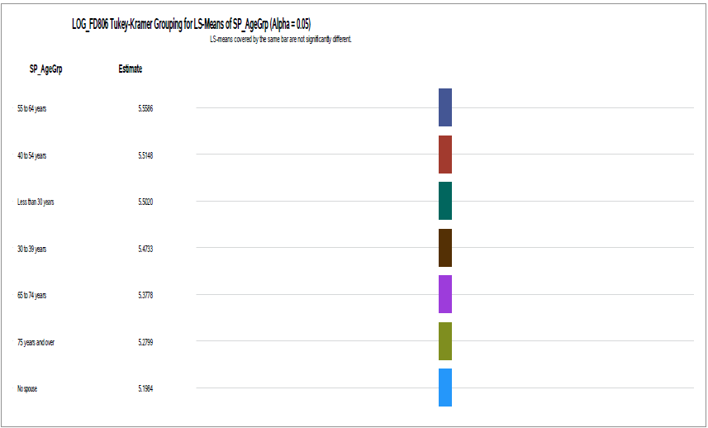

We see that the biggest expense is within 55 to 64 years old group. We, also, see that all groups are different at 5% significance level.

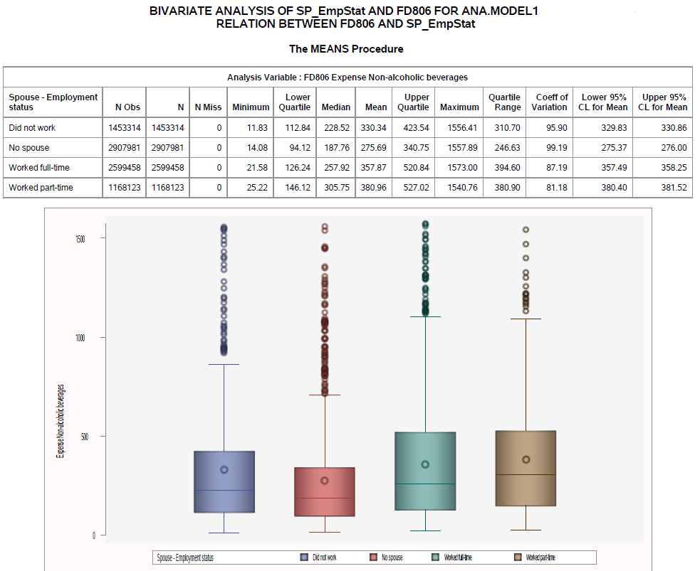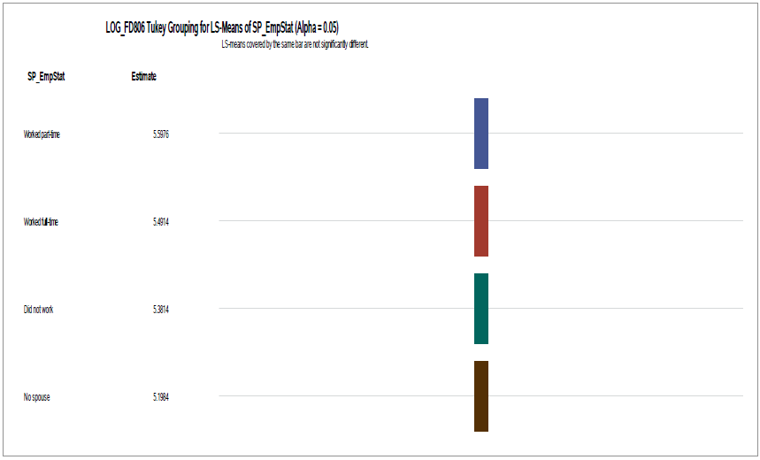

We see that the biggest expense is within worked part-time group. We, also, see that all groups are different at 5% significance level.

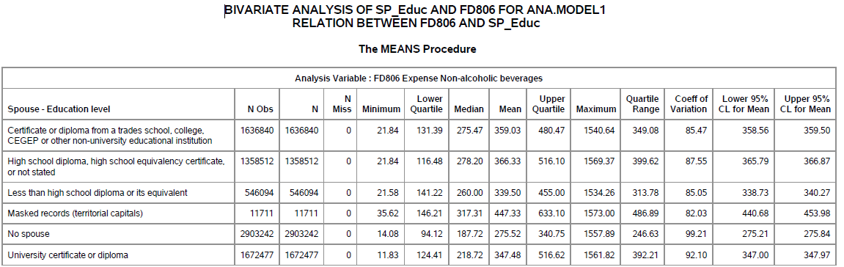

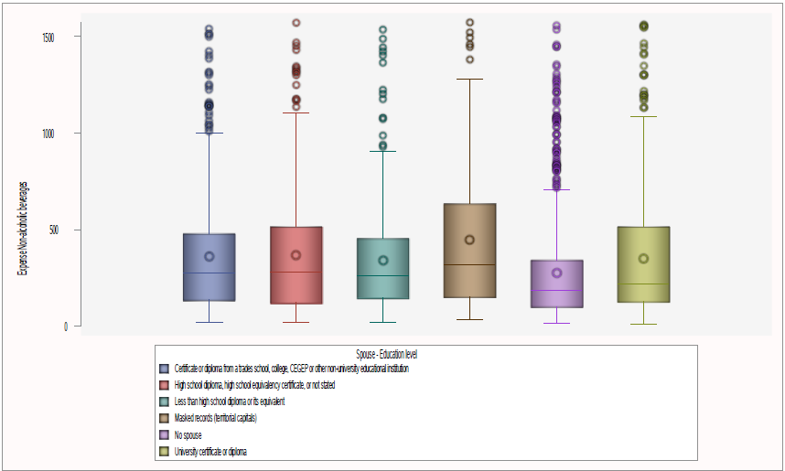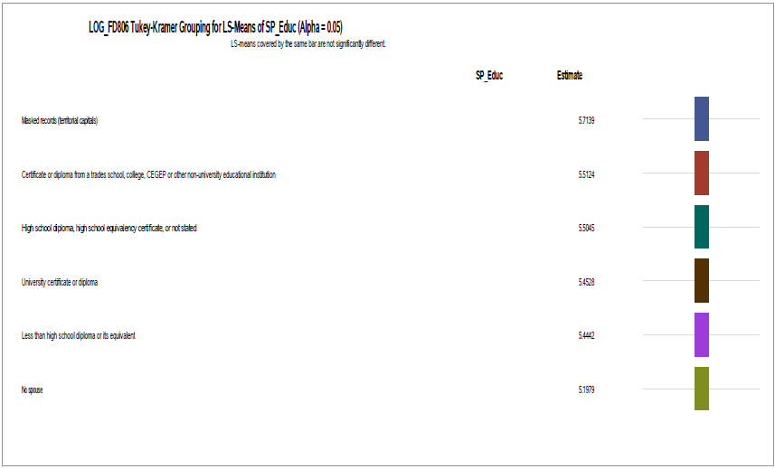

We see that the biggest expense is within Territorial capitals (masked records). We, also, see that all groups are different at 5% significance level.

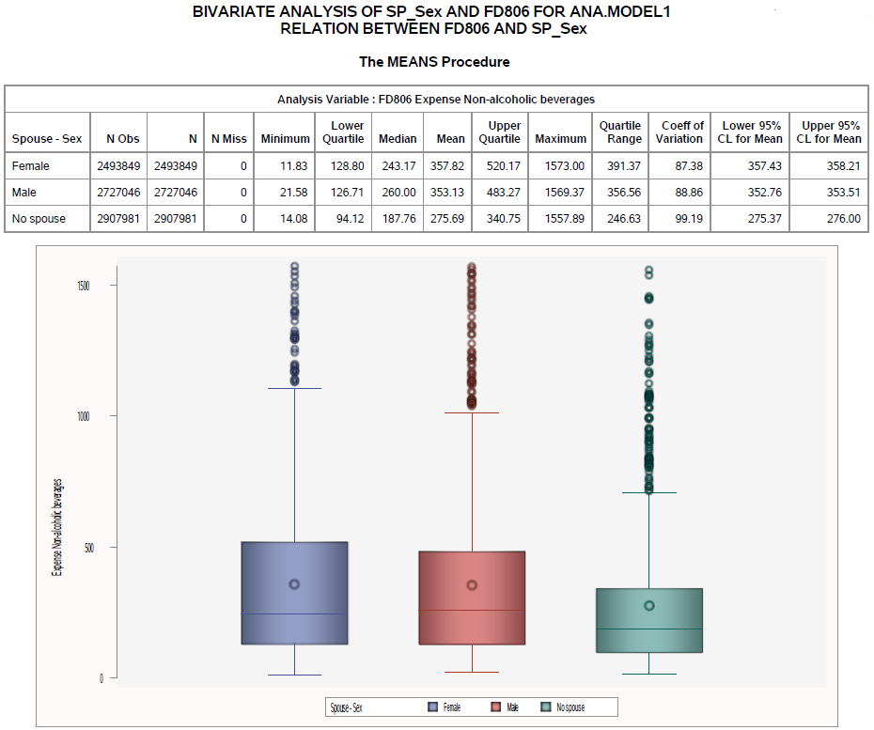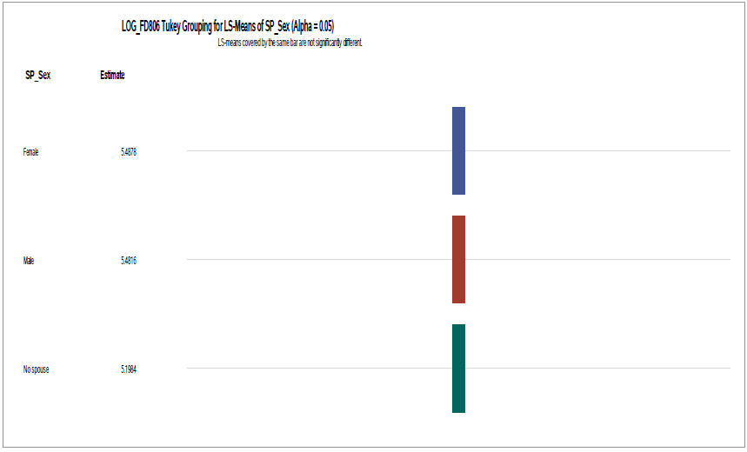

We see that the biggest expense is within Female followed by Males. We, also, see that all groups are different at 5% significance level.

# Inferential Statistics

## Is the expense diverse regarding geography(Region and Provinces)?

Null hypothesis: The expense is the same across regions.

Alternative Hypothesis: The expense is the different across regions.

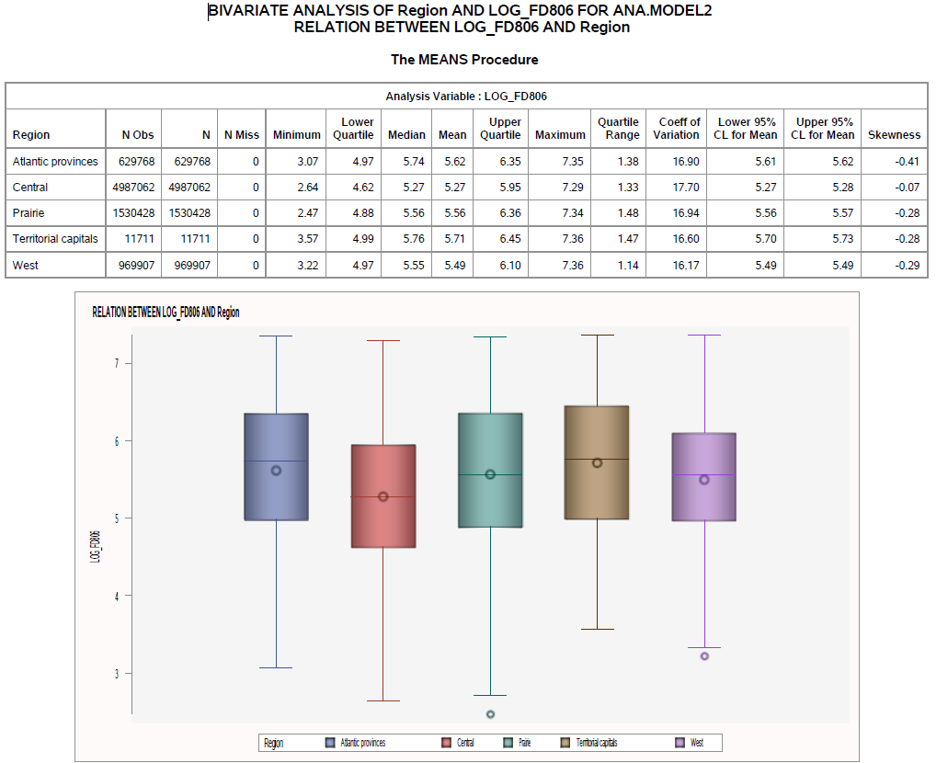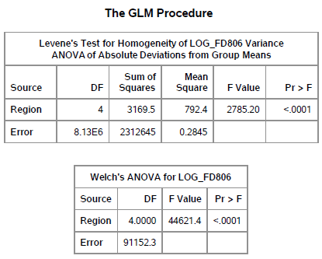

We reject the null hypothesis and say that at least one group differs from the expected value.

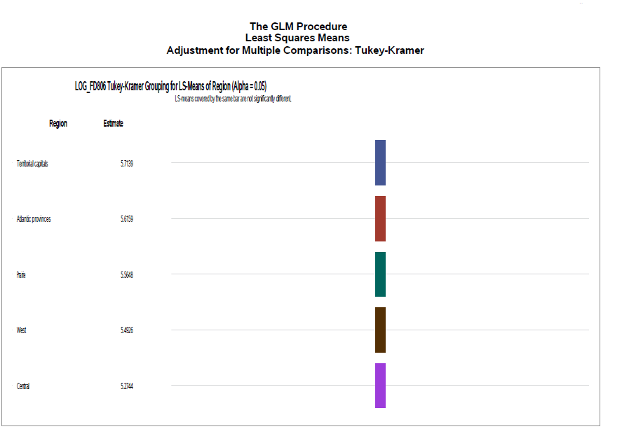

We see that at 5% significance level expense in all groups are different.

Null hypothesis: The expense is the same across provinces.

Alternative Hypothesis: The expense is the different across provinces.

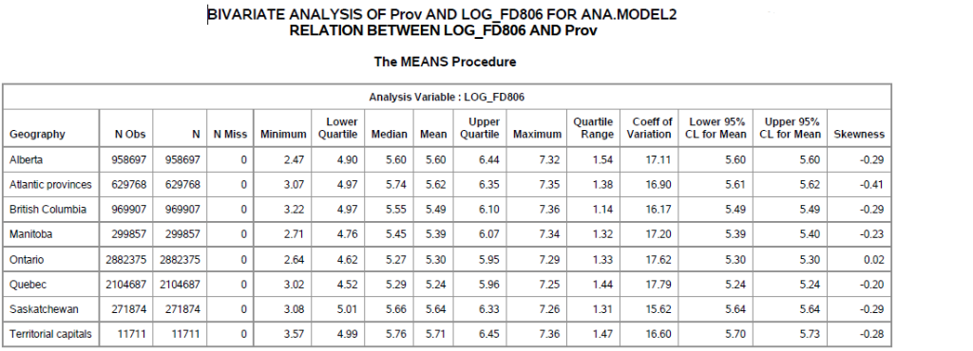

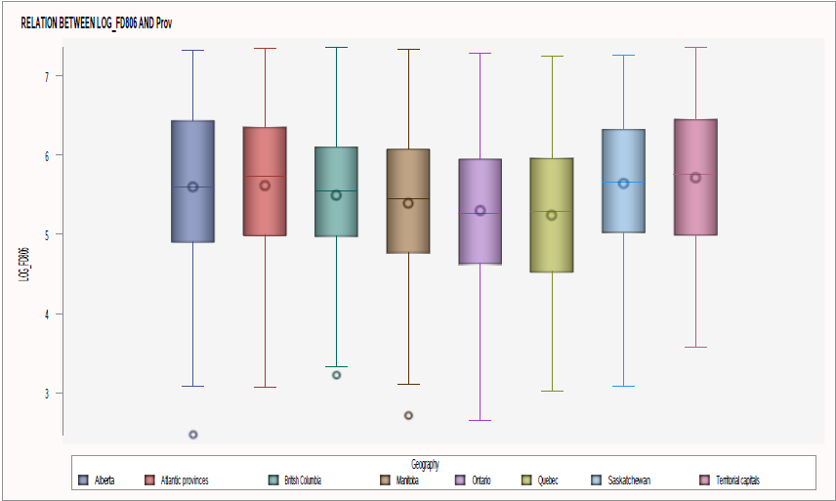 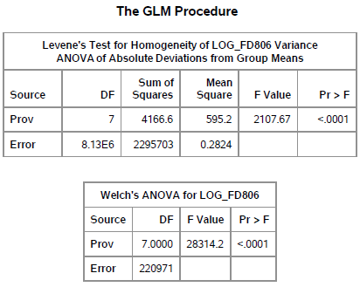

We reject the null hypothesis and say that at least one group differs from the expected value.

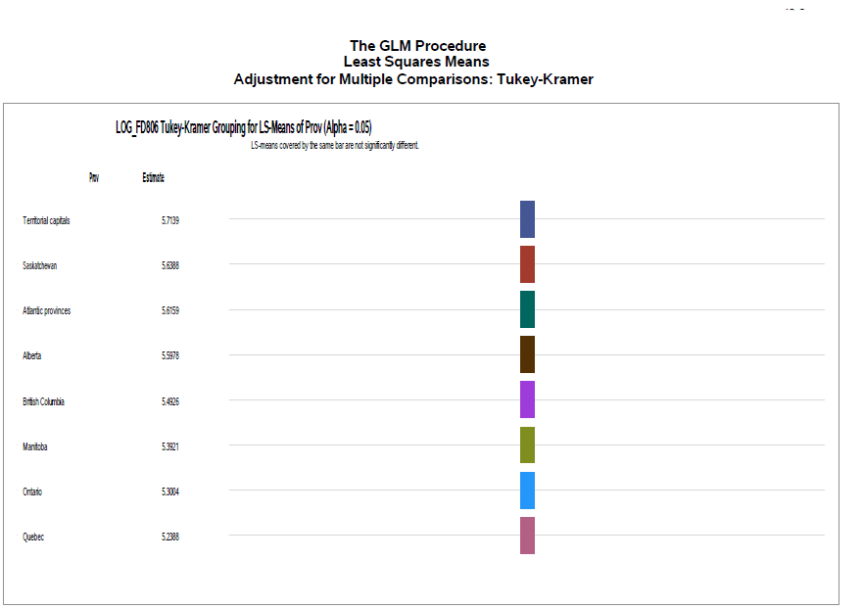

Yes, we see that at 5% significance level expense in all groups are different.

All groups have different expense behaviour with Territorial capitals having the biggest mean expense despite having the smallest population. Due to larger population, although having the second to last biggest mean, Ontario has a greater proportion of national expense due to larger population.

## Is the expense diverse regarding Household Type?[9]

Null hypothesis: The expense is the same across household types.

Alternative Hypothesis: The expense is the different across household types.

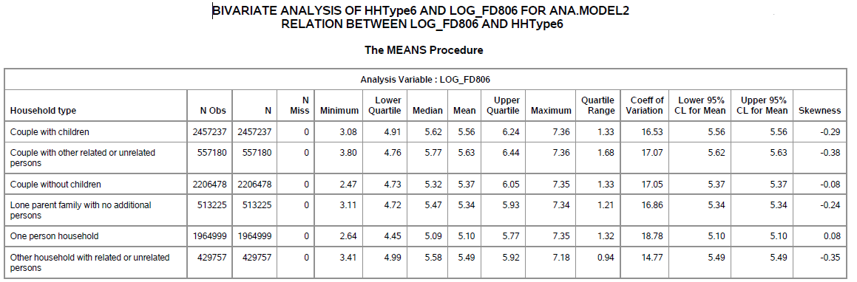

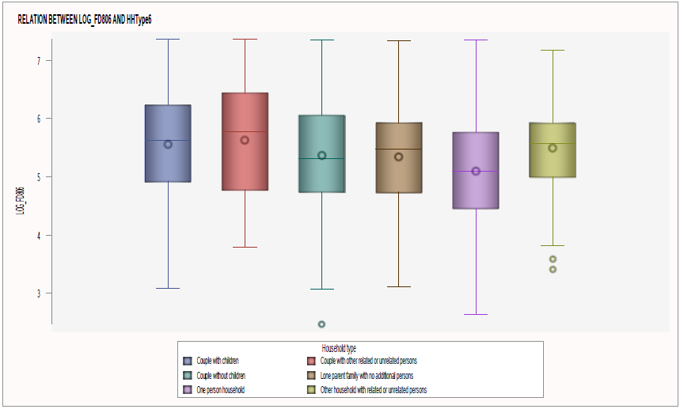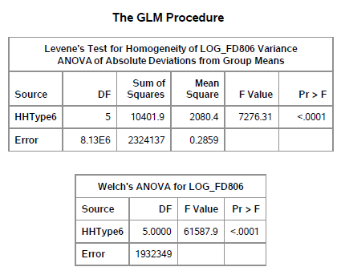

We reject the null hypothesis and say that at least one group differs from the expected value.

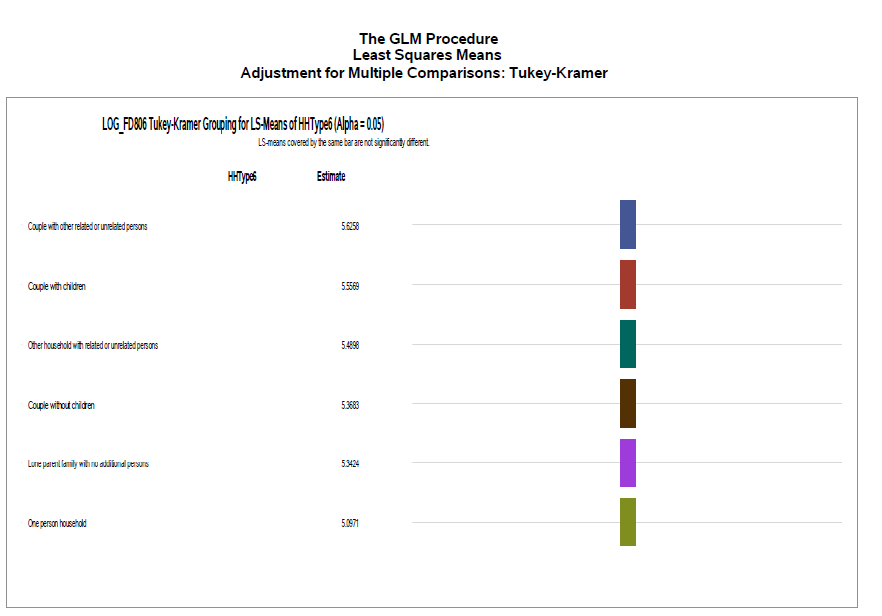

Yes, we see that at 5% significance level expense in all groups are different with households having Couple with other related or unrelated person having the biggest mean and couple with Children following and having greater proportion of the population.

## Does higher Household Income mean higher expense? [10]

Null hypothesis: The higher income is correlated with higher expense.

Alternative Hypothesis: Higher income is not correlated with higher expense.

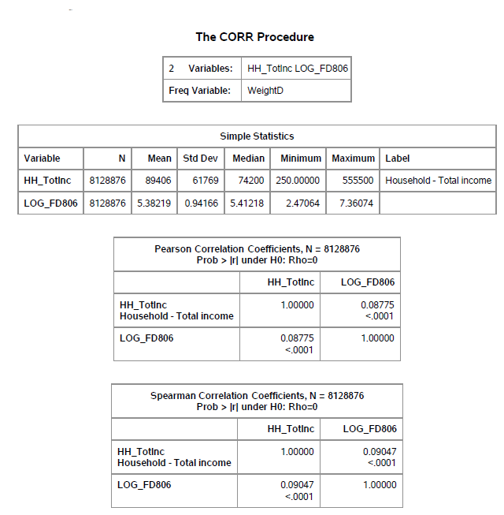

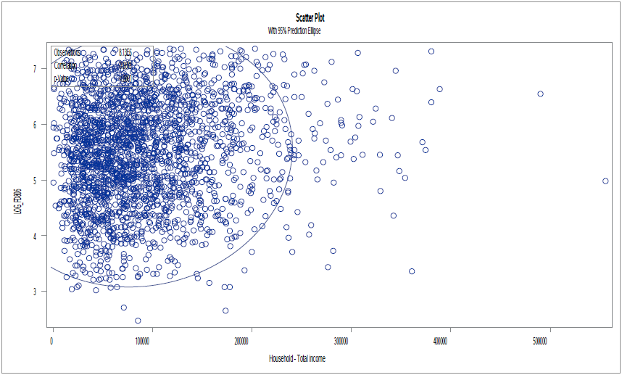

No, Household Income does not mean a higher expense. We see that there is little to no correlation between Income and Expense.

# Model

The following variables were included in the linear regression model:

* Dependent variable:
  + Log_FD806 (Expense of Non-alcoholic beverages)
* Independent variables:
  + Region
  + Prov
  + HHType6
  + RP_AgeGrp
  + RP_Sex
  + RP_MarStat
  + RP_Educ
  + SP_AgeGrp
  + SP_Sex
  + SP_Educ
  + SP_EmpStat

Categorical values have the first level regarding descending frequency count (levels that have more observations come earlier in the order) as the reference feature.

Stepwise significance with significance level of 5% for entry and stay was applied as a technique for dimensionality reduction, with the output of:

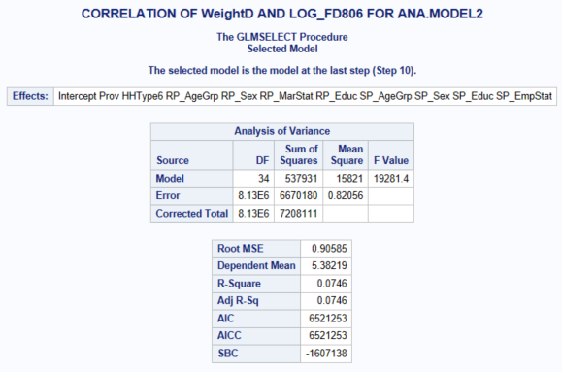

We see that the model has no prediction power and will be use only for explanations purposes.

## Parameters

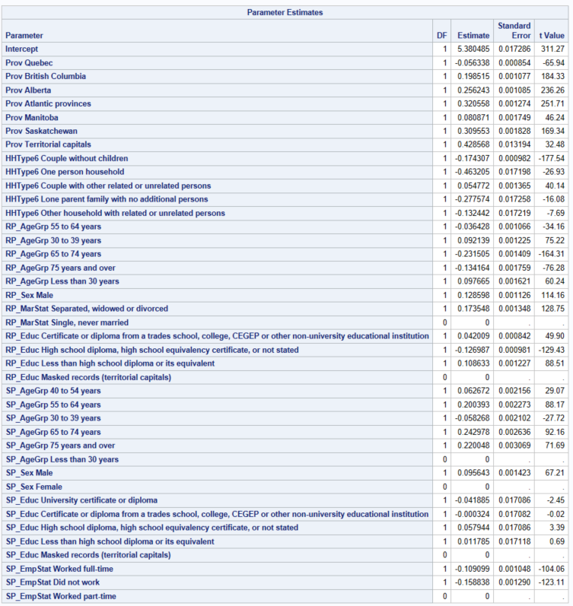

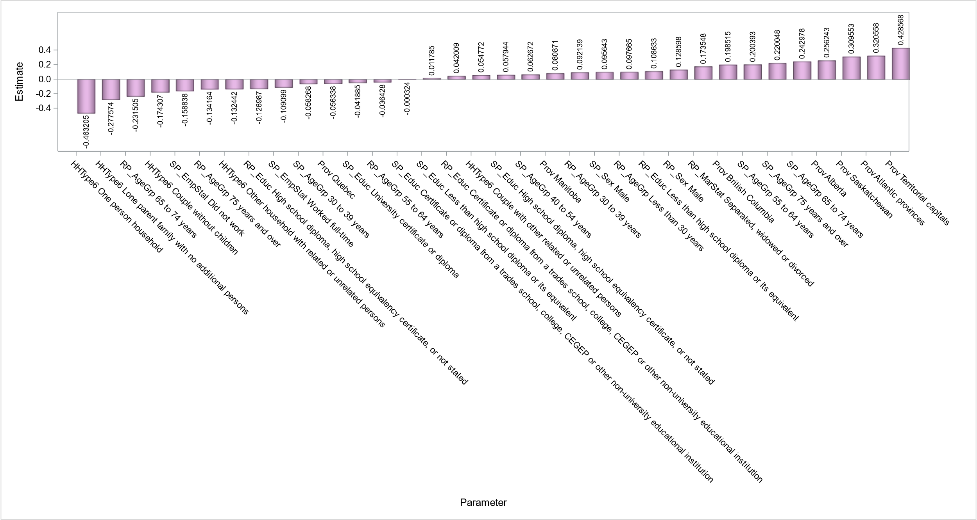

# High level Findings/Conclusions

## Summary of Results

* Expense with non-alcoholic beverages is 4% from the purchase from store spending nationally.
* Spending behavior is different regarding Geography (Region and Province-wise)
* Household type changes the behaviour of spending, having Couple with children the ones that does the most spending
* Higher Income does not mean higher spending
* We see that being in the following groups has the following influence on spending:
* Household with Couple with other related or unrelated persons spend around **.055 times** more than household with Couple with Children
* Household with Couple without children spend around .174 times less than household with Couple with Children
* Household with Lone parent family with no additional persons spend around .278 times less than household with Couple with Children
* Household with One person household spend around **.463 times less** than household with Couple with Children
* Household with Other household with related or unrelated persons spend around .132 times less than household with Couple with Children
* Household with respondent spouse with Certificate or diploma from a trades school, college, CEGEP or other non -university educational institution spend around the same as household with respondent with no spouse
* Household with respondent spouse with Less than high school diploma or its equivalent institution spend around .012 times more than household with respondent no spouse
* Household with respondent spouse with University certificate or diploma spend around **.042 times less** than household with no spouse
* Household with respondent with Certificate or diploma from a trades school, college, CEGEP or other non
* Household with respondent with High school diploma, high school equivalency certificate, or not stated spend around .127 times less than respondent with University certificate or diploma
* Household with respondent within the age group of 30 to 39 years spend around .092 times more than respondent in the 40 to 54 years group
* Household with respondent within the age group of 55 to 64 years spend around .036 times less than respondent in the 40 to 54 years group
* Household with respondent within the age group of 65 to 74 years spend around .232 times more than respondent in the 40 to 54 years group
* Household with respondent within the age group of 75 years and over spend around **.134 times less** than respondent in the 40 to 54 years group
* Household with respondent within the age group of Less than 30 years spend around .098 times more than respondent in the 40 to 54 years group
* Household with Spouse of respondent within the age group of 55 to 64 years spend around .2 times more than household with no spouse.
* Household with Spouse of respondent within the age group of 65 to 74 years spend around .243 times more than household with no spouse.
* Household with Spouse of respondent within the age group of 75 years and over spend around .22 times more than household with no spouse.
* Household with Spouse of respondents that Did not work spend around **.159 times less** than household with no spouse
* Household with Spouse of respondents that Worked full time spend 0.06 times morethan No spouse group
* Household with Spouse of respondents within the age group 30 to 39 years spend around .058 times less than household with no spouse
* Household with Spouse of respondents within the age group of 40 to 54 years spend around .63 times more than household with no spouse
* Household with the respondent Male spend around **.129 times** more than Female
* Household with the respondent Separated, widowed or divorced spend around **.174 times more** than married or in common
* Household with the respondent spouse Male spend around .096 times more than household with no spouse
* Household with the respondent spouse with High school diploma, high school equivalency certificate, or not stated spend around .058 times more than household with no spouse
* Household with the respondent with Less than high school diploma or its equivalent spend around **.109 times more** than with respondents with University or certificate diploma
* Residents of Alberta spend around .256 times more than Ontario residents
* Residents of Atlantic provinces spend around .321 times more than Ontario residents
* Residents of British Columbia spend around .199 times more than Ontario residents
* Residents of Manitoba spend around .081 times more than Ontario residents
* Residents of Quebec spend around **.056 times less** than Ontario residents
* Residents of Saskatchewan spend around .31 times more than Ontario residents
* Residents of Territorial capitals spend around **.429 times more** than Ontario residents

# Recommendations

To maintain revenue and potential increase of profit, the recommendation is to focus on stock keeping and target marketing in areas with higher concentration of:

* Households with **Couple with other related or unrelated persons**
* **Males**
* **Separated, widowed, or divorced**
* Households with **couples that both have Less than high school diploma or its equivalent**

Furthermore, **Ontario** and **Couple with children** due to large population, is recommended targeted marketing and customization of products, such as:

* Flavours, such as strawberry, coffee tea/pop, colorful and sized/themed packages per group.

To potential increase of profit, target marketing in areas with higher concentration of:

* **One person households**
* Households with couples with a **combination of age group of with more than 65 years and over and spouse within 30 to 39 years**

Target for **Quebec** (due to large population): is recommended aimed marketing and customization of products per the mentioned groups as recommended for Ontario.

# Next steps – Questions

With Territorial capitals having the biggest expected expense and Quebec the smallest expected expense, it may be worth to investigate:

* Is the price, availability, product characteristics, logistics infrastructure or culture that motivates these regions to such contrast spending with non-alcoholic beverages?

# Appendix

## Observations

Some of the code to generate visuals were commented out from the SAS macro due to computational power that was prevent timely generation of output and distorting information, especially in labels, as exemplified below:

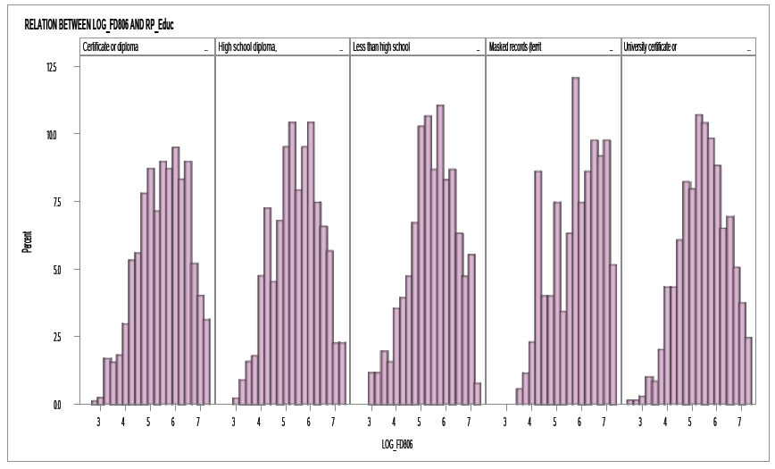

## Code

LIBNAME ANA "D:\1_Metro College\Courses\DSP-SAS\Project";

*READ:https://blogs.sas.com/content/iml/2017/10/04/create-interpret-weighted-histogram.html;

******************************************************************** SAS Macros *********************************************************************************;

**PROC** **OPTIONS** OPTION = MACRO;

**RUN**;

ODS GRAPHICS ON;

/*Auxiliar Information*/

*T-test - Road map:;

**DATA** TESTT;

INPUT @**1** TEXT $CHAR125.;

INFILE DATALINES TRUNCOVER;

DATALINES;

Null hypothesis: There’s no difference in means

Assumptions:

1.Sample distribution must be normal:

e.g:Shapiro (null hypothesis: sample has a normal distribution)

CLT :

a.If it looks normal and each group have more than 30 observations

b.If moderately skewed, each group must have more than 100 observations

2.Groups are independent of one another.

3.There are no major outliers.

4.A check for unequal variances will help determine which version of an independent samples t-test is most appropriate:

(e.g:Levene’s test, null hypothesis: equal variances)

a.If variances are equal, then a pooled t-test is appropriate

b.If variances are unequal, then a Satterthwaite (also known as Welch’s) t-test is appropriate

;

**RUN**;

**DATA** TEST_ANOVA;

INPUT @**1** TEXT $CHAR125.;

INFILE DATALINES TRUNCOVER;

DATALINES;

One-way ANOVA Assumptions

In order to run a one-way ANOVA the following assumptions must be met:

1.The response of interest is continuous and normally distributed for each treatment group:

Normality test: PROC UNIVARIATE NORMAL and QQPlot for each group.

2.Treatment groups are independent of one another. Experimental units only receive one treatment,and they do not overlap.

3.There are no major outliers.

4.A check for unequal variances will help determine which version of a one-way ANOVA is most appropriate

(Levene’s test, Null hypothesis: variances are equal between groups):

A .If variances are equal, then the assumptions of a standard one-way ANOVA are met.

B. If variances are unequal, then a Welch’s one-way ANOVA is appropriate.

;

*Levene’s test:;

**DATA** LEVENE;

INPUT @**1** TEXT $CHAR125. ;

INFILE DATALINES TRUNCOVER;

DATALINES;

Null hypothesis: equal variances

a.If variances are equal, then a pooled t-test is appropriate

b.If variances are unequal, then a Satterthwaite (also known as Welch’s) test is appropriate

;

**RUN**;

**DATA** SHAPIRO;

INPUT @**1** TEXT $CHAR140.;

INFILE DATALINES TRUNCOVER;

DATALINES;

Normal Distribution?

Null hypothesis: sample has a normal distribution

CLT :

a.If it looks normal and each group have more than 30 observations

b.If moderately skewed, each group must have more than 100 observations

*rule of thumb: If skewness is between -1 and -0.5 or between 0.5 and 1, the distribution is moderately skewed.

*if the sample size is over 2000, the Kolmgorov test should be used. If the sample size is less than 2000, the Shapiro test is better.

;

**RUN**;

**DATA** TESTT1;

INPUT TEXT $160.;

DATALINES;

"Null hypothesis: There’s no difference in means"

;

**RUN**;

**DATA** CHI;

INPUT TEXT $140.;

DATALINES;

Chi – square (Road Map and Assumptions):

If condition of chi-square are satisfied and p-value is less than significant level (5%) reject null hypothesis:

There is a relationship between variables at the defined significant level.

Null hypothesis: Variables are independents.

1. N, the total frequency, should be reasonably large (greater than 50)

2. The sample observations should be independent. No individual item should be included twice or more in the sample

3. No expected frequencies should be small. Preferably each expected frequency should be larger than 10 but in any case not less than 5.

;

**RUN**;

**DATA** CORR;

INPUT TEXT $160.;

DATALINES;

Null hypothesis: there’s no association between variables.

1.Normal distribution for both variables for pearson

2.homoscedasticity assumes that data is equally distributed about the regression line.

3.Linear:

Linear: pearson

Monotonically related (not normal): spearman kendall hoeffding

;

**RUN**;

/*UNIVARIATE*/

**%MACRO** EDA(DATA,WEIGHT=,ALPHA=,OUTPUT_FILE_PATH=);

*PDF PAGE CONFIGURATION;

options orientation=landscape;

ods listing close;

*gRAPH SIZE;

ODS GRAPHICS / HEIGHT=12CM WIDTH=20CM;

*CHECK IF A ALPHA VALUE WAS INFORMED;

%IF %SUPERQ(ALPHA) NE %STR() %THEN %LET ALPHA= &ALPHA; %ELSE %LET ALPHA = 0.05;

*SEPARATING CATEGORICAL AND NUMERICAL VALUES;

PROC CONTENTS DATA = &DATA. OUT= &DATA._PROJECT_VARS;RUN;

PROC SQL;

SELECT NAME INTO: NUM_ONLY SEPARATED BY " "

FROM &DATA._PROJECT_VARS

WHERE TYPE EQ **1**

;

SELECT NAME INTO : CHAR_ONLY SEPARATED BY " "

FROM &DATA._PROJECT_VARS

WHERE TYPE EQ **2**

;

QUIT;

/*************************NUMERICAL ANALYSIS **********************/

%LET N1 = %SYSFUNC(COUNTW(&NUM_ONLY));

%DO I1 = **1** %TO &N1;

%LET VAR = %SCAN(&NUM_ONLY,&I1);

*EXTRACTING LABEL;

DATA DEM2 ;

SET &DATA.;

KEEP &VAR.;

RUN;

proc sql

noprint;

select label into: label1

from dictionary.columns

where libname = 'WORK' and memname = 'DEM2';

/* libname and memname values must be upper case */

quit;

***********************************************************;

ODS PDF FILE = "&OUTPUT_FILE_PATH.\&DATA._PROFILING_&VAR._&SYSDATE9..PDF" STARTPAGE=NO UNIFORM;

***********************************************************;

TITLE "NUMERICAL UNIVARIATE ANALYSIS FOR &DATA";

PROC MEANS DATA=&DATA N NMISS MEAN MEDIAN MODE MIN MAX RANGE QRANGE CLM MAXDEC=**2** ALPHA = &ALPHA;

FREQ &WEIGHT;

VAR &VAR;RUN;

PROC SGPLOT DATA=&DATA;

TITLE J=LEFT "&LABEL1.(&VAR.)";

HISTOGRAM &VAR / FILLATTRS =(COLOR = PLUM) DATASKIN=PRESSED FREQ=&WEIGHT;

DENSITY &VAR/ LINEATTRS = (COLOR = BLACK);

DENSITY &VAR/TYPE = KERNEL LINEATTRS = (COLOR = DARKBLUE) ;

STYLEATTRS

BACKCOLOR = SNOW

WALLCOLOR = WHITESMOKE;

KEYLEGEND / LOCATION = INSIDE POSITION = TOPRIGHT;

XAXIS DISPLAY=(NOLABEL);

RUN;

PROC SGPLOT DATA=&DATA;

TITLE J=LEFT "&LABEL1.(&VAR.)";

HBOX &VAR / FILLATTRS =(COLOR = PLUM) DATASKIN=PRESSED FREQ=&WEIGHT;

STYLEATTRS

BACKCOLOR = SNOW

WALLCOLOR = WHITESMOKE;

KEYLEGEND / LOCATION = INSIDE POSITION = TOPRIGHT;

XAXIS DISPLAY=(NOLABEL);

RUN;

QUIT;

TITLE;

RUN;

ODS PDF CLOSE;

%END;

/***********************CATEGORICAL ANALYSIS******************/

%LET N2 = %SYSFUNC(COUNTW(&CHAR_ONLY));

%DO I2 = **1** %TO &N2;

%LET VAR = %SCAN(&CHAR_ONLY,&I2);

***********************************************************;

*EXTRACTING LABEL;

DATA DEM2 ;

SET &DATA.;

KEEP &VAR.;

RUN;

proc sql

noprint;

select label into: label1

from dictionary.columns

where libname = 'WORK' and memname = 'DEM2';

/* libname and memname values must be upper case */

quit;

***********************************************************;

ODS PDF FILE = "&OUTPUT_FILE_PATH.\&DATA._PROFILING_&VAR._&SYSDATE9..PDF" STARTPAGE=NO UNIFORM;

***********************************************************;

TITLE "CATEGORICAL UNIVARIATE ANALYSIS FOR &DATA";

PROC FREQ DATA=&DATA NLEVELS ;

TABLE &VAR / MISSING;

WEIGHT &WEIGHT;

RUN;

PROC SGPLOT DATA = &DATA ;

TITLE J=LEFT "&LABEL1.(&VAR.)";

VBAR &VAR / CATEGORYORDER=RESPASC FREQ= &WEIGHT

FILLATTRS=(COLOR = PLUM)

DATASKIN=pressed;

STYLEATTRS

BACKCOLOR=snow

WALLCOLOR=WhiteSmoke

AXISEXTENT= DATA

;

XAXIS DISPLAY=(NOLABEL);

RUN;

TITLE;

QUIT;

ODS PDF CLOSE;

%END;

**%MEND** EDA ;

/*BIVARIATE*/

**%MACRO** BIVAR_CAT_CONT(DATA,VAR,ALPHA,WEIGHT=,OUTPUT_FILE_PATH= )/minoperator;

*PDF PAGE CONFIGURATION;

options orientation=landscape;

ods listing close;

*GRAPH SIZE;

ODS GRAPHICS / HEIGHT=12CM WIDTH=20CM;

*CHECK IF A ALPHA VALUE WAS INFORMED;

%IF %SUPERQ(ALPHA) NE %STR() %THEN %LET ALPHA= &ALPHA; %ELSE %LET ALPHA = 0.05;

*SEPARATING CATEGORICAL AND NUMERICAL VALUES;

PROC CONTENTS DATA = &DATA. OUT= &DATA._PROJECT_VARS;RUN;

PROC SQL;

SELECT NAME INTO: NUM_ONLY SEPARATED BY " "

FROM &DATA._PROJECT_VARS

WHERE TYPE EQ **1**

;

SELECT NAME INTO : CHAR_ONLY SEPARATED BY " "

FROM &DATA._PROJECT_VARS

WHERE TYPE EQ **2**

;

QUIT;

/*CATEGORICAL VARIABLES*/

%LET N2 = %SYSFUNC(COUNTW(&CHAR_ONLY));

%DO I2 = **1** %TO &N2;*CATEGORICAL IF;

%LET CLASS = %SCAN(&CHAR_ONLY,&I2);

***********************************************************;

*EXTRACTING LABEL -CAT;

DATA DEM2 ;

SET &DATA.;

KEEP &CLASS.;

RUN;

proc sql

noprint;

select label into: LABEL_CAT

from dictionary.columns

where libname = 'WORK' and memname = 'DEM2';

/* libname and memname values must be upper case */

quit;

*EXTRACTING LABEL -CONT;

DATA DEM3 ;

SET &DATA.;

KEEP &VAR.;

RUN;

proc sql

noprint;

select label into: LABEL_CONT

from dictionary.columns

where libname = 'WORK' and memname = 'DEM3';

/* libname and memname values must be upper case */

quit;

***********************************************************;

ODS PDF FILE = "&OUTPUT_FILE_PATH.\&DATA._BIVARIATE_&CLASS._AND_&VAR._&SYSDATE9..PDF" STARTPAGE=NO UNIFORM;

***********************************************************;

TITLE "BIVARIATE ANALYSIS OF &CLASS. AND &VAR. FOR &DATA";

PROC SORT DATA = &DATA;

BY &CLASS; RUN;

/*This presents summary for bivariate analysis*/

%LET N = %SYSFUNC(COUNTW(&VAR));

%DO I = **1** %TO &N;

%LET X = %SCAN(&VAR,&I);

PROC MEANS DATA = &DATA. N NMISS MIN Q1 MEDIAN MEAN Q3 MAX QRANGE CV CLM SKEW MAXDEC=**2** ALPHA = &ALPHA ;

FREQ &WEIGHT;

TITLE2 " RELATION BETWEEN &X. AND &CLASS.";

CLASS &CLASS. ;

VAR &X.;

OUTPUT OUT= OUT_&CLASS._&X. MIN = MEAN= STD = MAX = /AUTONAME ;

RUN;

%END;

TITLE;TITLE2; RUN;

/*This presents visual for bivariate analysis*/

*BOXPLOT;

PROC SGPLOT DATA=&DATA;

TITLE J=LEFT " RELATION BETWEEN &X. AND &CLASS.";

VBOX &VAR/ GROUP = &CLASS DATASKIN=pressed FREQ=WEIGHTD;

STYLEATTRS

BACKCOLOR=snow

WALLCOLOR=WhiteSmoke

AXISEXTENT= DATA ;

RUN;

QUIT;

*HISTOGRAM;

/*PROC SGPANEL DATA=&DATA;*/

/* PANELBY &CLASS. / layout=COLUMNLATTICE ONEPANEL NOVARNAME;*/

/* HISTOGRAM &VAR. / DATASKIN=PRESSED FILLATTRS=(COLOR = PLUM);*/

/*RUN;*/

/*This presents test of independency for bivariate analysis*/

/*How many levels has CLASS variable?*/

PROC SQL NOPRINT;

SELECT COUNT(DISTINCT &CLASS.) INTO: LEVELS

FROM &DATA.

QUIT;

*CONDUCT T-TEST IF CAT HAS 2 LEVELS;

%IF &LEVELS. EQ **2** %THEN %DO;

TITLE "T-test - Road map:";

PROC REPORT DATA = TESTT NOWINDOWS NOHEADER NOCENTER

STYLE(COLUMN) = { BACKGROUND= NONE }; RUN;

TITLE1;

/*Normality check*/

TITLE "THIS IS FOR NORMALITY CHECK OF &VAR. AND &CLASS";

proc report data= SHAPIRO nowindows noheader nocenter

style(column) = { background = NONE }; RUN;

TITLE1;TITLE2;

PROC UNIVARIATE DATA=&DATA NORMAL ALPHA=&ALPHA;

FREQ &WEIGHT;

VAR &VAR;

*pLOTS WERE COMMENTED BECAUSE OF COMPUTATIONAL POWER;

*QQPLOT / NORMAL(MU=EST SIGMA=EST) SQUARE ;

/*HISTOGRAM / NORMAL(COLOR=(RED BLUE) mu= est sigma= est);*/

BY &CLASS;

RUN;

/*Variance check*/

TITLE "THIS IS FOR VARIANCE CHECK OF &VAR. AND &CLASS";

TITLE2 "Levene’s test";

proc report data= LEVENE nowindows noheader nocenter

style(column) = { background = NONE }; RUN;

TITLE1;TITLE2;

PROC GLM data=&DATA ALPHA=&ALPHA PLOTS=NONE;

CLASS &CLASS;

FREQ &WEIGHT;

MODEL &VAR = &CLASS;

MEANS &CLASS / hovtest=levene(type=abs) WELCH ALPHA=&ALPHA;

RUN;

QUIT;

/*TTEST*/

TITLE "THIS IS FOR TTEST OF &VAR. AND &CLASS";

TITLE2 "Levene’s test";

proc report data= TESTT1 nowindows noheader nocenter

style(column) = { background = NONE }; RUN;

TITLE1;

PROC TTEST DATA = &DATA ALPHA=**0.05** PLOTS(ONLY)=SUMMARY;*(UNPACK);

VAR &VAR;

CLASS &CLASS;

FREQ &WEIGHT;

RUN;

%END;

%ELSE %DO;*CONDUCT ANOVA IF CAT HAS MORE THAN 2 LEVELS;

TITLE "Anova - Roadmap";

PROC REPORT DATA = TEST_ANOVA NOWINDOWS NOHEADER NOCENTER

STYLE(COLUMN) = { BACKGROUND= NONE }; RUN;

TITLE1;

/*Normality check*/

TITLE "THIS IS FOR NORMALITY CHECK OF &VAR. AND &CLASS";

proc report data= SHAPIRO nowindows noheader nocenter

style(column) = { background = NONE }; RUN;

TITLE1;TITLE2;

PROC UNIVARIATE DATA=&DATA NORMAL ALPHA=&ALPHA;

FREQ &WEIGHT;

VAR &VAR;

*pLOTS WERE COMMENTED BECAUSE OF COMPUTATIONAL POWER;

*QQPLOT / NORMAL(MU=EST SIGMA=EST) SQUARE ;

/*HISTOGRAM / NORMAL(COLOR=(RED BLUE) mu= est sigma= est);*/

BY &CLASS;

RUN;

/*Variance check*/

TITLE "THIS IS FOR ANOVA AND VARIANCE CHECK OF &VAR. AND &CLASS";

TITLE2 "Levene’s test";

proc report data= LEVENE nowindows noheader nocenter

style(column) = { background = NONE }; RUN;

TITLE1;TITLE2;

*******************************************************************;

/* https://www.google.com/url?sa=t&rct=j&q=&esrc=s&source=web&cd=&ved=2ahUKEwiH7PaNjKf0AhWEZzABHaZiDXEQFnoECBgQAQ&url=https%3A%2F%2Fsupport.sas.com%2Fresources%2Fpapers%2Fproceedings%2Fproceedings%2Fsugi24%2FStats%2Fp264-24.pdf&usg=AOvVaw0bommMFk3-gjL7Yx5fwExW

*"For unequal sample sizes, the confidence coefficient is greater than 1 - a.

*In other words,

the Tukey method is conservative when there are unequal sample sizes."

https://en.wikipedia.org/wiki/Tukey%27s_range_test

*Tukey's assumptions:

The observations being tested are independent within and among the groups.

The groups associated with each mean in the test are normally distributed.

There is equal within-group variance across the groups associated with each

mean in the test (homogeneity of variance). */

PROC GLM data=&DATA ALPHA=&ALPHA PLOTS(ONLY)= CONTROLPLOT;

CLASS &CLASS;

FREQ &WEIGHT;

MODEL &VAR = &CLASS;

MEANS &CLASS / hovtest=levene(type=abs) WELCH CLDIFF ALPHA=&ALPHA;*balanced one-way;

LSMEANS &CLASS /PDIFF ADJUST=TUKEY PLOT = MEANPLOT(CONNECT CL) LINES ALPHA=&ALPHA;*unbalanced one-way;

RUN;

QUIT;

%END;

ODS PDF CLOSE;

%END; *CATEGORICAL IF;

/*NUMERICAL VARIABLES*/

*EXTRACTING LABEL -CONT;

DATA DEM3 ;

SET &DATA.;

KEEP &VAR.;

RUN;

proc sql

noprint;

select label into: LABEL_CONT

from dictionary.columns

where libname = 'WORK' and memname = 'DEM3';

/* libname and memname values must be upper case */

quit;

%LET N3 = %SYSFUNC(COUNTW(&NUM_ONLY));

%DO I3 = **1** %TO &N3;*NUMERICAL IF;

%LET VAR1 = %SCAN(&NUM_ONLY,&I3);

%IF %SUPERQ(VAR1) NE %SUPERQ(VAR) %THEN %DO ;*VERIFY VAR AND VAR1;

***********************************************************;

*EXTRACTING LABEL -CAT;

DATA DEM2 ;

SET &DATA.;

KEEP &VAR1.;

RUN;

proc sql

noprint;

select label into: LABEL_CAT

from dictionary.columns

where libname = 'WORK' and memname = 'DEM2';

/* libname and memname values must be upper case */

quit;

***********************************************************;

ODS PDF FILE = "&OUTPUT_FILE_PATH.\&DATA._BIVARIATE_&VAR._AND_&VAR1._&SYSDATE9..PDF" STARTPAGE=NO UNIFORM;

***********************************************************;

TITLE "BIVARIATE ANALYSIS OF &VAR1. AND &VAR. FOR &DATA";

proc report data= CORR nowindows noheader nocenter

style(column) = { background = NONE }; RUN;

TITLE1;TITLE2;

TITLE "CORRELATION OF &VAR1 AND &VAR. FOR &DATA";

PROC CORR DATA = &DATA PEARSON SPEARMAN PLOTS= (SCATTER MATRIX(HISTOGRAM));

TITLE "CORRELATION OF &VAR1 AND &VAR. FOR &DATA";

VAR &VAR1. &VAR.;

FREQ &WEIGHT.;

RUN;

ODS PDF CLOSE;

%END; *NUMERICAL IF;

%END;*VERIFY VAR AND VAR1;

**%MEND** BIVAR_CAT_CONT;

*DUMMY VARIABLES;

*SOURCE: https://blogs.sas.com/content/iml/2020/08/31/best-generate-dummy-variables-sas.html;

/* define a macro to create dummy variables */

**%macro** DummyVars(DSIn, /* the name of the input data set */

VarList, /* the names of the categorical variables */

DSOut); /* the name of the output data set */

/* 1. add a fake response variable */

data AddFakeY / view=AddFakeY;

set &DSIn;

_Y = **0**; /* add a fake response variable */

run;

/* 2. Create the design matrix. Include the original variables, if desired */

proc glmselect data=AddFakeY NOPRINT outdesign(addinputvars)=&DSOut(drop=_Y);

class &VarList;

model _Y = &VarList / noint selection=none;

run;

**%mend**;

********************************************************** Beginning of Analysis **************************************************************************;

* LOADING DATA;

**PROC** **IMPORT** OUT = ANA.DEM

DATAFILE = "D:\1_Metro College\Courses\DSP-SAS\HouseHolding Spending\Data\SHS_EDM_2017-eng\SHS_EDM_2017\Data - Données\CSV\SHS-62M004X-E-2017-Diary_F1.csv"

DBMS = CSV

REPLACE;

GETNAMES =YES;

DATAROW=**2**;

GUESSINGROWS=**300**;

**RUN**;

*DATA PROFILING;

**PROC** **CONTENTS** DATA = ANA.DEM;

**RUN**;

**PROC** **PRINT** DATA=ANA.DEM (OBS=**10**);**RUN**;

**PROC** **CONTENTS** DATA = ANA.DEM VARNUM SHORT; **RUN**;

*CaseID WeightD Prov HHType6 HHSize P0to4YN P5to17YN P18to24YN P25to64YN P65to74YN

P75plusYN NumFT NumPT RP_AgeGrp RP_Sex RP_MarStat RP_Educ RP_EmpStat SP_AgeGrp SP_Sex

SP_Educ SP_EmpStat DwelTyp Tenure CondoYN YearBuilt Repairs NumBedr NumBthr SecResYN

OthPropYN LandlineYN NumCell ComputerYN InternetYN IntCon_HSTel IntCon_Cable

IntCon_Wireless IntCon_Other TVCon_Cable CableTyp TVCon_SatDish TVCon_Phone VehicleYN

RecVehYN RP_TotInc RP_EarnInc RP_InvInc RP_GovInc RP_OthInc SP_TotInc SP_EarnInc

SP_InvInc SP_GovInc SP_OthInc OTH_TotInc OTH_EarnInc OTH_InvInc OTH_GovInc OTH_OthInc

HH_TotInc HH_EarnInc HH_InvInc HH_GovInc HH_OthInc HH_MajIncSrc CC001 CC001_C CC001_D

CF001 CI001 CL001 CL001_C CL001_D CL007 CL010 CL010_C CL010_D CM001 CS001 CS001_C CS001_D

CS003 CS004 CS005 CS007 CS008 CS010 CS011 CT010 ED002 ED002_C ED002_D ED003 ED010 ED020

ED030 ED030_C ED030_D EP001 FD001 FD003 FD100 FD1001 FD1002 FD1003 FD1004 FD101 FD102 FD103

FD104 FD105 FD106 FD107 FD108 FD112 FD200 FD201 FD202 FD203 FD204 FD205 FD206 FD207 FD208

FD209 FD212 FD300 FD301 FD302 FD303 FD304 FD305 FD308 FD309 FD315 FD316 FD330 FD331 FD350

FD380 FD381 FD382 FD400 FD401 FD402 FD403 FD404 FD405 FD406 FD407 FD408 FD409 FD410 FD411

FD412 FD418 FD421 FD440 FD441 FD442 FD447 FD470 FD471 FD478 FD479 FD500 FD501 FD502 FD503

FD504 FD505 FD520 FDD852 FD853 FD854 FD855 FD857 FD870 FD871 FD872 FD873 FD874 FD875 FD879 FD880

FD881 FD882 FD883 FD884 FD885 FD889 FD990 FD991 FD992 FD993 FD994 FD995 GC001 HC001 HC001_C

HC001_D HC002 HC002_C HC002_D HC022 HC023 HC024 HC025 HE001 HE001_C HE001_D HE002 HE002_C

HE002_D HE010 HE010_C HE010_D HE016 HE020 HF001 HF001_C HF001_D HF002 HF002_C HF002_D HO001

HO001_C HO001_D HO002 HO003 HO003_C HO003_D HO004 HO005 HO006 HO010 HO014 HO018 HO018_C

HO018_D HO022 ME001 ME001_C ME001_D ME002 ME010 ME010_C ME010_D MG001 PC001 PC001_C PC001_D

PC002 PC020 RE001 RE001_C RE001_D RE002 RE002_C RE002_D RE004 RE005 RE006 RE007 RE008 RE010

RE010_C RE010_D RE016 RE016_C RE016_D RE022 RE026 RE040 RE040_C RE040_D RE041 RE041_C

RE041_D RE052 RE060 RE060_C RE060_D RE061 RE061_C RE061_D RE062 RE063 RE066 RE067 RE070

RE074 RE078 RO001 RO001_C RO001_D RO002 RO003 RO004 RO005 RO006 RV001 RV001_C RV001_D

RV002 RV010 RV010_C RV010_D SH001 SH002 SH003 SH004 SH010 SH011 SH012 SH015 SH016 SH019

SH030 SH031 SH032 SH033 SH034 SH040 SH041 SH042 SH044 SH046 SH047 SH050 SH060 SH061 SH062

SH990 SH991 SH992 TA001 TA002 TA005 TA006 TA007 TA008 TC001 TC001_C TC001_D TE001 TE001_C

TE001_D TR001 TR001_C TR001_D TR002 TR002_C TR002_D TR003 TR004 TR008 TR010 TR020 TR020_C

TR020_D TR021 TR022 TR030 TR030_C TR030_D TR031 TR032 TR033 TR034 TR035 TR036 TR037 TR038

TR039 TR050 TX001;

/*CATEGORICAL OR NUMERICAL?*/

/*FORMATS*/

**PROC** **FORMAT**;

VALUE Prov_F

**14** = "Atlantic provinces"

**24** = "Quebec"

**35** = "Ontario"

**46** = "Manitoba"

**47** = "Saskatchewan"

**48** = "Alberta"

**59** = "British Columbia"

**63** = "Territorial capitals"

;

VALUE HHType6_F

**1** = "One person household"

**2** = "Couple without children"

**3** = "Couple with children"

**4** = "Couple with other related or unrelated persons"

**5** = "Lone parent family with no additional persons"

**6** = "Other household with related or unrelated persons"

;

VALUE HHSize_F

**1** = "1"

**2** = "2"

**3** = "3"

**4** = "4 or more"

;

VALUE Yes_No_F

**1** = "Yes"

**2** = "No"

;

VALUE Num_F

**0** = "0"

**1** = "1"

**2** = "2 or more"

;

VALUE RP_AgeGrp_F

**01** = "Less than 30 years"

**02** = "30 to 39 years"

**03** = "40 to 54 years"

**04** = "55 to 64 years"

**05** = "65 to 74 years"

**06** = "75 years and over"

;

VALUE RP_Sex_F

**1** = "Male"

**2** = "Female"

;

VALUE MarStat_F

**1** = "Married or common-law"

**2** = "Single, never married"

**3** = "Separated, widowed or divorced"

;

VALUE RP_Educ_F

**1** = "Less than high school diploma or its equivalent"

**2** = "High school diploma, high school equivalency certificate, or not stated"

**3** = "Certificate or diploma from a trades school, college, CEGEP or other non-university educational institution"

**4** = "University certificate or diploma"

**9** = "Masked records (territorial capitals)"

;

VALUE RP_EmpStat_F

**1** = "Worked full-time"

**2** = "Worked part-time"

**3** = "Did not work"

;

VALUE SP_AgeGrp_F

**01** = "Less than 30 years"

**02** = "30 to 39 years"

**03** = "40 to 54 years"

**04** = "55 to 64 years"

**05** = "65 to 74 years"

**06** = "75 years and over"

**96** = "No spouse"

;

VALUE SP_Sex_F

**1** = "Male"

**2** = "Female"

**6** = "No spouse"

;

VALUE SP_Educ_F

**1** = "Less than high school diploma or its equivalent"

**2** = "High school diploma, high school equivalency certificate, or not stated"

**3** = "Certificate or diploma from a trades school, college, CEGEP or other non-university educational institution"

**4** = "University certificate or diploma"

**6** = "No spouse"

**9** = "Masked records (territorial capitals)"

;

VALUE SP_EmpStat_F

**1** = "Worked full-time"

**2** = "Worked part-time"

**3** = "Did not work"

**6** = "No spouse"

;

VALUE DwelTyp_F

**1** = "Single detached"

**2** = "Double, row, terrace or duplex"

**3** = "Apartment or other"

;

VALUE Tenure_F

**1** = "Owned with mortgage"

**2** = "Owned without mortgage"

**3** = "Rented"

;

VALUE YearBuilt_F

**1** = "1960 or before"

**2** = "1961 to 1980"

**3** = "1981 and after"

**9** = "Masked records (territorial capitals)"

;

VALUE Repairs_F

**1** = "Regular maintenance"

**2** = "Minor repairs"

**3** = "Major repairs"

**9** = "Masked records (territorial capitals)"

;

VALUE NumBedr_F

**1** = "0 or 1"

**2** = "2"

**3** = "3"

**4** = "4 or more"

**9** = "Masked records (territorial capitals)"

;

VALUE NumBthr_F

**1** = "0 or 1"

**2** = "2"

**3** = "3 or more"

;

VALUE NumCell_F

**0** = "0"

**1** = "1"

**2** = "2"

**3** = "3 or more"

;

VALUE CableTyp_F

**1** = "Basic cable service"

**2** = "Extended cable service"

**6** = "Not applicable"

;

VALUE HH_MajIncSrc_F

**1** = "Earnings (employment income)"

**2** = "Investment income"

**3** = "Government transfer payments"

**4** = "Other income"

**5** = "All sources = 0"

;

**RUN**;

**DATA** ANA.DEM1;

SET ANA.DEM;

/*CONVERTING DATA TYPE*/

Prov_1 = PUT(Prov,$Prov_F.);

HHType6_1 = PUT(HHType6,$HHType6_F.);

HHSize_1 = PUT(HHSize,$HHSize_F.);

P0to4YN_1 = PUT(P0to4YN,$Yes_No_F.);

P5to17YN_1 = PUT(P5to17YN,$Yes_No_F.);

P18to24YN_1 = PUT(P18to24YN,$Yes_No_F.);

P25to64YN_1 = PUT(P25to64YN,$Yes_No_F.);

P65to74YN_1 = PUT(P65to74YN,$Yes_No_F.);

P75plusYN_1 = PUT(P75plusYN,$Yes_No_F.);

NumFT_1 = PUT(NumFT,$Num_F.);

NumPT_1 = PUT(NumPT,$Num_F.);

RP_AgeGrp_1 = PUT(RP_AgeGrp,$RP_AgeGrp_F.);

RP_Sex_1 = PUT(RP_Sex,$RP_Sex_F.);

RP_MarStat_1 = PUT(RP_MarStat,$MarStat_F.);

RP_Educ_1 = PUT(RP_Educ,$RP_Educ_F.);

RP_EmpStat_1 = PUT(RP_EmpStat,$RP_EmpStat_F.);

SP_AgeGrp_1 = PUT(SP_AgeGrp,$SP_AgeGrp_F.);

SP_Sex_1 = PUT(SP_Sex,$SP_Sex_F.);

SP_Educ_1 = PUT(SP_Educ,$SP_Educ_F.);

SP_EmpStat_1 = PUT(SP_EmpStat,$SP_EmpStat_F.);

DwelTyp_1 = PUT(DwelTyp,$DwelTyp_F.);

Tenure_1 = PUT(Tenure,$Tenure_F.);

CondoYN_1 = PUT(CondoYN,$Yes_No_F.);

YearBuilt_1 = PUT(YearBuilt,$YearBuilt_F.);

Repairs_1 = PUT(Repairs,$Repairs_F.);

NumBedr_1 = PUT(NumBedr,$NumBedr_F.);

NumBthr_1 = PUT(NumBedr,$NumBthr_F.);

SecResYN_1 = PUT(SecResYN,$Yes_No_F.);

OthPropYN_1 = PUT(OthPropYN,$Yes_No_F.);

LandlineYN_1 = PUT(LandlineYN,$Yes_No_F.);

NumCell_1 = PUT(NumCell,$NumCell_F.);

ComputerYN_1 = PUT(ComputerYN,$Yes_No_F.);

InternetYN_1 = PUT(InternetYN,$Yes_No_F.);

IntCon_HSTel_1 = PUT(IntCon_HSTel,$Yes_No_F.);

IntCon_Cable_1 = PUT(IntCon_Cable,$Yes_No_F.);

IntCon_Wireless_1 = PUT(IntCon_Wireless,$Yes_No_F.);

IntCon_Other_1 = PUT(IntCon_Other,$Yes_No_F.);

TVCon_Cable_1 = PUT(TVCon_Cable,$Yes_No_F.);

CableTyp_1 = PUT(CableTyp,$CableTyp_F.);

TVCon_SatDish_1 = PUT(TVCon_SatDish,$Yes_No_F.);

TVCon_Phone_1 = PUT(TVCon_Phone,$Yes_No_F.);

VehicleYN_1 = PUT(VehicleYN,$Yes_No_F.);

RecVehYN_1 = PUT(RecVehYN,$Yes_No_F.);

HH_MajIncSrc_1 = PUT(RecVehYN,$HH_MajIncSrc_F.);

DROP /*OLD VARIABLES*/

Prov

HHType6

HHSize

P0to4YN

P5to17YN

P18to24YN

P25to64YN

P65to74YN

P75plusYN

NumFT

NumPT

RP_AgeGrp

RP_Sex

RP_MarStat

RP_Educ

RP_EmpStat

SP_AgeGrp

SP_Sex

SP_Educ

SP_EmpStat

DwelTyp

Tenure

CondoYN

YearBuilt

Repairs

NumBedr

NumBthr

SecResYN

OthPropYN

LandlineYN

NumCell

ComputerYN

InternetYN

IntCon_HSTel

IntCon_Cable

IntCon_Wireless

IntCon_Other

TVCon_Cable

CableTyp

TVCon_SatDish

TVCon_Phone

VehicleYN

RecVehYN

HH_MajIncSrc

;

RENAME /*NEW VARIABLES*/

Prov_1 = Prov

HHType6_1 = HHType6

HHSize_1 = HHSize

P0to4YN_1 = P0to4YN

P5to17YN_1 = P5to17YN

P18to24YN_1 = P18to24YN

P25to64YN_1 = P25to64YN

P65to74YN_1 = P65to74YN

P75plusYN_1 = P75plusYN

NumFT_1 = NumFT

NumPT_1 = NumPT

RP_AgeGrp_1 = RP_AgeGrp

RP_Sex_1 = RP_Sex

RP_MarStat_1 = RP_MarStat

RP_Educ_1 = RP_Educ

RP_EmpStat_1 = RP_EmpStat

SP_AgeGrp_1 = SP_AgeGrp

SP_Sex_1 = SP_Sex

SP_Educ_1 = SP_Educ

SP_EmpStat_1 = SP_EmpStat

DwelTyp_1 = DwelTyp

Tenure_1 = Tenure

CondoYN_1 = CondoYN

YearBuilt_1 = YearBuilt

Repairs_1 = Repairs

NumBedr_1 = NumBedr

NumBthr_1 = NumBthr

SecResYN_1 = SecResYN

OthPropYN_1 = OthPropYN

LandlineYN_1 = LandlineYN

NumCell_1 = NumCell

ComputerYN_1 = ComputerYN

InternetYN_1 = InternetYN

IntCon_HSTel_1 = IntCon_HSTel

IntCon_Cable_1 = IntCon_Cable

IntCon_Wireless_1 = IntCon_Wireless

IntCon_Other_1 = IntCon_Other

TVCon_Cable_1 = TVCon_Cable

CableTyp_1 = CableTyp

TVCon_SatDish_1 = TVCon_SatDish

TVCon_Phone_1 = TVCon_Phone

VehicleYN_1 = VehicleYN

RecVehYN_1 = RecVehYN

HH_MajIncSrc_1 = HH_MajIncSrc

;

**RUN**;

/* INSERTING LABELS */

**DATA** ANA.DEM1;

SET ANA.DEM1;

LABEL

CableTyp="Type of cable television service"

CC001="Child care"

CC001_C="Child care - Interview"

CC001_D="Child care - Diary"

CF001="Women's and girls' wear (4 years and over)"

CI001="Children's wear (under 4 years)"

CL001="Clothing and accessories"

CL001_C="Clothing and accessories - Interview"

CL001_D="Clothing and accessories - Diary"

CL007="Clothing fabric, yarn, thread, and other notions"

CL010="Clothing services"

CL010_C="Clothing services - Interview"

CL010_D="Clothing services - Diary"

CM001="Men's and boys' wear (4 years and over)"

ComputerYN="Home computer"

CondoYN="Condominium"

CS001="Communications"

CS001_C="Communications - Interview"

CS001_D="Communications - Diary"

CS003="Telephone services and equipment"

CS004="Landline telephone services"

CS005="Cell phone and pager services"

CS007="Internet access services"

CS008="Online services"

CS010="Postal, courier and other communication services"

CS011="Telephones and equipment"

CT010="Gifts of clothing for non-household members"

DwelTyp="Dwelling type"

ED002="Education"

ED002_C="Education - Interview"

ED002_D="Education - Diary"

ED003="Tuition fees"

ED010="School supplies"

ED020="Textbooks"

ED030="Textbooks and school supplies"

ED030_C="Textbooks and school supplies - Interview"

ED030_D="Textbooks and school supplies - Diary"

EP001="Personal insurance payments and pension contributions"

FD001="Food expenditures"

FD003="Food purchased from stores"

FD100="Bakery products"

FD1001="Frozen side dishes and other frozen prepared food"

FD1002="Other ready-to-serve prepared food"

FD1003="Cod, flounder, sole and haddock (fresh or frozen, uncooked)"

FD1004="Other oils and fats"

FD101="Bread and unsweetened rolls and buns"

FD102="Bread"

FD103="Unsweetened rolls and buns"

FD104="Cookies and crackers"

FD105="Cookies and sweet biscuits"

FD106="Crackers and crisp breads"

FD107="Other bakery products"

FD108="Other bakery products (except frozen)"

FD112="Frozen bakery products"

FD200="Cereal grains and cereal products"

FD201="Rice and rice mixes"

FD202="Rice"

FD203="Rice mixes"

FD204="Pasta products"

FD205="Pasta (fresh or dry)"

FD206="Pasta (canned)"

FD207="Pasta mixes"

FD208="Other cereal grains and cereal products"

FD209="Flour and flour-based mixes"

FD212="Breakfast cereal and other grain products (except infant)"

FD300="Fruit, fruit preparations and nuts"

FD301="Fresh fruit"

FD302="Apples (fresh)"

FD303="Bananas and plantains (fresh)"

FD304="Grapes (fresh)"

FD305="Peaches and nectarines (fresh)"

FD308="Pears (fresh)"

FD309="Berries (fresh)"

FD315="Citrus fruit (fresh)"

FD316="Other fruit (fresh)"

FD330="Preserved fruit and fruit preparations"

FD331="Fruit juice"

FD350="Other preserved fruit and fruit preparations"

FD380="Nuts and seeds"

FD381="Peanuts (shelled or unshelled)"

FD382="Other nuts and seeds"

FD400="Vegetables and vegetable preparations"

FD401="Fresh vegetables"

FD402="Potatoes (except sweet potatoes)"

FD403="Tomatoes (fresh)"

FD404="Lettuce (fresh)"

FD405="Cabbage (fresh)"

FD406="Carrots (fresh)"

FD407="Onions (fresh)"

FD408="Celery (fresh)"

FD409="Cucumber (fresh)"

FD410="Mushrooms (fresh)"

FD411="Broccoli (fresh)"

FD412="Other vegetables (fresh)"

FD418="Peppers (fresh)"

FD421="Fresh herbs"

FD440="Frozen and dried vegetables"

FD441="Potato products (frozen)"

FD442="Other frozen vegetables"

FD447="Dried vegetables and legumes"

FD470="Canned vegetables and other vegetable preparations"

FD471="Canned or bottled vegetables"

FD478="Ready-to-serve or ready-to-cook prepared salads and side dishes, fruit or vegetable based"

FD479="Vegetable juice (canned or bottled)"

FD500="Dairy products and eggs"

FD501="Cheese"

FD502="Cheddar cheese"

FD503="Mozzarella cheese"

FD504="Processed cheese"

FD505="Other cheeses"

FD520="Milk"

FD521="Fluid whole milk"

FD522="Fluid low-fat milk"

FD525="Skim and other fluid milk"

FD540="Butter"

FD541="Ice cream and ice milk (including novelties)"

FD550="Other dairy products"

FD551="Other processed milk products"

FD555="Other processed dairy products"

FD570="Eggs and other egg products"

FD571="Eggs"

FD572="Other egg products"

FD600="Meat"

FD601="Meat (except processed meat)"

FD602="Beef"

FD603="Pork"

FD604="Poultry"

FD607="Other meat and poultry"

FD650="Processed meat"

FD651="Bacon and ham"

FD660="Other processed meat"

FD700="Fish and seafood"

FD701="Fresh or frozen fish"

FD705="Salmon (fresh or frozen, uncooked)"

FD706="Other fish (fresh or frozen, uncooked)"

FD720="Canned fish or other preserved fish"

FD721="Tuna (canned)"

FD722="Salmon (canned)"

FD723="Other fish (canned or bottled)"

FD724="Cured fish"

FD730="Seafood and other marine products"

FD731="Shrimp and prawns"

FD732="Other seafood and marine products"

FD800="Non-alcoholic beverages and other food products"

FD801="Non-alcoholic beverages and beverage mixes"

FD802="Coffee and tea"

FD806="Non-alcoholic beverages"

FD814="Sugar and confectionery"

FD815="Sugar, syrups and sugar substitutes"

FD821="Candies and chocolates"

FD827="Margarine, oils and fats (excluding butter)"

FD828="Margarine"

FD829="Cooking and salad oils"

FD833="Condiments, spices and vinegars"

FD834="Mayonnaise, salad dressings and dips"

FD835="Pasta and pizza sauces (canned, bottled or dried)"

FD836="Other sauces and gravies (canned, bottled or dried)"

FD837="Dried herbs and spices"

FD838="Ketchup"

FD839="Other condiments (including vinegar)"

FD840="Pickled vegetables (including olives)"

FD841="Infant food"

FD842="Infant formula"

FD843="Infant cereals and biscuits"

FD844="Canned or bottled infant food"

FD845="Frozen prepared food"

FD846="Frozen dinners and entrees"

FD847="Frozen pizza"

FD850="Soup (except infant soup)"

FD851="Soup (chilled, frozen, canned or bottled)"

FD852="Soup (dried)"

FD853="Ready-to-serve prepared food"

FD854="Dinners and entrees (except frozen)"

FD855="Pizza (except frozen)"

FD857="Fish portions (pre-cooked and frozen)"

FD870="Other food preparations"

FD871="Peanut butter and other nut butters"

FD872="Honey"

FD873="Flavoured drink powders, crystals and syrups"

FD874="Non-dairy frozen ice treats"

FD875="Dessert powders"

FD879="Food seasonings (including table salt)"

FD880="Other materials for food preparation"

FD881="Tofu"

FD882="Other canned, bottled or dried meals"

FD883="Snack food"

FD884="Potato-based snack foods"

FD885="Other snack foods"

FD889="Other infant food (including frozen)"

FD990="Food purchased from restaurants"

FD991="Restaurant meals"

FD992="Restaurant dinners"

FD993="Restaurant lunches"

FD994="Restaurant breakfasts"

FD995="Restaurant snacks and beverages"

GC001="Games of chance"

HC001="Health care"

HC001_C="Health care - Interview"

HC001_D="Health care - Diary"

HC002="Direct costs to household for health care"

HC002_C="Direct costs to household - Interview"

HC002_D="Direct costs to household - Diary"

HC022="Private health insurance plan premiums"

HC023="Private health care plan premiums"

HC024="Dental plan premiums"

HC025="Premiums for accident or disability insurance"

HE001="Household equipment"

HE001_C="Household equipment - Interview"

HE001_D="Household equipment - Diary"

HE002="Household appliances"

HE002_C="Household appliances - Interview"

HE002_D="Household appliances - Diary"

HE010="Other household equipment"

HE010_C="Other household equipment - Interview"

HE010_D="Other household equipment - Diary"

HE016="Maintenance and repairs of household furnishings and equipment"

HE020="Services related to household furnishings and equipment"

HF001="Household furnishings and equipment"

HF001_C="Household furnishings and equipment - Interview"

HF001_D="Household furnishings and equipment - Diary"

HF002="Household furnishings"

HF002_C="Household furnishings - Interview"

HF002_D="Household furnishings - Diary"

HH_EarnInc="Household - Earnings"

HH_GovInc="Household - Government transfer payments"

HH_InvInc="Household - Investment income"

HH_MajIncSrc="HH_MajIncSrc"

HH_OthInc="Household - Other income"

HH_TotInc="Household - Total income"

HHSize="Household size"

HHType6="Household type"

HH_MajIncSrc="Household - Major source of income"

HO001="Household operations"

HO001_C="Household operations - Interview"

HO001_D="Household operations - Diary"

HO002="Domestic and other custodial services (excluding child care)"

HO003="Pet expenses"

HO003_C="Pet expenses - Interview"

HO003_D="Pet expenses - Diary"

HO004="Pet food"

HO005="Purchase of pets and pet-related goods"

HO006="Veterinarian and other services"

HO010="Household cleaning supplies and equipment"

HO014="Paper, plastic and foil supplies"

HO018="Garden supplies and services"

HO018_C="Garden supplies and services - Interview"

HO018_D="Garden supplies and services - Diary"

HO022="Other household supplies"

IntCon_Cable="Type of Internet connection - Cable"

IntCon_HSTel="Type of Internet connection - High-speed telephone"

IntCon_Other="Type of Internet connection - Other"

IntCon_Wireless="Type of Internet connection - Wireless"

InternetYN="Internet access"

LandlineYN="Landline telephone service"

ME001="Miscellaneous expenditures"

ME001_C="Miscellaneous expenditures - Interview"

ME001_D="Miscellaneous expenditures - Diary"

ME002="Financial services"

ME010="Other miscellaneous goods and services"

ME010_C="Other miscellaneous goods and services - Interview"

ME010_D="Other miscellaneous goods and services - Diary"

MG001="Gifts of money, support payments and charitable contributions"

NumBedr="Number of bedrooms"

NumBthr="Number of bathrooms"

NumCell="Number of cell phones"

NumFT="Number of full-time earners"

NumPT="Number of part-time earners"

OTH_EarnInc="Other persons - Earnings"

OTH_GovInc="Other persons - Government transfer payments"

OTH_InvInc="Other persons - Investment income"

OTH_OthInc="Other persons - Other income"

OTH_TotInc="Other persons - Total income"

OthPropYN="Other property"

P0to4YN="Presence of persons aged 0 to 4 years"

P18to24YN="Presence of persons aged 18 to 24 years"

P25to64YN="Presence of persons aged 25 to 64 years"

P5to17YN="Presence of persons aged 5 to 17 years"

P65to74YN="Presence of persons aged 65 to 74 years"

P75plusYN="Presence of persons aged 75 years and over"

PC001="Personal care"

PC001_C="Personal care - Interview"

PC001_D="Personal care - Diary"

PC002="Personal care products"

PC020="Personal care services"

Prov="Geography"

RE001="Recreation"

RE001_C="Recreation - Interview"

RE001_D="Recreation - Diary"

RE002="Recreation equipment and related services"

RE002_C="Recreation equipment and related services - Interview"

RE002_D="Recreation equipment and related services - Diary"

RE004="Outdoor play equipment and accessories"

RE005="Children's toys"

RE006="Video game systems and accessories"

RE007="Art and craft materials"

RE008="Sports, athletic and recreation equipment and related services"

RE010="Computer equipment and supplies"

RE010_C="Computer equipment and supplies - Interview"

RE010_D="Computer equipment and supplies - Diary"

RE016="Photographic goods and services"

RE016_C="Photographic goods and services - Interview"

RE016_D="Photographic goods and services - Diary"

RE022="Collectors' items"

RE026="Other recreational equipment and related services"

RE040="Home entertainment equipment and services"

RE040_C="Home entertainment equipment and services - Interview"

RE040_D="Home entertainment equipment and services - Diary"

RE041="Home entertainment equipment"

RE041_C="Home entertainment equipment - Interview"

RE041_D="Home entertainment equipment - Diary"

RE052="Home entertainment services"

RE060="Recreation services"

RE060_C="Recreation services - Interview"

RE060_D="Recreation services - Diary"

RE061="Entertainment"

RE061_C="Entertainment - Interview"

RE061_D="Entertainment - Diary"

RE062="Movie theatres"

RE063="Live sporting and performing arts events"

RE066="Admission fees to museums, zoos, and other sites"

RE067="Television and satellite radio services"

RE070="Use of recreation facilities"

RE074="Package trips"

RE078="Other recreational activities and services"

RecVehYN="Owned or operated a recreational vehicle"

Repairs="Dwelling condition"

RO001="Reading materials and other printed matter"

RO001_C="Reading materials and other printed matter - Interview"

RO001_D="Reading materials and other printed matter - Diary"

RO002="Newspapers"

RO003="Magazines and periodicals"

RO004="Books and E-Books"

RO005="Maps, sheet music and other printed matter"

RO006="Services related to reading materials"

RP_AgeGrp="Reference person - Age group"

RP_EarnInc="Reference person - Earnings"

RP_Educ="Reference person - Education level"

RP_EmpStat="Reference person - Employment status"

RP_GovInc="Reference person - Government transfer payments"

RP_InvInc="Reference person - Investment income"

RP_MarStat="Reference person - Marital status"

RP_OthInc="RP_OthInc"

RP_Sex="Reference person - Sex"

RP_TotInc="Reference person - Total income"

RV001="Recreational vehicles and associated services"

RV001_C="Recreational vehicles and associated services - Interview"

RV001_D="Recreational vehicles and associated services - Diary"

RV002="Purchase of recreational vehicles"

RV010="Operation of recreational vehicles"

RV010_C="Operation of recreational vehicles - Interview"

RV010_D="Operation of recreational vehicles - Diary"

SecResYN="Secondary residence"

SH001="Shelter"

SH002="Principal accommodation"

SH003="Rented principal residence"

SH004="Rent"

SH010="Owned principal residence"

SH011="Mortgage paid on the principal residence"

SH012="Repairs and maintenance of owned principal residence"

SH015="Homeowners’ property insurance for owned principal residence"

SH016="Other expenditures for owned principal residence"

SH019="Premiums for mortgage-related insurance for owned principal residence"

SH030="Water, fuel and electricity for principal accommodation"

SH031="Water and sewage"

SH032="Electricity"

SH033="Natural gas"

SH034="Other fuel"

SH040="Other accommodation"

SH041="Owned secondary residences"

SH042="Mortgage paid on secondary residences"

SH044="Property insurance for owned secondary residences"

SH046="Other expenses for owned secondary residences"

SH047="Other owned properties"

SH050="Accommodation away from home"

SH060="Communication and home security services, satellite radio and Internet for owned secondary residences"

SH061="Property and school taxes, water and sewage charges for owned secondary residences"

SH062="Electricity and fuel for owned secondary residences"

SH990="Other expenses for rented principal residence"

SH991="Condominium fees, property taxes and school taxes for owned principal residence"

SH992="All other expenses for the principal residence"

SP_AgeGrp="Spouse - Age group"

SP_EarnInc="Spouse - Earnings"

SP_Educ="Spouse - Education level"

SP_EmpStat="Spouse - Employment status"

SP_GovInc="Spouse - Government transfer payments"

SP_InvInc="Spouse - Investment income"

SP_OthInc="Spouse - Other income"

SP_Sex="Spouse - Sex"

SP_TotInc="Spouse - Total income"

TA001="Tobacco products and alcoholic beverages"

TA002="Tobacco products and smokers' supplies"

TA005="Alcoholic beverages"

TA006="Alcoholic beverages served on licensed premises and in restaurants"

TA007="Alcoholic beverages purchased from stores"

TA008="Self-made alcoholic beverages"

TC001="Total current consumption"

TC001_C="Total current consumption - Interview"

TC001_D="Total current consumption - Diary"

TE001="Total expenditure"

TE001_C="Total expenditure - Interview"

TE001_D="Total expenditure - Diary"

Tenure="Dwelling tenure"

TR001="Transportation"

TR001_C="Transportation - Interview"

TR001_D="Transportation - Diary"

TR002="Private transportation"

TR002_C="Private transportation - Interview"

TR002_D="Private transportation - Diary"

TR003="Private use vehicles"

TR004="Purchase of vehicles"

TR008="Accessories for vehicles"

TR010="Fees for leased vehicles"

TR020="Rented vehicles"

TR020_C="Rented vehicles - Interview"

TR020_D="Rented vehicles - Diary"

TR021="Rental fees for vehicles"

TR022="Other expenses for rented vehicles"

TR030="Vehicle operations"

TR030_C="Vehicle operations - Interview"

TR030_D="Vehicle operations - Diary"

TR031="Vehicle registration fees"

TR032="Vehicle insurance premiums for owned and leased vehicles"

TR033="Tires, batteries, and other parts and supplies for vehicles"

TR034="Maintenance and repairs of vehicles"

TR035="Vehicle security and communication services"

TR036="Gas and other fuels"

TR037="Other vehicle services"

TR038="Parking costs"

TR039="Drivers' licences and tests, and driving lessons"

TR050="Public transportation"

TVCon_Cable="Type of television services - Cable"

TVCon_Phone="Type of television services - Phone line"

TVCon_SatDish="Type of television services - Satellite dish"

TX001="Income taxes"

VehicleYN="Owned, leased or operated a vehicle"

YearBuilt="Period of construction of the dwelling"

;

**RUN**;

*DATA PROFILING;

**PROC** **CONTENTS** DATA=ANA.DEM1;

**RUN**;

**PROC** **PRINT** DATA=ANA.DEM1 (OBS=**10**)LABEL ;

**RUN**;

%LET PATH=D:\1_Metro College\Courses\DSP-SAS\Project\PROFILING\ORIGINAL_FORMATED_DATASET;

/*%MACRO EDA(DATA,WEIGHT=,ALPHA=,OUTPUT_FILE_PATH=);*/

%***EDA***(ANA.DEM1,WEIGHT=WeightD,ALPHA=**0.05**,OUTPUT_FILE_PATH=&PATH.);

* DATA TRANSFORMATION/VARIABLE SELECTION/FEATURING ENGINEERING FOR STUDY:

Expense Behaviour;

*SETTING SCOPE SUb categories;

**DATA** FOOD1;

SET ANA.DEM1;

KEEP CaseID Prov WeightD FD003 FD100 FD1001 FD1002 FD1003 FD1004 FD101

FD102 FD103 FD104 FD105 FD106 FD107 FD108 FD112 FD200 FD201 FD202 FD203

FD204 FD205 FD206 FD207 FD208 FD209 FD212 FD300 FD301 FD302 FD303 FD304

FD305 FD308 FD309 FD315 FD316 FD330 FD331 FD350 FD380 FD381 FD382 FD400

FD401 FD402 FD403 FD404 FD405 FD406 FD407 FD408 FD409 FD410 FD411 FD412

FD418 FD421 FD440 FD441 FD442 FD447 FD470 FD471 FD478 FD479 FD500 FD501

FD502 FD503 FD504 FD505 FD520 FD521 FD522 FD525 FD540 FD541 FD550 FD551

FD555 FD570 FD571 FD572 FD600 FD601 FD602 FD603 FD604 FD607 FD650 FD651

FD660 FD700 FD701 FD705 FD706 FD720 FD721 FD722 FD723 FD724 FD730 FD731

FD732 FD800 FD801 FD802 FD806 FD814 FD815 FD821 FD827 FD828 FD829 FD833

FD834 FD835 FD836 FD837 FD838 FD839 FD840 FD841 FD842 FD843 FD844 FD845

FD846 FD847 FD850 FD851 FD852 FD853 FD854 FD855 FD857 FD870 FD871 FD872

FD873 FD874 FD875 FD879 FD880 FD881 FD882 FD883 FD884 FD885 FD889 ;

**RUN**;

**PROC** **CONTENTS** DATA=FOOD1;**RUN**;

**PROC** **PRINT** DATA=WORK.FOOD1(OBS=**10**);**RUN**;

*https://communities.sas.com/t5/New-SAS-User/creating-BOXPLOT-for-multiple-variables/td-p/519688;

**data** long;

set food1;

array FDS(*) FD003--FD889;

do I=**1** to dim(FDS);

FD=compress(vname(FDS(I)), 'kd');

Value=FDS(i);

output;

DROP FD003--FD889 I;

end;

**run**;

**PROC** **CONTENTS** DATA=LONG;**RUN**;

**PROC** **PRINT** DATA=LONG (OBS=**15**) LABEL; **RUN**;

* ADDING CATEGORIES;

**PROC** **SQL**;

CREATE TABLE ANA.FOOD AS

SELECT CASEID, WEIGHTD,

(CASE

WHEN PROV = 'Atlantic provinces' THEN 'Atlantic provinces'

WHEN PROV = 'Quebec' THEN 'Central'

WHEN PROV = 'Ontario' THEN 'Central'

WHEN PROV = 'Manitoba' THEN 'Prairie'

WHEN PROV = 'Saskatchewan' THEN 'Prairie'

WHEN PROV = 'Alberta' THEN 'Prairie'

WHEN PROV = 'British Columbia' THEN 'West'

WHEN PROV = 'Territorial capitals' THEN 'Territorial capitals'

END) AS Region,

Prov,

FD,

(CASE

WHEN FD LIKE 'FD100' THEN 'Bakery products'

WHEN FD LIKE 'FD200' THEN 'Cereal grains and cereal products'

WHEN FD LIKE 'FD300' THEN 'Fruit, fruit preparations and nuts'

WHEN FD LIKE 'FD400' THEN 'Vegetables and vegetable preparations'

WHEN FD LIKE 'FD500' THEN 'Dairy products and eggs'

WHEN FD LIKE 'FD600' THEN 'Meat'

WHEN FD LIKE 'FD700' THEN 'Fish and seafood'

WHEN FD LIKE 'FD800' THEN 'Non-alcoholic beverages and other food products'

END) AS Product_Category,

(CASE

WHEN FD LIKE 'FD1001' THEN 'Frozen side dishes and other frozen prepared food'

WHEN FD LIKE 'FD104' THEN 'Cookies and crackers'

WHEN FD LIKE 'FD107' THEN 'Other bakery products'

WHEN FD LIKE 'FD201' THEN 'Rice and rice mixes'

WHEN FD LIKE 'FD204' THEN 'Pasta products'

WHEN FD LIKE 'FD208' THEN 'Other cereal grains and cereal products'

WHEN FD LIKE 'FD301' THEN 'Fresh fruit'

WHEN FD LIKE 'FD330' THEN 'Preserved fruit and fruit preparations'

WHEN FD LIKE 'FD380' THEN 'Nuts and seeds'

WHEN FD LIKE 'FD401' THEN 'Fresh vegetables'

WHEN FD LIKE 'FD440' THEN 'Frozen and dried vegetables'

WHEN FD LIKE 'FD470' THEN 'Canned vegetables and other vegetable preparations'

WHEN FD LIKE 'FD501' THEN 'Cheese'

WHEN FD LIKE 'FD520' THEN 'Milk'

WHEN FD LIKE 'FD540' THEN 'Butter'

WHEN FD LIKE 'FD541' THEN 'Ice cream and ice milk (including novelties)'

WHEN FD LIKE 'FD550' THEN 'Other dairy products'

WHEN FD LIKE 'FD570' THEN 'Eggs and other egg products'

WHEN FD LIKE 'FD601' THEN 'Meat (except processed meat)'

WHEN FD LIKE 'FD650' THEN 'Processed meat'

WHEN FD LIKE 'FD701' THEN 'Fresh or frozen fish'

WHEN FD LIKE 'FD720' THEN 'Canned fish or other preserved fish'

WHEN FD LIKE 'FD730' THEN 'Seafood and other marine products'

WHEN FD LIKE 'FD801' THEN 'Non-alcoholic beverages and beverage mixes'

WHEN FD LIKE 'FD814' THEN 'Sugar and confectionery'

WHEN FD LIKE 'FD827' THEN 'Margarine, oils and fats (excluding butter)'

WHEN FD LIKE 'FD833' THEN 'Condiments, spices and vinegars'

WHEN FD LIKE 'FD841' THEN 'Infant food'

WHEN FD LIKE 'FD845' THEN 'Frozen prepared food'

WHEN FD LIKE 'FD850' THEN 'Soup (except infant soup)'

WHEN FD LIKE 'FD853' THEN 'Ready-to-serve prepared food'

WHEN FD LIKE 'FD883' THEN 'Snack food'

END) AS Product_Sub_Category,

(CASE

WHEN FD LIKE 'FD1002' THEN 'Other ready-to-serve prepared food'

WHEN FD LIKE 'FD1003' THEN 'Cod, flounder, sole and haddock (fresh or frozen, uncooked)'

WHEN FD LIKE 'FD1004' THEN 'Other oils and fats'

WHEN FD LIKE 'FD101' THEN 'Bread and unsweetened rolls and buns'

WHEN FD LIKE 'FD102' THEN 'Bread'

WHEN FD LIKE 'FD103' THEN 'Unsweetened rolls and buns'

WHEN FD LIKE 'FD105' THEN 'Cookies and sweet biscuits'

WHEN FD LIKE 'FD106' THEN 'Crackers and crisp breads'

WHEN FD LIKE 'FD108' THEN 'Other bakery products (except frozen)'

WHEN FD LIKE 'FD112' THEN 'Frozen bakery products'

WHEN FD LIKE 'FD202' THEN 'Rice'

WHEN FD LIKE 'FD203' THEN 'Rice mixes'

WHEN FD LIKE 'FD205' THEN 'Pasta (fresh or dry)'

WHEN FD LIKE 'FD206' THEN 'Pasta (canned)'

WHEN FD LIKE 'FD207' THEN 'Pasta mixes'

WHEN FD LIKE 'FD209' THEN 'Flour and flour-based mixes'

WHEN FD LIKE 'FD212' THEN 'Breakfast cereal and other grain products (except infant)'

WHEN FD LIKE 'FD302' THEN 'Apples (fresh)'

WHEN FD LIKE 'FD303' THEN 'Bananas and plantains (fresh)'

WHEN FD LIKE 'FD304' THEN 'Grapes (fresh)'

WHEN FD LIKE 'FD305' THEN 'Peaches and nectarines (fresh)'

WHEN FD LIKE 'FD308' THEN 'Pears (fresh)'

WHEN FD LIKE 'FD309' THEN 'Berries (fresh)'

WHEN FD LIKE 'FD315' THEN 'Citrus fruit (fresh)'

WHEN FD LIKE 'FD316' THEN 'Other fruit (fresh)'

WHEN FD LIKE 'FD331' THEN 'Fruit juice'

WHEN FD LIKE 'FD350' THEN 'Other preserved fruit and fruit preparations'

WHEN FD LIKE 'FD381' THEN 'Peanuts (shelled or unshelled)'

WHEN FD LIKE 'FD382' THEN 'Other nuts and seeds'

WHEN FD LIKE 'FD402' THEN 'Potatoes (except sweet potatoes)'

WHEN FD LIKE 'FD403' THEN 'Tomatoes (fresh)'

WHEN FD LIKE 'FD404' THEN 'Lettuce (fresh)'

WHEN FD LIKE 'FD405' THEN 'Cabbage (fresh)'

WHEN FD LIKE 'FD406' THEN 'Carrots (fresh)'

WHEN FD LIKE 'FD407' THEN 'Onions (fresh)'

WHEN FD LIKE 'FD408' THEN 'Celery (fresh)'

WHEN FD LIKE 'FD409' THEN 'Cucumber (fresh)'

WHEN FD LIKE 'FD410' THEN 'Mushrooms (fresh)'

WHEN FD LIKE 'FD411' THEN 'Broccoli (fresh)'

WHEN FD LIKE 'FD412' THEN 'Other vegetables (fresh)'

WHEN FD LIKE 'FD418' THEN 'Peppers (fresh)'

WHEN FD LIKE 'FD421' THEN 'Fresh herbs'

WHEN FD LIKE 'FD441' THEN 'Potato products (frozen)'

WHEN FD LIKE 'FD442' THEN 'Other frozen vegetables'

WHEN FD LIKE 'FD447' THEN 'Dried vegetables and legumes'

WHEN FD LIKE 'FD471' THEN 'Canned or bottled vegetables'

WHEN FD LIKE 'FD478' THEN 'Ready-to-serve or ready-to-cook prepared salads and side dishes, fruit or vegetable based'

WHEN FD LIKE 'FD479' THEN 'Vegetable juice (canned or bottled)'

WHEN FD LIKE 'FD502' THEN 'Cheddar cheese'

WHEN FD LIKE 'FD503' THEN 'Mozzarella cheese'

WHEN FD LIKE 'FD504' THEN 'Processed cheese'

WHEN FD LIKE 'FD505' THEN 'Other cheeses'

WHEN FD LIKE 'FD521' THEN 'Fluid whole milk'

WHEN FD LIKE 'FD522' THEN 'Fluid low-fat milk'

WHEN FD LIKE 'FD525' THEN 'Skim and other fluid milk'

WHEN FD LIKE 'FD551' THEN 'Other processed milk products'

WHEN FD LIKE 'FD555' THEN 'Other processed dairy products'

WHEN FD LIKE 'FD571' THEN 'Eggs'

WHEN FD LIKE 'FD572' THEN 'Other egg products'

WHEN FD LIKE 'FD602' THEN 'Beef'

WHEN FD LIKE 'FD603' THEN 'Pork'

WHEN FD LIKE 'FD604' THEN 'Poultry'

WHEN FD LIKE 'FD607' THEN 'Other meat and poultry'

WHEN FD LIKE 'FD651' THEN 'Bacon and ham'

WHEN FD LIKE 'FD660' THEN 'Other processed meat'

WHEN FD LIKE 'FD705' THEN 'Salmon (fresh or frozen, uncooked)'

WHEN FD LIKE 'FD706' THEN 'Other fish (fresh or frozen, uncooked)'

WHEN FD LIKE 'FD721' THEN 'Tuna (canned)'

WHEN FD LIKE 'FD722' THEN 'Salmon (canned)'

WHEN FD LIKE 'FD723' THEN 'Other fish (canned or bottled)'

WHEN FD LIKE 'FD724' THEN 'Cured fish'

WHEN FD LIKE 'FD731' THEN 'Shrimp and prawns'

WHEN FD LIKE 'FD732' THEN 'Other seafood and marine products'

WHEN FD LIKE 'FD802' THEN 'Coffee and tea'

WHEN FD LIKE 'FD806' THEN 'Non-alcoholic beverages'

WHEN FD LIKE 'FD815' THEN 'Sugar, syrups and sugar substitutes'

WHEN FD LIKE 'FD821' THEN 'Candies and chocolates'

WHEN FD LIKE 'FD828' THEN 'Margarine'

WHEN FD LIKE 'FD829' THEN 'Cooking and salad oils'

WHEN FD LIKE 'FD834' THEN 'Mayonnaise, salad dressings and dips'

WHEN FD LIKE 'FD835' THEN 'Pasta and pizza sauces (canned, bottled or dried)'

WHEN FD LIKE 'FD836' THEN 'Other sauces and gravies (canned, bottled or dried)'

WHEN FD LIKE 'FD837' THEN 'Dried herbs and spices'

WHEN FD LIKE 'FD838' THEN 'Ketchup'

WHEN FD LIKE 'FD839' THEN 'Other condiments (including vinegar)'

WHEN FD LIKE 'FD840' THEN 'Pickled vegetables (including olives)'

WHEN FD LIKE 'FD842' THEN 'Infant formula'

WHEN FD LIKE 'FD843' THEN 'Infant cereals and biscuits'

WHEN FD LIKE 'FD844' THEN 'Canned or bottled infant food'

WHEN FD LIKE 'FD846' THEN 'Frozen dinners and entrees'

WHEN FD LIKE 'FD847' THEN 'Frozen pizza'

WHEN FD LIKE 'FD851' THEN 'Soup (chilled, frozen, canned or bottled)'

WHEN FD LIKE 'FD852' THEN 'Soup (dried)'

WHEN FD LIKE 'FD854' THEN 'Dinners and entrees (except frozen)'

WHEN FD LIKE 'FD855' THEN 'Pizza (except frozen)'

WHEN FD LIKE 'FD857' THEN 'Fish portions (pre-cooked and frozen)'

WHEN FD LIKE 'FD870' THEN 'Other food preparations'

WHEN FD LIKE 'FD871' THEN 'Peanut butter and other nut butters'

WHEN FD LIKE 'FD872' THEN 'Honey'

WHEN FD LIKE 'FD873' THEN 'Flavoured drink powders, crystals and syrups'

WHEN FD LIKE 'FD874' THEN 'Non-dairy frozen ice treats'

WHEN FD LIKE 'FD875' THEN 'Dessert powders'

WHEN FD LIKE 'FD879' THEN 'Food seasonings (including table salt)'

WHEN FD LIKE 'FD880' THEN 'Other materials for food preparation'

WHEN FD LIKE 'FD881' THEN 'Tofu'

WHEN FD LIKE 'FD882' THEN 'Other canned, bottled or dried meals'

WHEN FD LIKE 'FD884' THEN 'Potato-based snack foods'

WHEN FD LIKE 'FD885' THEN 'Other snack foods'

WHEN FD LIKE 'FD889' THEN 'Other infant food (including frozen)'

END) AS Product,

VALUE AS Expense

FROM LONG;

**QUIT**;

* SORTING DATA;

**PROC** **SORT** DATA=ANA.FOOD;

BY Region Prov Product_Category Product_Category;

**RUN**;

*FORMATTING DATA;

**DATA** ANA.FOOD;

SET ANA.FOOD;

FORMAT EXPENSE DOLLAR13.2;

**RUN**;

**PROC** **CONTENTS** DATA=ANA.FOOD;**RUN**;

**PROC** **PRINT** DATA=ANA.FOOD (OBS=**10**);**RUN**;

**************************************************

* VISUALS AND SUMMARIES;

%LET PATH_IMG = "D:\1_Metro College\Courses\DSP-SAS\Project\IMAGES";

ODS HTML PATH= &PATH_IMG.;

TITLE "NATIONAL EXPENSE BY PRODUCT CATEGORY";

**PROC** **MEANS** DATA=ANA.FOOD N NMISS MEAN MEDIAN MODE MIN MAX RANGE QRANGE CLM MAXDEC=**2** ALPHA = **0.05** ORDER=DATA;

WHERE Product_Category IS NOT NULL;

FREQ WeightD;

CLASS Product_Category;

VAR Expense;

**RUN**;

ODS HTML CLOSE;

ODS HTML PATH= &PATH_IMG.;

ODS GRAPHICS / IMAGENAME="NAT_PROD" HEIGHT=**6**IN WIDTH=**10**IN ;

**PROC** **SGPLOT** DATA=ANA.FOOD;

WHERE Product_Category IS NOT NULL;

TITLE J=CENTER "NATIONAL EXPENSE BY PRODUCT CATEGORY";

VBOX Expense/FREQ=WeightD GROUP = Product_Category DATASKIN=pressed ;

STYLEATTRS

BACKCOLOR=snow

WALLCOLOR=WhiteSmoke

AXISEXTENT=DATA;

XAXIS DISCRETEORDER=DATA;

**RUN**;

ODS HTML CLOSE;

**QUIT**;

ODS HTML PATH= &PATH_IMG.;

TITLE "REGIONAL EXPENSE BY PRODUCT CATEGORY";

**PROC** **MEANS** DATA=ANA.FOOD N NMISS MEAN MEDIAN MODE MIN MAX RANGE QRANGE CLM MAXDEC=**2** ALPHA = **0.05** ORDER=DATA;

WHERE Product_Category IS NOT NULL;

FREQ WeightD;

CLASS REGION Product_Category;

VAR Expense;

**RUN**;

ODS HTML CLOSE;

ODS HTML PATH= &PATH_IMG.;

ODS GRAPHICS / IMAGENAME="REG_PROD" HEIGHT=**7**IN WIDTH=**13**IN;

**PROC** **SGPANEL** DATA=ANA.FOOD;

WHERE Product_Category IS NOT NULL;

TITLE J=CENTER "REGIONAL EXPENSE BY PRODUCT CATEGORY";

PANELBY REGION / COLUMNS = **5** SPACING=**3** NOVARNAME;

VBOX Expense/ GROUP = Product_Category DATASKIN=pressed;

STYLEATTRS

BACKCOLOR=snow

WALLCOLOR=WhiteSmoke;

**RUN**;

ODS HTML CLOSE;

**QUIT**;

ODS HTML PATH= &PATH_IMG.;

ODS GRAPHICS / IMAGENAME="REG_PROV_PROD_MEANS" HEIGHT=**7**IN WIDTH=**10**IN;

TITLE "PROVINCIAL/TERRITORIES EXPENSE BY PRODUCT CATEGORY";

**PROC** **MEANS** DATA=ANA.FOOD N NMISS MEAN MEDIAN MODE MIN MAX RANGE QRANGE CLM MAXDEC=**2** ALPHA = **0.05** ORDER=DATA;

WHERE Product_Category IS NOT NULL;

FREQ WeightD;

CLASS REGION PROV Product_Category;

VAR Expense;

**RUN**;

ODS HTML CLOSE;

ODS HTML PATH= &PATH_IMG.;

ODS GRAPHICS / IMAGENAME="REG_PROV_PROD" HEIGHT=**7**IN WIDTH=**15**IN;

**PROC** **SGPLOT** DATA=ANA.FOOD;

WHERE Product_Category IS NOT NULL;

TITLE "PROVINCIAL/TERRITORIES EXPENSE BY PRODUCT CATEGORY";

BLOCK X=PROV BLOCK=Region / POSITION=BOTTOM ;

VBOX Expense/ GROUP = Product_Category CATEGORY=Prov

DATASKIN=pressed;

STYLEATTRS

BACKCOLOR=snow

WALLCOLOR=WhiteSmoke;

XAXIS DISCRETEORDER=DATA;

**RUN**;

ODS HTML CLOSE;

**QUIT**;

ODS HTML PATH= &PATH_IMG.;

TITLE "NATIONAL EXPENSE Non-alcoholic beverages and other food products";

**PROC** **MEANS** DATA=ANA.FOOD N NMISS MEAN MEDIAN MODE MIN MAX RANGE QRANGE CLM MAXDEC=**2** ALPHA = **0.05** ORDER=DATA;

WHERE FD LIKE "FD801" OR FD LIKE "FD814" OR

FD LIKE "FD827" OR FD LIKE "FD833" OR

FD LIKE "FD841" OR FD LIKE "FD845" OR

FD LIKE "FD850" OR FD LIKE "FD853" OR

FD LIKE "FD883";

FREQ WeightD;

CLASS Product_Sub_Category;

VAR Expense;

**RUN**;

ODS HTML CLOSE;

ODS HTML PATH= &PATH_IMG.;

ODS GRAPHICS / IMAGENAME="NAT_NONALC_PROD" HEIGHT=**6**IN WIDTH=**10**IN;

**PROC** **SGPLOT** DATA=ANA.FOOD;

WHERE FD LIKE "FD801" OR FD LIKE "FD814" OR

FD LIKE "FD827" OR FD LIKE "FD833" OR

FD LIKE "FD841" OR FD LIKE "FD845" OR

FD LIKE "FD850" OR FD LIKE "FD853" OR

FD LIKE "FD883";

TITLE J=CENTER "NATIONAL EXPENSE Non-alcoholic beverages and other food products";

VBOX Expense/FREQ=WeightD GROUP = Product_Sub_Category DATASKIN=pressed ;

STYLEATTRS

BACKCOLOR=snow

WALLCOLOR=WhiteSmoke

AXISEXTENT=DATA;

XAXIS DISCRETEORDER=DATA;

**RUN**;

ODS HTML CLOSE;

**QUIT**;

ODS HTML PATH= &PATH_IMG.;

TITLE "NATIONAL EXPENSE Non-alcoholic beverages and beverage mixes";

**PROC** **MEANS** DATA=ANA.FOOD N NMISS MEAN MEDIAN MODE MIN MAX RANGE QRANGE CLM MAXDEC=**2** ALPHA = **0.05** ORDER=DATA;

WHERE FD LIKE "FD802" OR FD LIKE "FD806";

FREQ WeightD;

CLASS Product;

VAR Expense;

**RUN**;

ODS HTML CLOSE;

ODS HTML PATH= &PATH_IMG.;

ODS GRAPHICS / IMAGENAME="NAT_BEV_PROD" HEIGHT=**6**IN WIDTH=**10**IN;

**PROC** **SGPLOT** DATA=ANA.FOOD;

WHERE FD LIKE "FD802" OR FD LIKE "FD806";

TITLE J=CENTER "NATIONAL EXPENSE Non-alcoholic beverages and beverage mixes";

VBOX Expense/FREQ=WeightD GROUP = Product DATASKIN=pressed ;

STYLEATTRS

BACKCOLOR=snow

WALLCOLOR=WhiteSmoke

AXISEXTENT=DATA;

XAXIS DISCRETEORDER=DATA;

**RUN**;

ODS HTML CLOSE;

**QUIT**;

* how much does expense of FD806 weights nationally?;

**PROC** **SQL**;

CREATE TABLE EXPS AS

SELECT "STORE PURCHASE",SUM(EXPENSE * WEIGHTD )

FROM ANA.FOOD

WHERE FD LIKE "FD003"

UNION

SELECT 'FD806 - Non-alcoholic beverages',SUM(EXPENSE * WEIGHTD)

FROM ANA.FOOD

WHERE FD LIKE "FD806" ;

**QUIT**;

**DATA** PERC_EXPS;

SET WORK.EXPS;

RENAME

_TEMA002=CATEGORY

_TEMA004=EXPENSE;

**RUN**;

**PROC** **PRINT** DATA=WORK.PERC_EXPS;**RUN**;

***********************************************************************

*Non-alcoholic beverages IS THE BIGGEST EXPENSE IN THE CATEGORY AND SUB CATEGORY WITH THE BIGGEST EXPENSES;

***********************************************************************

*SUBSETTING DATASET AND FEATURE ENGINEERING TO CONSTRUCT THE MODEL:

- ONLY THE OBSERVATIONS WITH EXPENSES WILL BE MAINTAINED, SINCE THE GOAL IS TO MODEL THE CONSUMERS BEHAVIOR;

**DATA** ANA.MODEL;

SET ANA.DEM1;

WHERE FD806 NE **0**;

KEEP WeightD Prov HHType6 RP_AgeGrp RP_Sex RP_MarStat RP_Educ SP_AgeGrp SP_Sex SP_Educ SP_EmpStat HH_TotInc FD806;

LABEL FD806 = "Expense Non-alcoholic beverages";

**RUN**;

**PROC** **SQL**;

CREATE TABLE ANA.MODEL AS

SELECT WeightD, Prov, HHType6, RP_AgeGrp, RP_Sex, RP_MarStat,

RP_Educ, SP_AgeGrp, SP_Sex, SP_Educ, SP_EmpStat, HH_TotInc, FD806,

(CASE

WHEN PROV = 'Atlantic provinces' THEN 'Atlantic provinces'

WHEN PROV = 'Quebec' THEN 'Central'

WHEN PROV = 'Ontario' THEN 'Central'

WHEN PROV = 'Manitoba' THEN 'Prairie'

WHEN PROV = 'Saskatchewan' THEN 'Prairie'

WHEN PROV = 'Alberta' THEN 'Prairie'

WHEN PROV = 'British Columbia' THEN 'West'

WHEN PROV = 'Territorial capitals' THEN 'Territorial capitals'

END) AS Region

From ANA.MODEL;

**QUIT**;

**DATA** ANA.MODEL;

SET ANA.MODEL;

LABEL Region="Region";

**RUN**;

**PROC** **CONTENTS** DATA=ANA.MODEL;**RUN**;

**PROC** **CONTENTS** DATA=ANA.MODEL VARNUM SHORT;**RUN**;

*WeightD HH_TotInc HHType6 RP_AgeGrp RP_Sex RP_

MarStat RP_Educ SP_AgeGrp SP_Sex SP_Educ SP_EmpStat FD806;

*UNIVARIATE ANALYSIS;

%LET PATH=D:\1_Metro College\Courses\DSP-SAS\Project\PROFILING\MODEL_DATASET_BEFORE_TREAT;

%***EDA***(ANA.MODEL,WEIGHT=WeightD,ALPHA=**0.05**,OUTPUT_FILE_PATH=&PATH.);

*PLOTTING RP_EDUCATION;

%LET PATH_IMG = "D:\1_Metro College\Courses\DSP-SAS\Project\IMAGES";

ODS HTML PATH= &PATH_IMG.;

ODS GRAPHICS / IMAGENAME="RP_Educ1" HEIGHT=**6**IN WIDTH=**10**IN;

**PROC** **SGPLOT** DATA = ANA.MODEL ;

TITLE J=LEFT "Reference person - Education level(RP_Educ)";

VBAR RP_Educ / CATEGORYORDER=RESPASC FREQ= WEIGHTD

FILLATTRS=(COLOR = Plum)

DATASKIN=pressed;

STYLEATTRS

BACKCOLOR=snow

WALLCOLOR=WhiteSmoke

AXISEXTENT= DATA ;

XAXIS DISPLAY=(NOLABEL);

**RUN**;

ODS HTML CLOSE;

**QUIT**;

*TREATING OUTLIERS;

%LET VAR = FD806;

%LET WEIGHT = WEIGHTD;

**PROC** **MEANS** DATA=ANA.MODEL N Q1 Q3 QRANGE;

VAR &VAR.;

FREQ &WEIGHT.;

OUTPUT OUT=TEMP Q1 =Q1 Q3=Q3 QRANGE=IQR;

**RUN**;

**DATA** TEMP;

SET TEMP;

LOWER_LIMIT = Q1 - (**3**\*IQR);

UPPER_LIMIT = Q3 + (**3**\*IQR);

**RUN**;

**PROC** **SQL** NOPRINT;* CREATE SQL TO EXCLUDE OUTLIERS;

CREATE TABLE TEMP2 AS

SELECT A.*,B.LOWER_LIMIT,B.UPPER_LIMIT

FROM ANA.MODEL AS A, TEMP AS B

WHERE &VAR. BETWEEN LOWER_LIMIT AND UPPER_LIMIT;*ADDED TO CREATE FINAL DATASET HERE;

**RUN**;

**QUIT**;

**DATA** ANA.MODEL1;

SET TEMP2;

DROP LOWER_LIMIT UPPER_LIMIT;

**RUN**;

*EDA;

**PROC** **CONTENTS** DATA=ANA.MODEL1;**RUN**;

*UNIVARIATE ANALYSIS;

%LET PATH=D:\1_Metro College\Courses\DSP-SAS\Project\PROFILING\MODEL_DATASET_AFTER_TREAT_OUT;

%***EDA***(ANA.MODEL1,WEIGHT=WeightD,ALPHA=**0.05**,OUTPUT_FILE_PATH=&PATH.);

*PLOTTING RP_EDUCATION;

ODS HTML PATH= &PATH_IMG.;

ODS GRAPHICS / IMAGENAME="RP_Educ2" HEIGHT=**6**IN WIDTH=**10**IN;

**PROC** **SGPLOT** DATA = ANA.MODEL ;

TITLE J=LEFT "Reference person - Education level(RP_Educ)";

VBAR RP_Educ / CATEGORYORDER=RESPASC FREQ= WEIGHTD

FILLATTRS=(COLOR = Plum)

DATASKIN=pressed;

STYLEATTRS

BACKCOLOR=snow

WALLCOLOR=WhiteSmoke

AXISEXTENT= DATA ;

XAXIS DISPLAY=(NOLABEL);

**RUN**;

ODS HTML CLOSE;

**QUIT**;

*BIVARIATE ANALYSIS;

%***BIVAR_CAT_CONT***(ANA.MODEL1,FD806,WEIGHT=WeightD,OUTPUT_FILE_PATH=&PATH.);

*WE SEE THAT Y VARIABLE IS VERY SKEWED;

*CHECKING RECOMMENDATION FOR TRANSFORMATION;

%***DummyVars***(ANA.MODEL1, HHType6 RP_AgeGrp RP_Sex RP_MarStat RP_Educ SP_AgeGrp SP_Sex SP_Educ SP_EmpStat, ClassDummy);

**PROC** **PRINT** DATA=CLASSDUMMY (OBS=**10**);**RUN**;

**DATA** TESTE;

SET WORK.CLASSDUMMY;

DROP HHType6 RP_AgeGrp RP_Sex RP_MarStat RP_Educ SP_AgeGrp SP_Sex SP_Educ SP_EmpStat ;

**RUN**;

**PROC** **CONTENTS** DATA=WORK.TESTE VARNUM SHORT; **RUN**;

*'HHType6 Couple with children'n 'HHType6 Couple with other relate'n

'HHType6 Couple without children'n 'HHType6 Lone parent family with'n

'HHType6 One person household'n 'HHType6 Other household with rel'n

'RP_AgeGrp 30 to 39 years'n 'RP_AgeGrp 40 to 54 years'n 'RP_AgeGrp 55 to 64 years'n

'RP_AgeGrp 65 to 74 years'n 'RP_AgeGrp 75 years and over'n 'RP_AgeGrp Less than 30 years'n

'RP_Sex Female'n 'RP_Sex Male'n 'RP_MarStat Married or common-law'n 'RP_MarStat Separated,

widowed or'n 'RP_MarStat Single, never married'n 'RP_Educ Certificate or diploma f'n

'RP_Educ High school diploma, hig'n 'RP_Educ Less than high school di'n

'RP_Educ Masked records (territor'n 'RP_Educ University certificate o'n

'SP_AgeGrp 30 to 39 years'n 'SP_AgeGrp 40 to 54 years'n 'SP_AgeGrp 55 to 64 years'n

'SP_AgeGrp 65 to 74 years'n 'SP_AgeGrp 75 years and over'n 'SP_AgeGrp Less than 30 years'n

'SP_AgeGrp No spouse'n 'SP_Sex Female'n 'SP_Sex Male'n 'SP_Sex No spouse'n

'SP_Educ Certificate or diploma f'n 'SP_Educ High school diploma, hig'n

'SP_Educ Less than high school di'n 'SP_Educ Masked records (territor'n

'SP_Educ No spouse'n 'SP_Educ University certificate o'n 'SP_EmpStat Did not work'n

'SP_EmpStat No spouse'n 'SP_EmpStat Worked full-time'n 'SP_EmpStat Worked part-time'n

WeightD HH_TotInc LOG_PERC_EXPENSE;

**proc** **transreg** data = WORK.TESTE;

model boxcox(FD806)=identity('HHType6 Couple with children'n 'HHType6 Couple with other relate'n 'HHType6 Couple without children'n 'HHType6 Lone parent family with'n 'HHType6 One person household'n 'HHType6 Other household with rel'n 'RP_AgeGrp 30 to 39 years'n 'RP_AgeGrp 40 to 54 years'n 'RP_AgeGrp 55 to 64 years'n 'RP_AgeGrp 65 to 74 years'n 'RP_AgeGrp 75 years and over'n 'RP_AgeGrp Less than 30 years'n 'RP_Sex Female'n 'RP_Sex Male'n 'RP_MarStat Married or common-law'n 'RP_MarStat Separated, widowed or'n 'RP_MarStat Single, never married'n 'RP_Educ Certificate or diploma f'n 'RP_Educ High school diploma, hig'n 'RP_Educ Less than high school di'n 'RP_Educ Masked records (territor'n 'RP_Educ University certificate o'n 'SP_AgeGrp 30 to 39 years'n 'SP_AgeGrp 40 to 54 years'n 'SP_AgeGrp 55 to 64 years'n 'SP_AgeGrp 65 to 74 years'n 'SP_AgeGrp 75 years and over'n 'SP_AgeGrp Less than 30 years'n 'SP_AgeGrp No spouse'n 'SP_Sex Female'n 'SP_Sex Male'n 'SP_Sex No spouse'n 'SP_Educ Certificate or diploma f'n 'SP_Educ High school diploma, hig'n 'SP_Educ Less than high school di'n 'SP_Educ Masked records (territor'n 'SP_Educ No spouse'n 'SP_Educ University certificate o'n 'SP_EmpStat Did not work'n 'SP_EmpStat No spouse'n 'SP_EmpStat Worked full-time'n 'SP_EmpStat Worked part-time'n HH_TotInc);

FREQ WeightD;

**run**;

*AS EXPECTED LOG IS THE RECCOMENDATION;

**DATA** ANA.MODEL2;

SET ANA.MODEL1;

LOG_FD806 = LOG(FD806);

DROP FD806;

**RUN**;

*EDA;

%LET PATH=D:\1_Metro College\Courses\DSP-SAS\Project\PROFILING\MODEL_DATASET_AFTER_TRANSF;*UNIVARIATE ANALYSIS;

%***EDA***(ANA.MODEL2,WEIGHT=WeightD,ALPHA=**0.05**,OUTPUT_FILE_PATH=&PATH.);

*BIVARIATE ANALYSIS;

%***BIVAR_CAT_CONT***(ANA.MODEL2,LOG_FD806,WEIGHT=WeightD,OUTPUT_FILE_PATH=&PATH.);

*MODELLING HAVING AS SELECTION PARAMETER FOR STEPWISE

METHOD THE SIGNIFICANCE OF FEATURES AS 0.05 FOR BOTH ENTRY

AND STAY FOR EXPLAINING PURPOSES;

**PROC** **GLMSELECT** DATA = ANA.MODEL2 PLOTS=ALL;

CLASS Region Prov HHType6 RP_AgeGrp RP_Sex

RP_MarStat RP_Educ SP_AgeGrp SP_Sex SP_Educ SP_EmpStat/PARAM=REFERENCE REF=FIRST ORDER=FREQ;

FREQ WeightD;

MODEL LOG_FD806 = Region Prov HHType6 RP_AgeGrp RP_Sex

RP_MarStat RP_Educ SP_AgeGrp SP_Sex SP_Educ

SP_EmpStat/SELECTION = STEPWISE DETAILS = STEPS

SELECT =SL SLSTAY=**0.05** SLENTRY=**0.05**;

**RUN**;

**QUIT**;

TITLE;

**PROC** **GLMSELECT** DATA = ANA.MODEL2 PLOTS=ALL;

CLASS Region Prov HHType6 RP_AgeGrp RP_Sex

RP_MarStat RP_Educ SP_AgeGrp SP_Sex SP_Educ SP_EmpStat/PARAM=REFERENCE REF=FIRST ORDER=FREQ;

FREQ WeightD;

MODEL LOG_FD806 = Region Prov HHType6 RP_AgeGrp RP_Sex

RP_MarStat RP_Educ SP_AgeGrp SP_Sex SP_Educ

SP_EmpStat/SELECTION = STEPWISE DETAILS = STEPS

SELECT =SL SLSTAY=**0.05** SLENTRY=**0.05**;

ods output ParameterEstimates = RobParamEst;

**RUN**;

**QUIT**;

TITLE;

*PLOTTING PARAMETERS;

**proc** **print** data=work.robparamest;

**PROC** **SORT** DATA=WORK.ROBPARAMEST;

BY Estimate;

**RUN**;

ODS GRAPHICS / HEIGHT=**8**IN WIDTH=**15**IN;

**proc** **sgplot** data=RobParamEst noautolegend;

TITLE "PARAMETERS";

where (Parameter not in ("Intercept" "Scale")) AND (Step EQ **10**) AND Estimate NE **0**;

vbarparm category=Parameter response=Estimate /

DISCRETEOFFSET=**0.4** DATALABEL = ESTIMATE

GROUPORDER=ascending BARWIDTH=**0.7**

FILLATTRS =(COLOR = PLUM) DATASKIN=PRESSED BASELINE=**0** ;

XAXIS DISPLAY=ALL;

**RUN**;

1. Source: <https://www150.statcan.gc.ca/n1/en/catalogue/62F0026M>
2. Source: <https://www150.statcan.gc.ca/n1/en/catalogue/62F0026M>
3. Although this data is surveyed every 2 years at the time of this study the source to extract newer data was unavailable, and the author was obligated to use data from 2017.
4. Hierarchy of expenditure categories, PUMF 2017.xlsx
5. Outliers were identified as: greater than Q3 + 3*IQR or less than Q1 + 3*IQR.
6. For detailed information about the transformed data, please consult the files attached to the package under the folder: MODEL_DATASET_AFTER_TRANSF
7. <https://statisticsbyjim.com/basics/central-limit-theorem/>
8. Values extracted from bivariate analysis after log transformation of target variable: expense with non-alcoholic beverages.
9. Data refers to bivariate analysis of feature x Transformed target: log_FD806
10. Data refers to bivariate analysis of feature x Transformed target: log_FD806